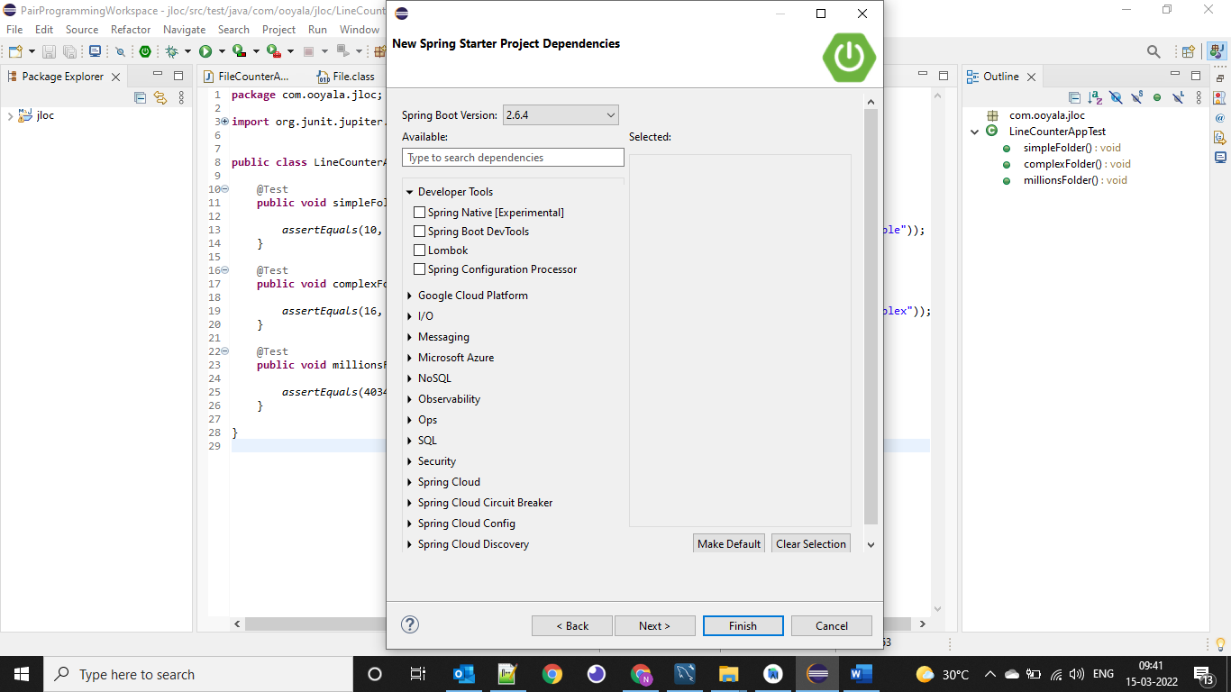

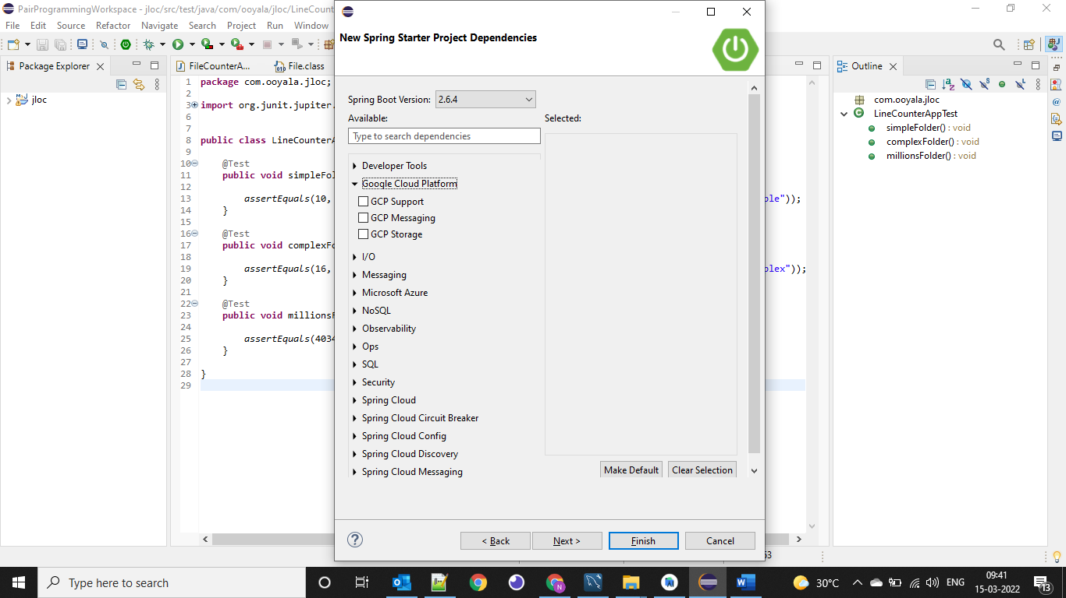

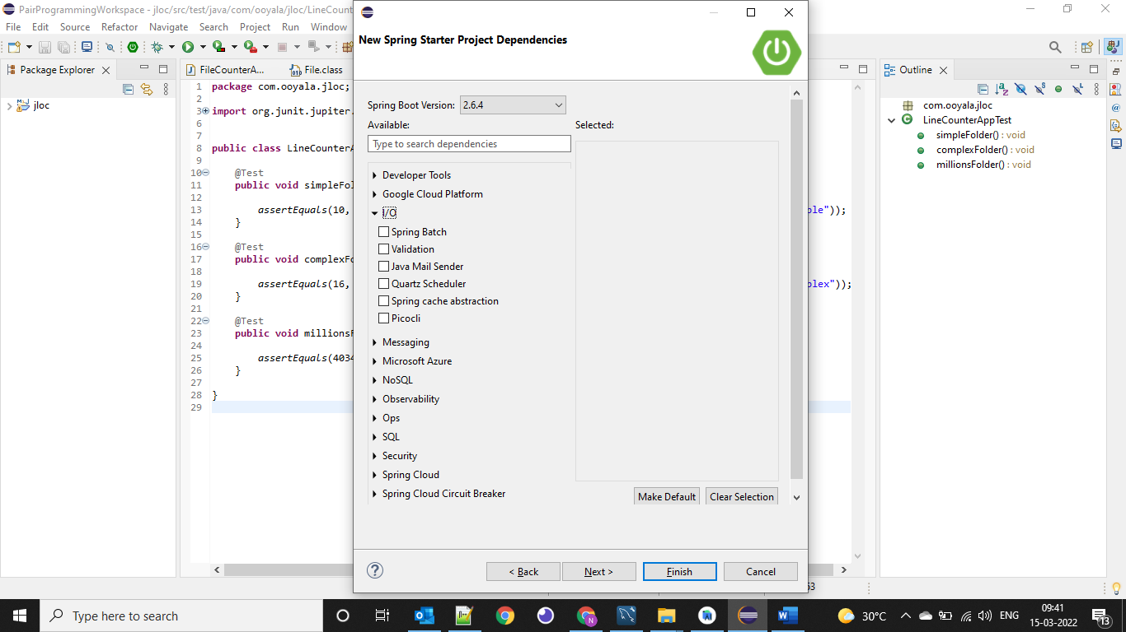

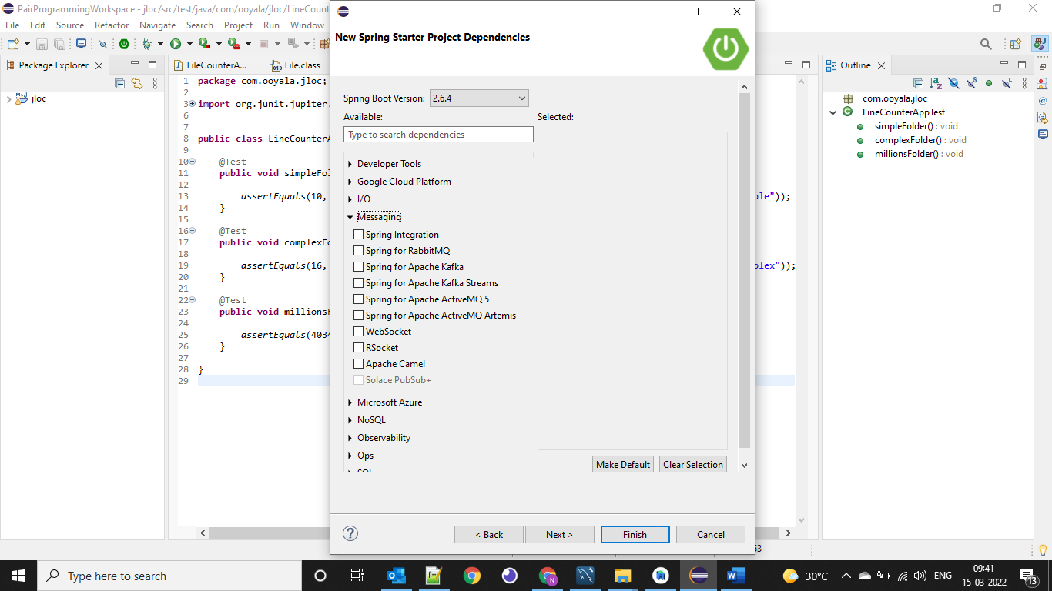

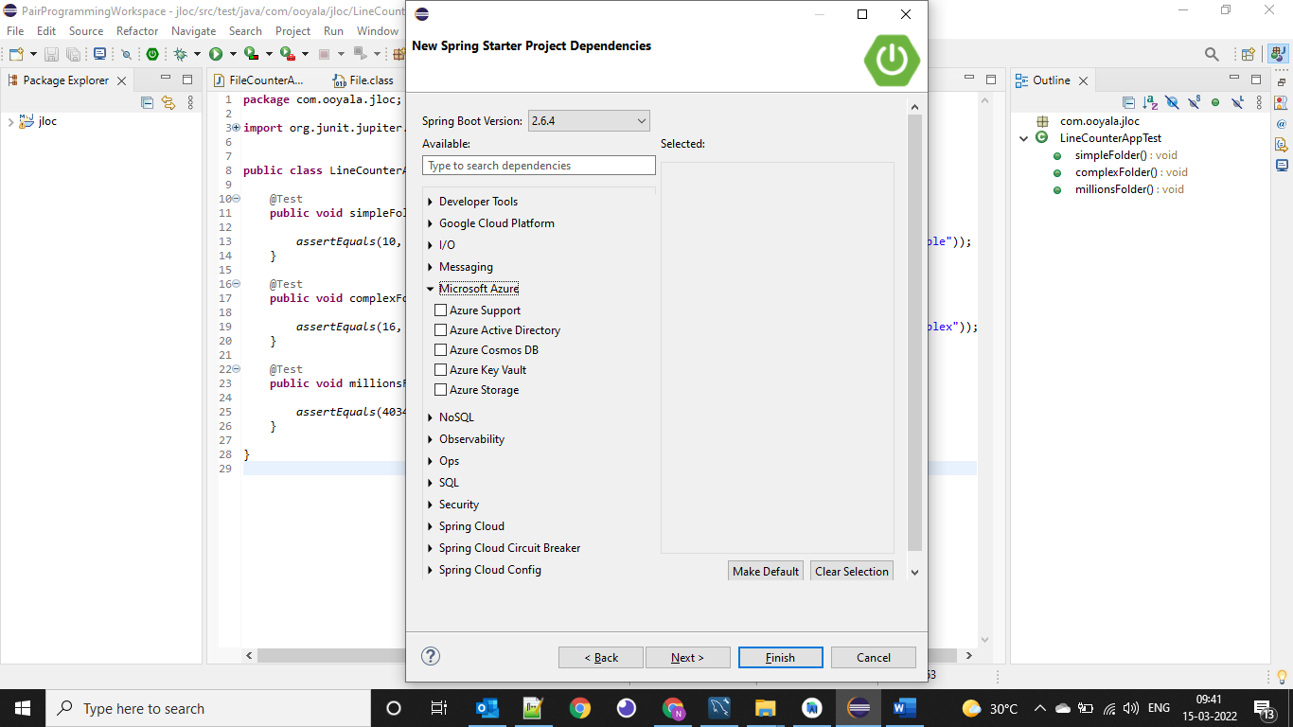

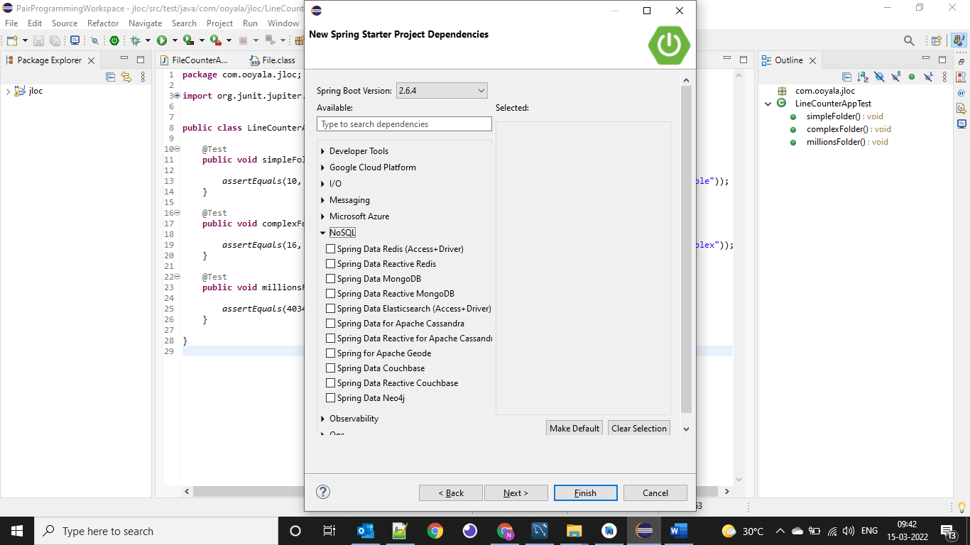

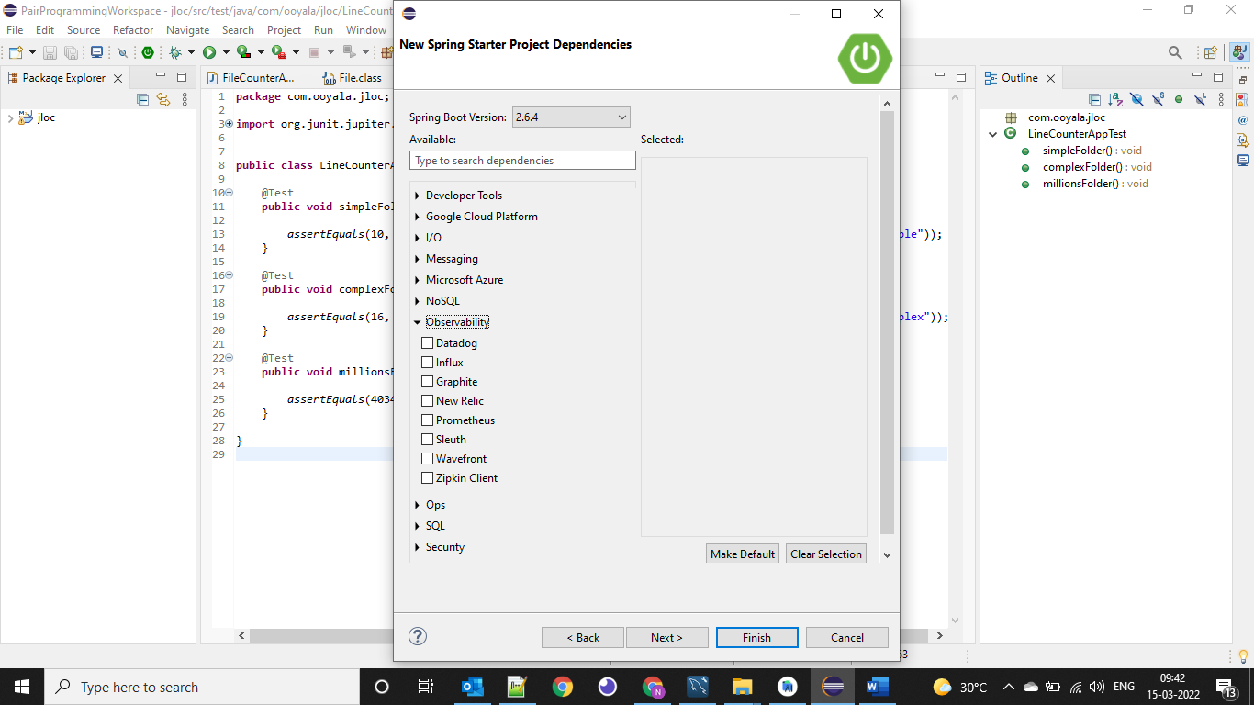

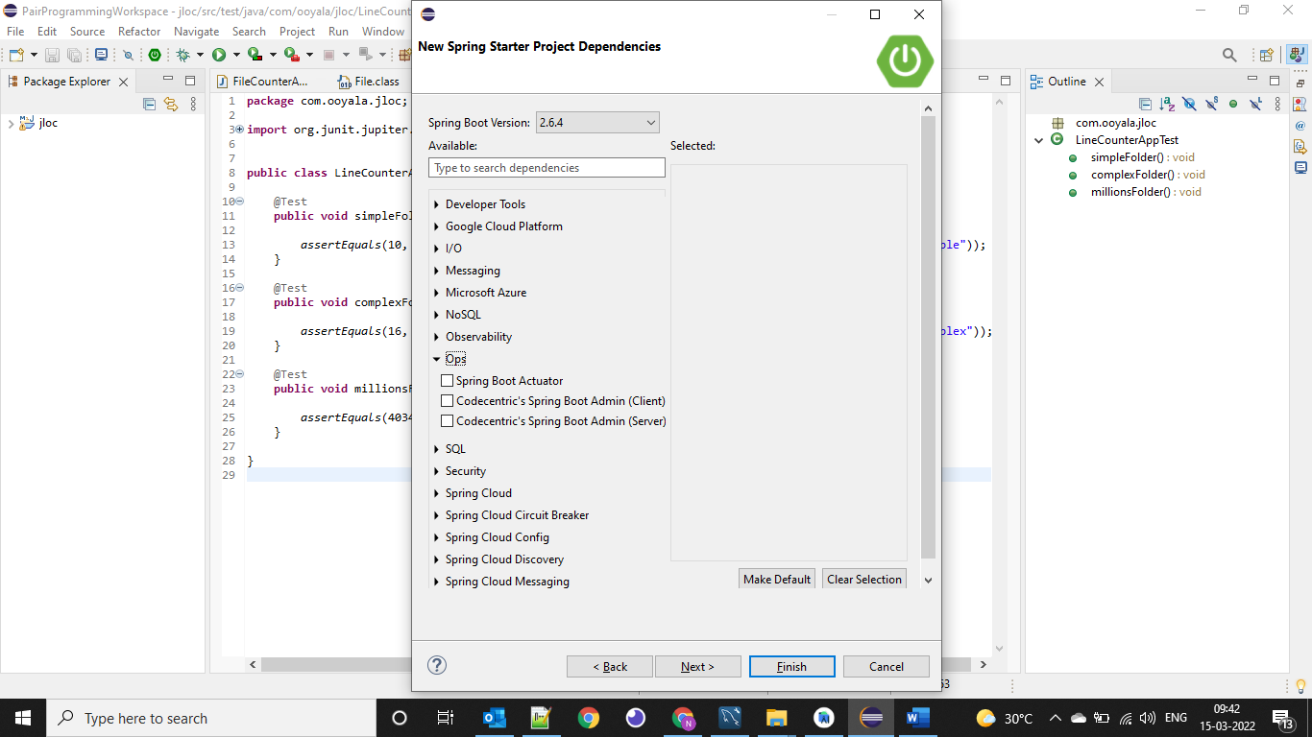

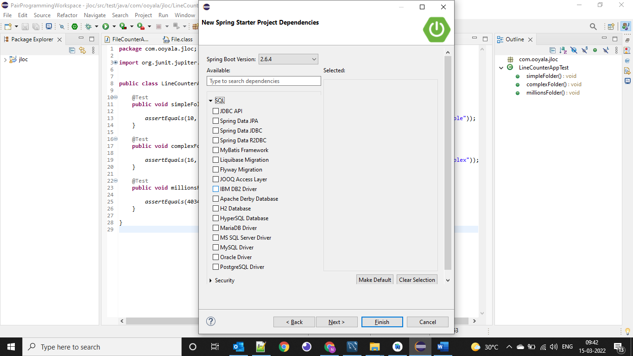

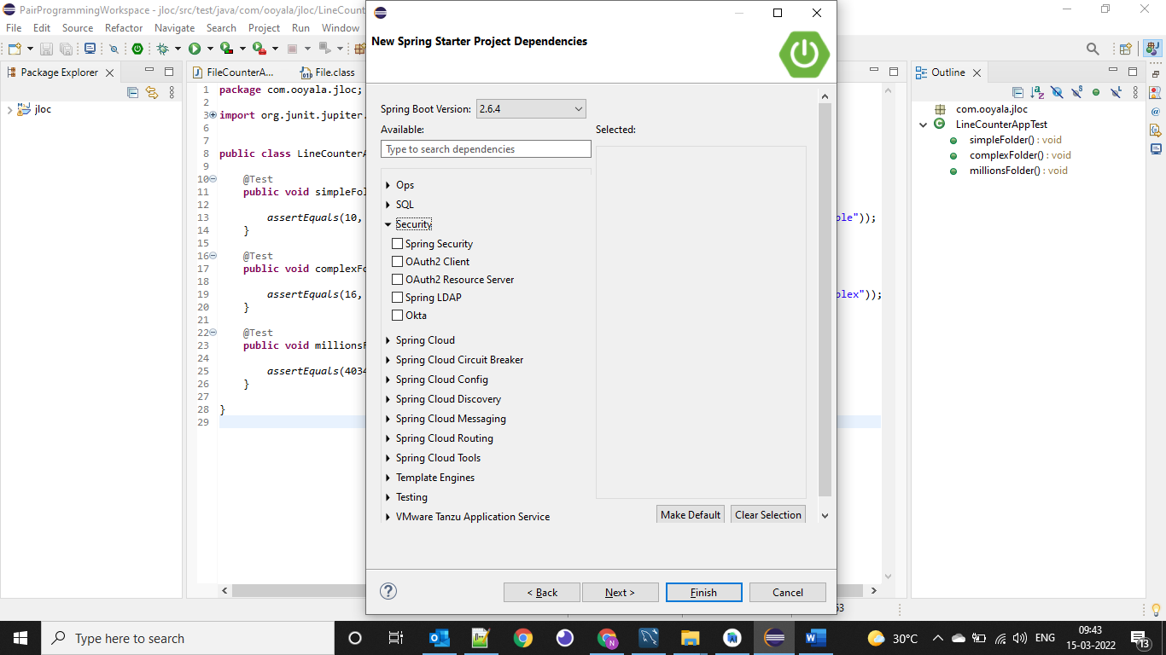

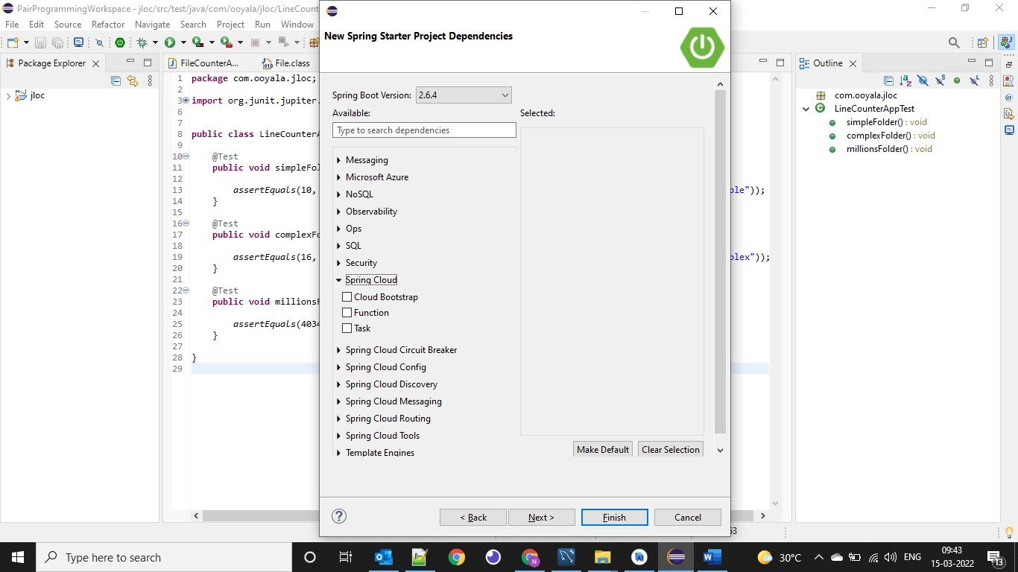

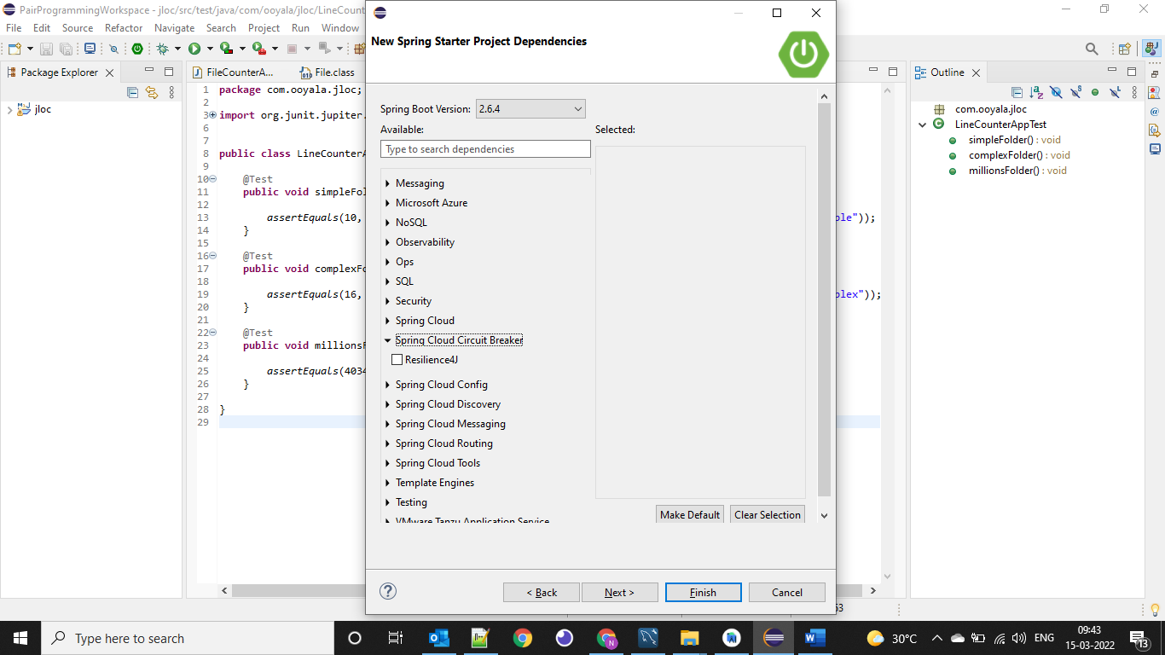

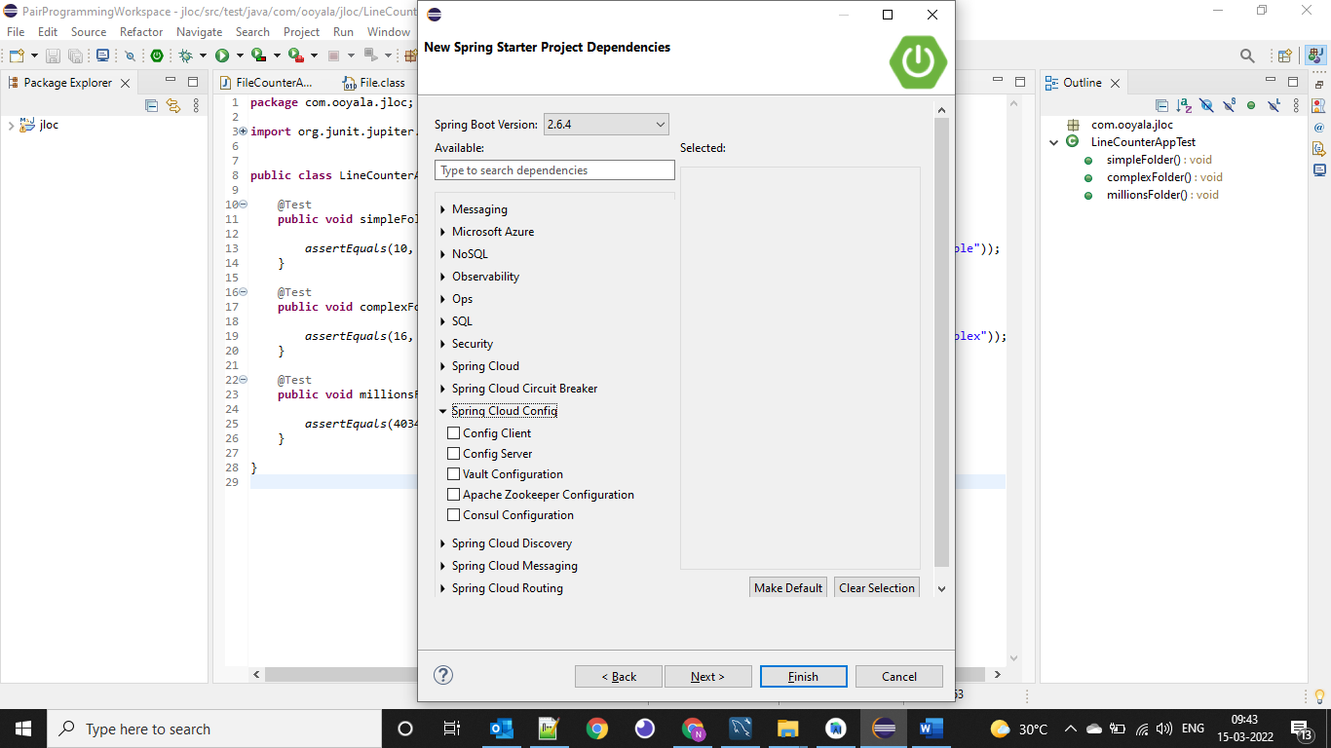

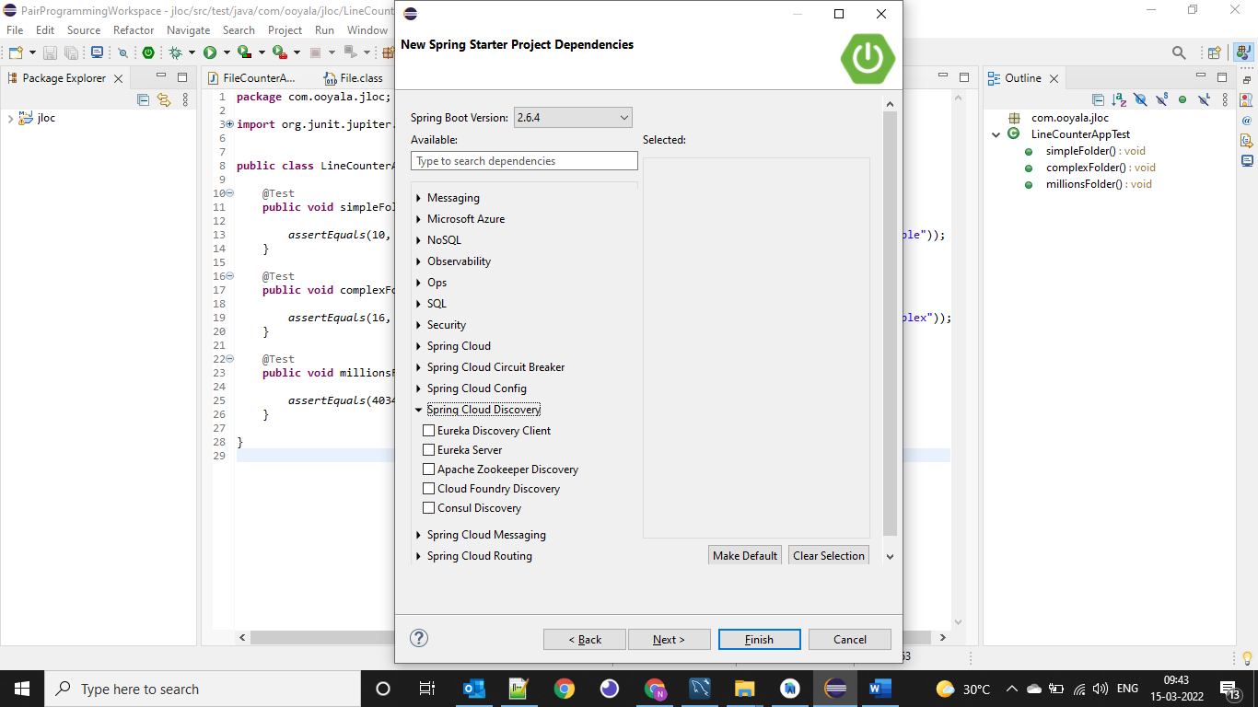

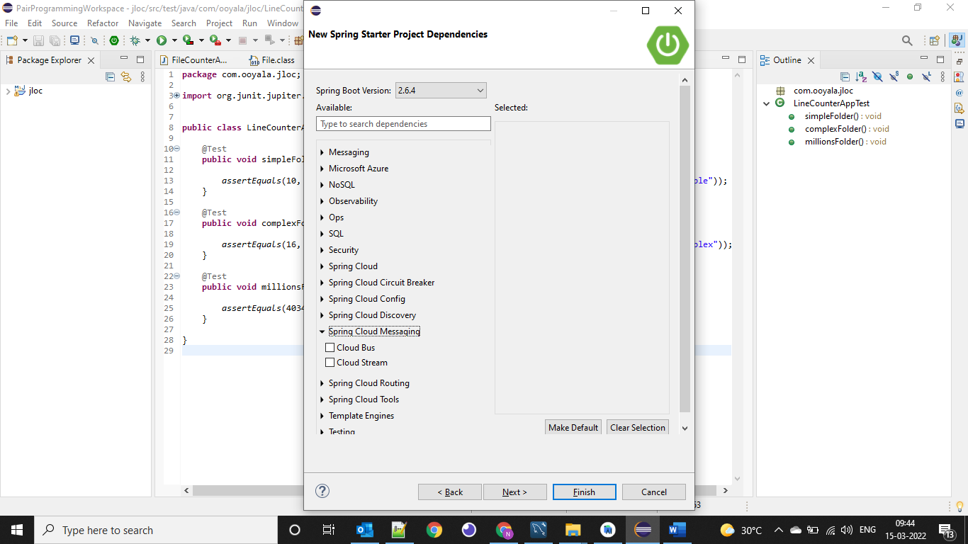

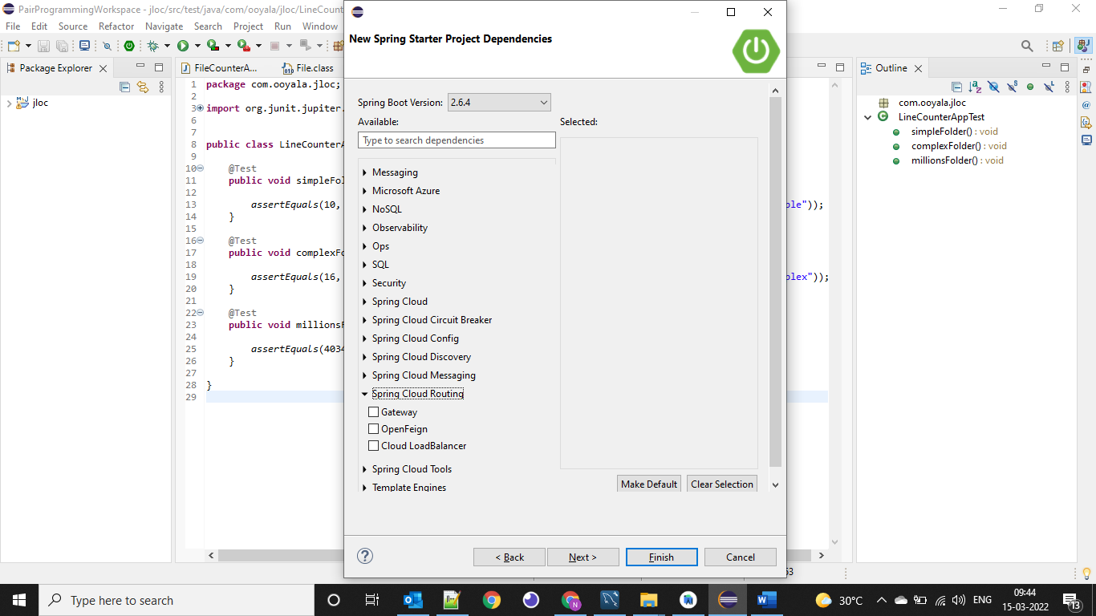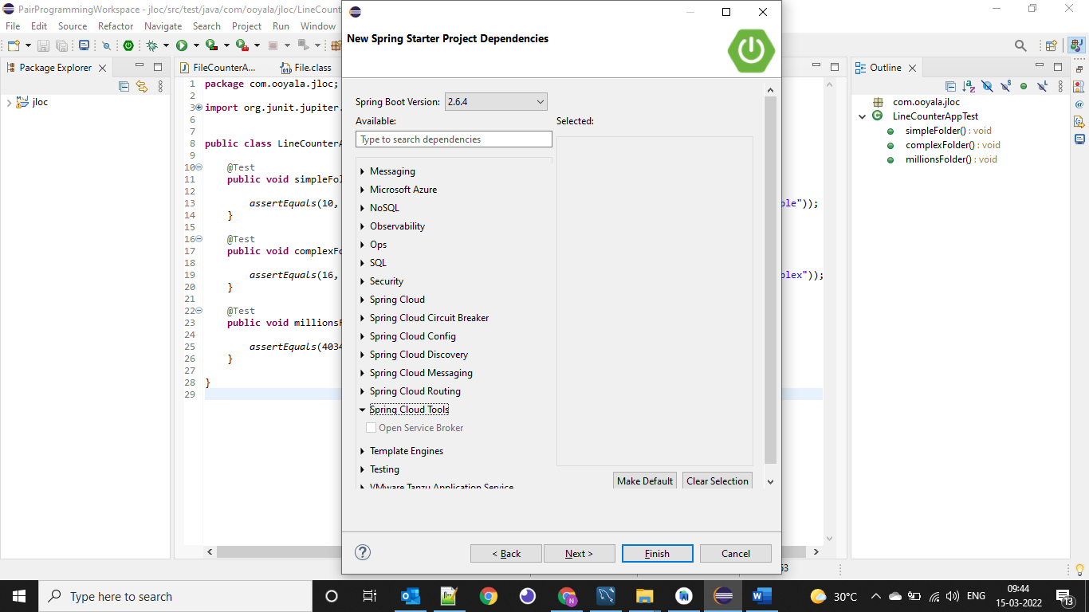



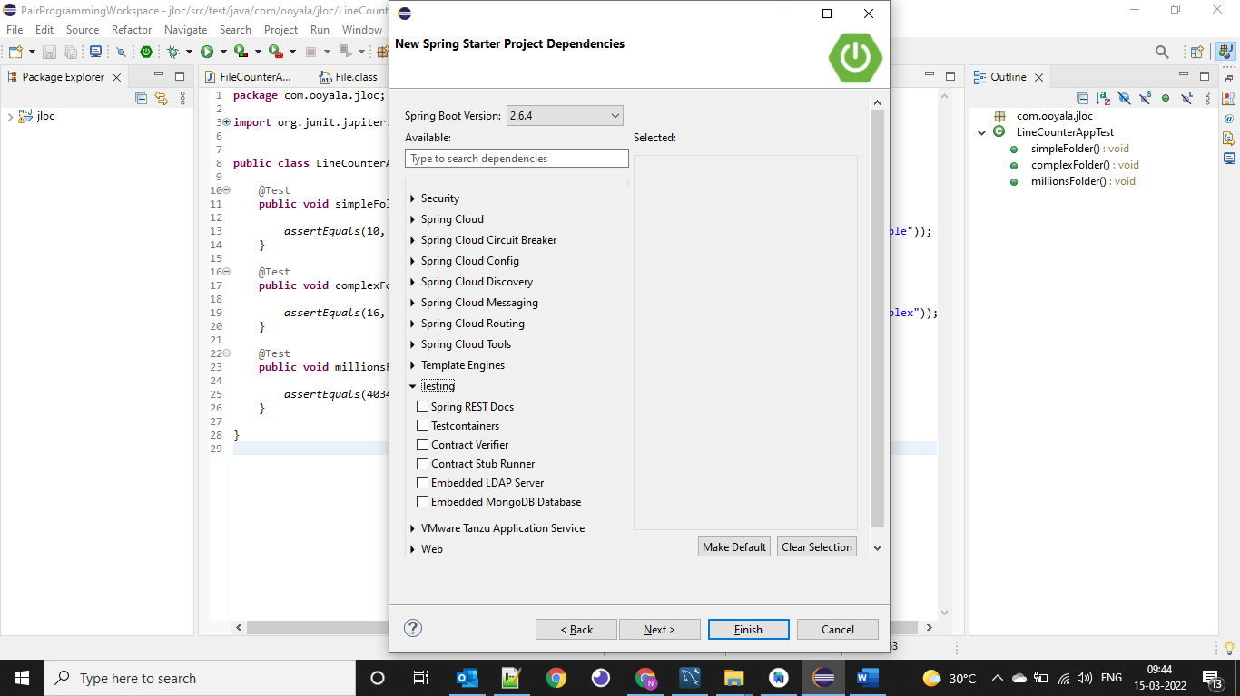

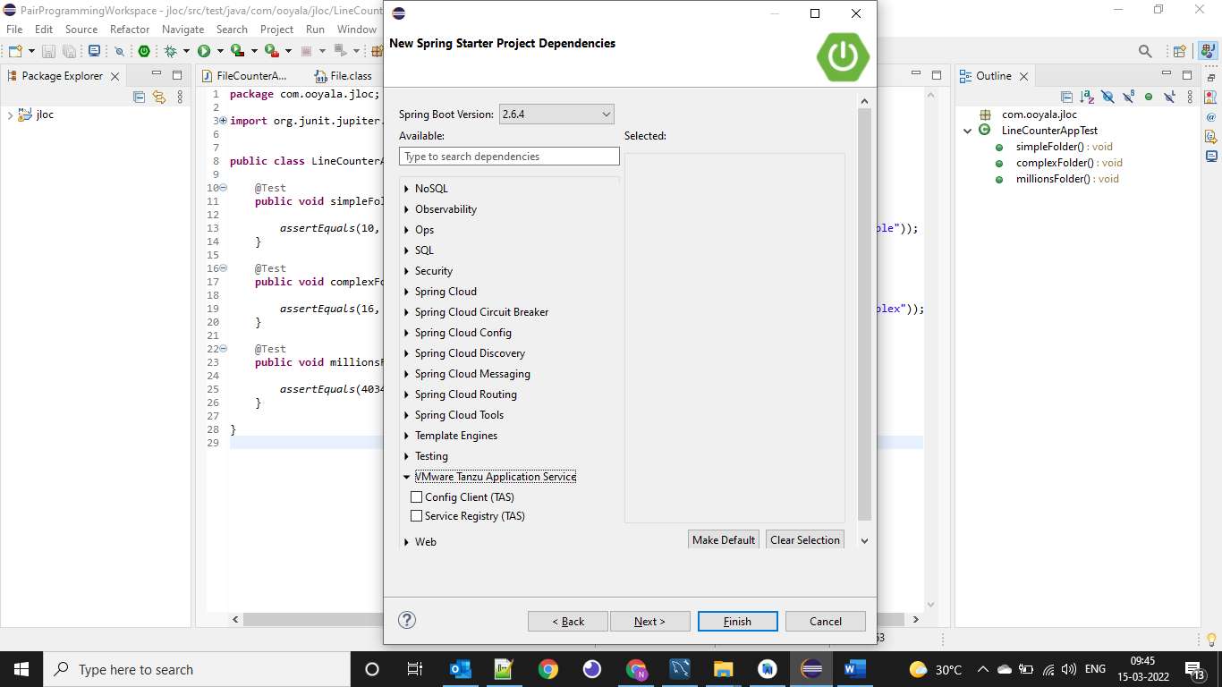

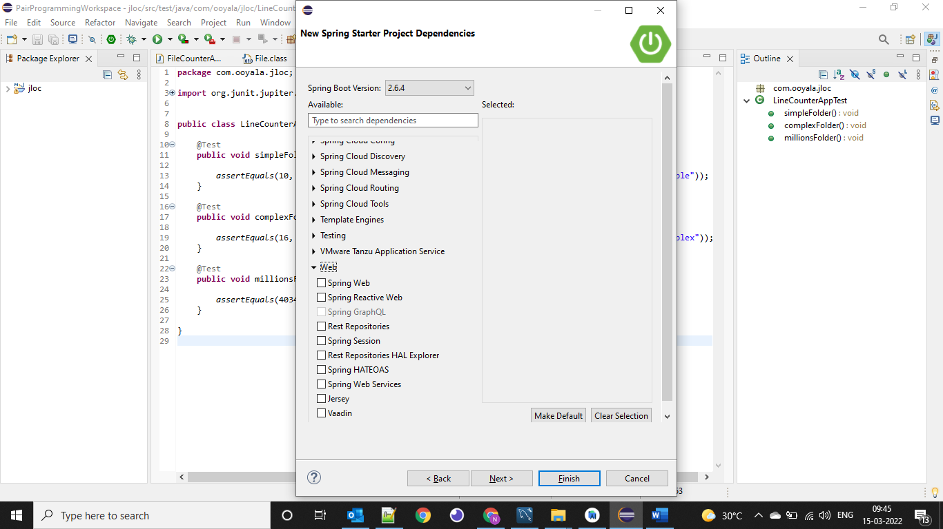

<https://docs.spring.io/spring-native/docs/current/reference/htmlsingle/> --- For reference

Spring boot runners

https://www.amitph.com/spring-boot-runners/

Setup Spring to run from command line

<https://morioh.com/p/b8d8ab74dcab>

or

<https://bushansirgur.in/run-spring-boot-application-command-line-maven/>

Spring boot tutorials

<https://www.javadevjournal.com/spring-boot/>

<https://howtodoinjava.com/interview-questions/spring-boot-interview-questions/>

<https://howtodoinjava.com/spring-boot-tutorials/>

<https://www.onlinetutorialspoint.com/spring-boot/spring-boot-actuator-database-health-check.html> --- Best link to refer make http to https

<https://www.youtube.com/watch?v=pUFGOngzJig> -- Saga Design Pattern

<https://www.youtube.com/watch?v=YLsG0mew2dU> – RabbitMQ complete video

<https://www.youtube.com/watch?v=kbr5RaRDgQk&list=PLS1QulWo1RIZ5Vy1lyTlfjqtbut9BijN9> -- Spring Boot Junit tutorial

<https://mkyong.com/tutorials/spring-boot-tutorials/> --- vvvvimp examples

<https://docs.spring.io/spring-boot/docs/current-SNAPSHOT/reference/htmlsingle/#getting-help> -- Complete Spring boot document to refer the concepts

[**https://docs.spring.io/spring-boot/docs/current/reference/html/application-properties.html#appendix.application-properties.server**](https://docs.spring.io/spring-boot/docs/current/reference/html/application-properties.html#appendix.application-properties.server) **– To know about all the properties in spring boot**

[**https://youtu.be/izDGlGY4rzA**](https://youtu.be/izDGlGY4rzA) **--- Loggers using slf4j (vvvvvvvvvvvvvvvvvvimp)**

[**https://howtodoinjava.com/log4j2/log4j2-properties-example/**](https://howtodoinjava.com/log4j2/log4j2-properties-example/) **-- Loggers with example**

[**https://www.youtube.com/watch?v=MEFoGR07qgw**](https://www.youtube.com/watch?v=MEFoGR07qgw) **-- Junit with MockItIo in Spring Boot - vvvvvvvvvvvvvvvvvvvvvvvvvvvvvvvvvvvvvvvvvvvvvvvvvvvvvvvvvvvvvimp**

[**https://www.youtube.com/watch?v=d2KwvXQgQx4**](https://www.youtube.com/watch?v=d2KwvXQgQx4) **– Junit with MockItIo in Spring Boot - vvvvvvvvvvvvvvvvvvvvvvvvvvvvvvvvvvvvvvvvvvvvvvvvvvvvvvvvvvvvvimp**

Quartz – To schedule the jobs

<https://www.youtube.com/watch?v=Z9AcBUKoic8&list=PLS1QulWo1RIZL1UicW3PV905pirgXjfQV&index=5>

Quartz to schedule job

https://www.baeldung.com/spring-quartz-schedule

<https://www.quickprogrammingtips.com/spring-boot/spring-boot-quartz-scheduler-integration.html>

Core Java

1. <https://www.interviewbit.com/java-interview-questions/#although-inheritance-is-a-popular-oop-concept-it-is-less-advantageous-than-composition-explain>
2. <https://www.interviewbit.com/java-interview-questions-for-5-years-experience/#is-it-necessary-to-declare-all-immutable-objects-as-final>
3. <https://www.interviewbit.com/android-interview-questions/>
4. https://beginnersbook.com/2017/10/java-8-stream-tutorial/
5. <https://www.programiz.com/java-programming/examples>
6. <https://www.javainterviewpoint.com/number-pattern-programs-in-java/>
7. https://appgrooves.com/android/com.sitseducators.javapatternprogramsfree/java-pattern-programs/sumit-tiwari-softethics
8. https://www.javapedia.net/module/Java

Blockchain

<https://builtin.com/blockchain>

<https://originstamp.com/blog/blockchain-technology-ppt-presentation/>

Other Important Ref Links

1. <https://howtodoinjava.com/java-version-wise-features-history/> --- Java Versions with features
2. <https://www.tutorialspoint.com/spring_boot/spring_boot_tomcat_deployment.htm> --- Spring boot
3. <https://www.guru99.com/spring-boot-interview-questions.html>
4. <https://www.interviewbit.com/spring-boot-interview-questions/>
5. <https://www.javatpoint.com/ioc-container> -Spring IOC
6. <https://www.tutorialspoint.com/spring_boot/spring_boot_tomcat_deployment.htm> -- Spring Boot Basics
7. <https://stackify.com/compare-java-logging-frameworks/> -- Loggers in Springboot
8. <https://www.youtube.com/watch?v=lt94m_-FBic> -- Log4j2
9. <https://springframework.guru/spring-boot-with-lombok-part-1/> -- Lombok library features
10. <https://www.tutorialspoint.com/differences-between-abstract-class-and-concrete-class-in-java> -- - Java Questions and Answers
11. <https://www.programiz.com/java-programming/examples/prime-number-function> - java programs
12. <https://www.journaldev.com/8611/spring-boot-interview-questions> -- Spring Boot
13. <https://www.journaldev.com/1321/java-string-interview-questions-and-answers> -- Core Java
14. <https://bushansirgur.in/spring-annotations/> --- Spring Boot Annotations
15. <https://everythingwhat.com/what-is-the-difference-between-autowired-and-bean> --- vvvvimp
16. <https://www.youtube.com/watch?v=o6-gRZfQqOE> --- Spring Boot Annotations with video
17. <https://bushansirgur.in/spring-boot-100-tutorials/>
18. <https://everythingwhat.com/what-is-the-difference-between-autowired-and-bean> --- VVVVVVIMP
19. <https://javagoal.com/finalize-method-in-java/> --- VVVIMP
20. <https://zetcode.com/springboot/controlleradvice/> --- VVVVVVVIMP
21. <https://attacomsian.com/blog/spring-data-jpa-one-to-many-mapping>
22. <https://zetcode.com/springboot/controlleradvice/>
23. <https://javagoal.com/final-finally-finalize/>
24. <https://javatechonline.com/how-to-implement-feign-client-in-spring-boot-microservices/> -- Feign Client vvvvvvvvvvvimp
25. <https://springframework.guru/spring-boot-messaging-with-rabbitmq/> - Rabbit MQ
26. <https://javabydeveloper.com/component-scanning-in-spring/> ---- VVVVVIMP link to refer the spring boot concepts in deep
27. <https://www.youtube.com/watch?v=5OMx4R9VT-0> --- In depth knowledge about API Gateway
28. <https://www.youtube.com/watch?v=-XGTjzz7nEs&list=PLkQkbY7JNJuDqCFncFdTzGm6cRYCF-kZO> -- Micro services in depth knowledge
29. <https://www.youtube.com/watch?v=_4n7NpdCECg> -Spring boot architecture
30. <https://www.codetd.com/en/article/6456808> -- junit with Mockitio and cobertura

Confluence

<https://marketplace.atlassian.com/apps/1211769/xray-test-management-for-jira?tab=overview&hosting=cloud>

versioning – How to maintain different versions of APIs

**Loose coupling:**

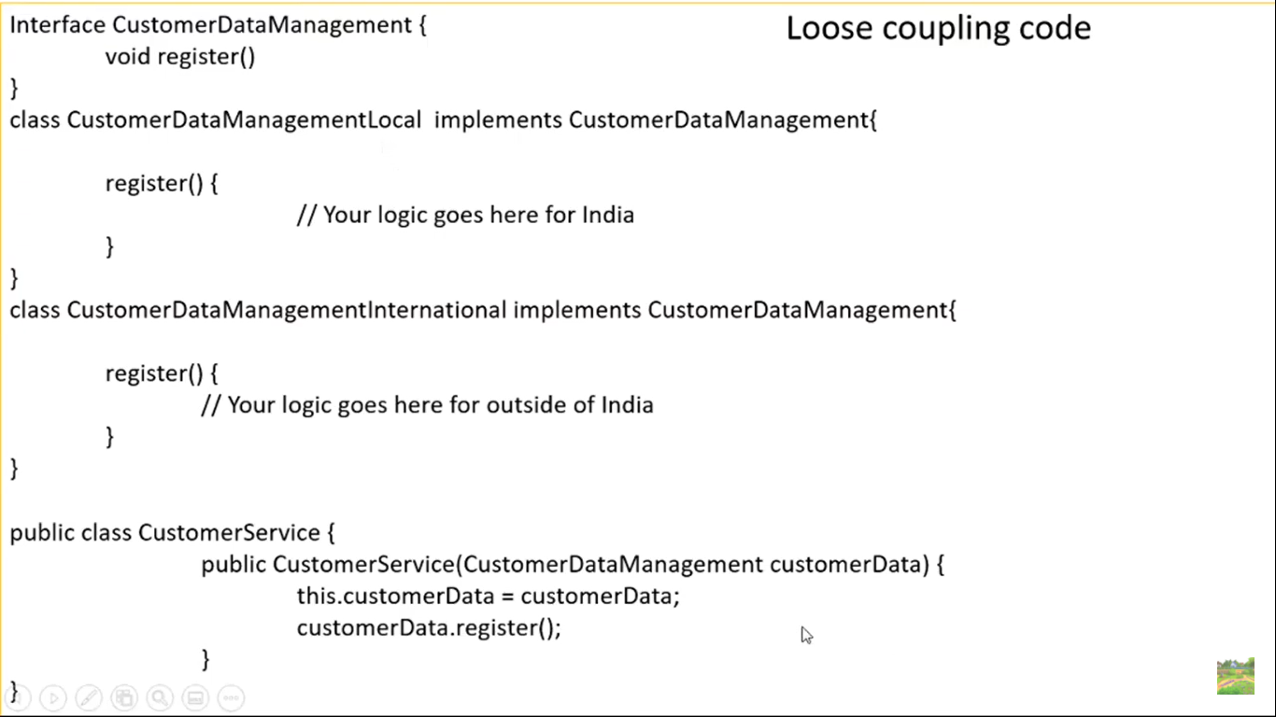

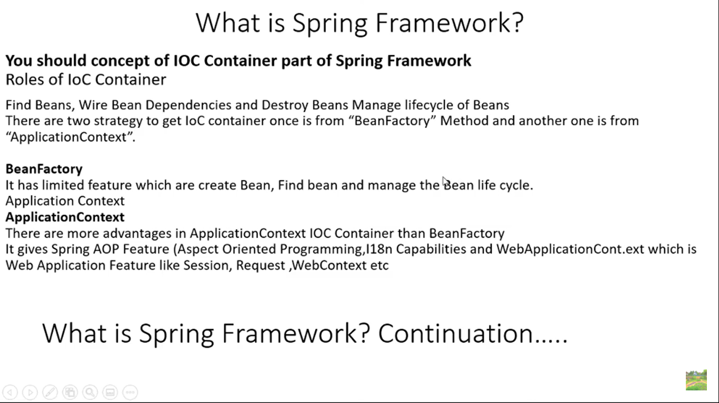

Unit Testing

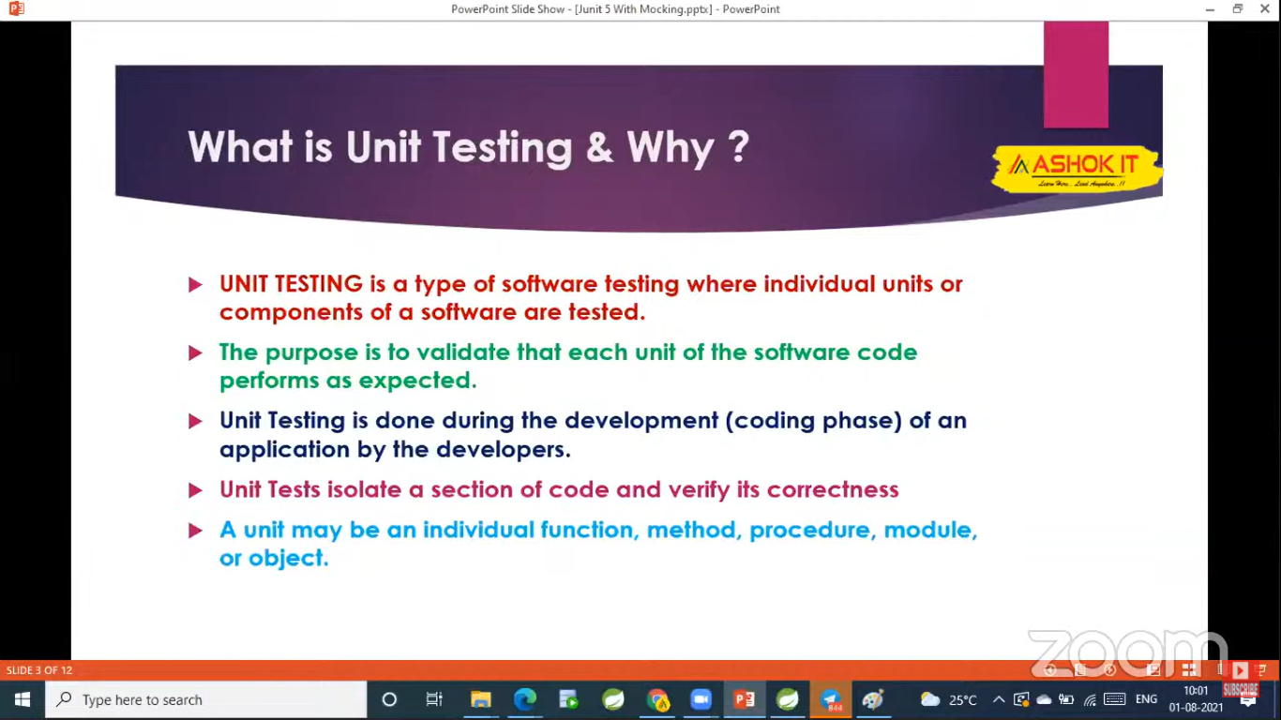

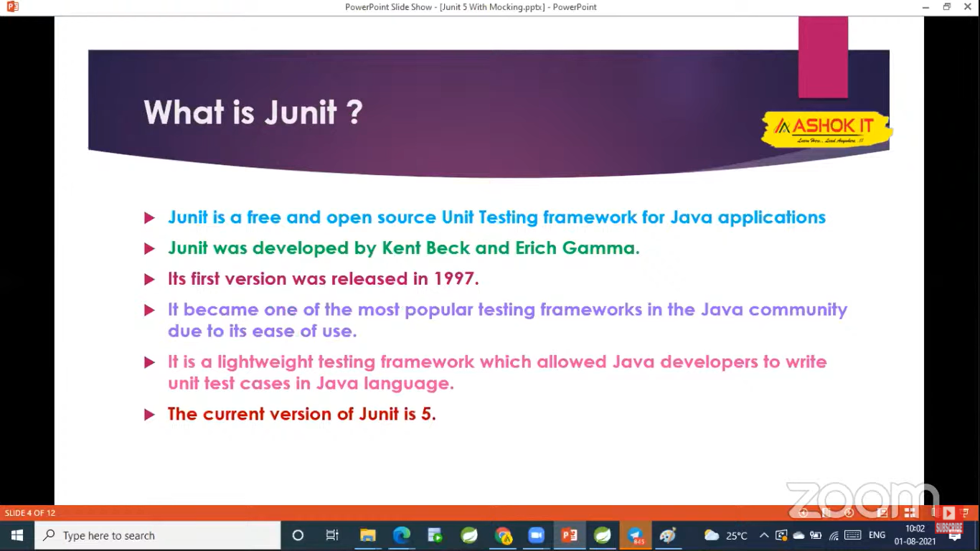

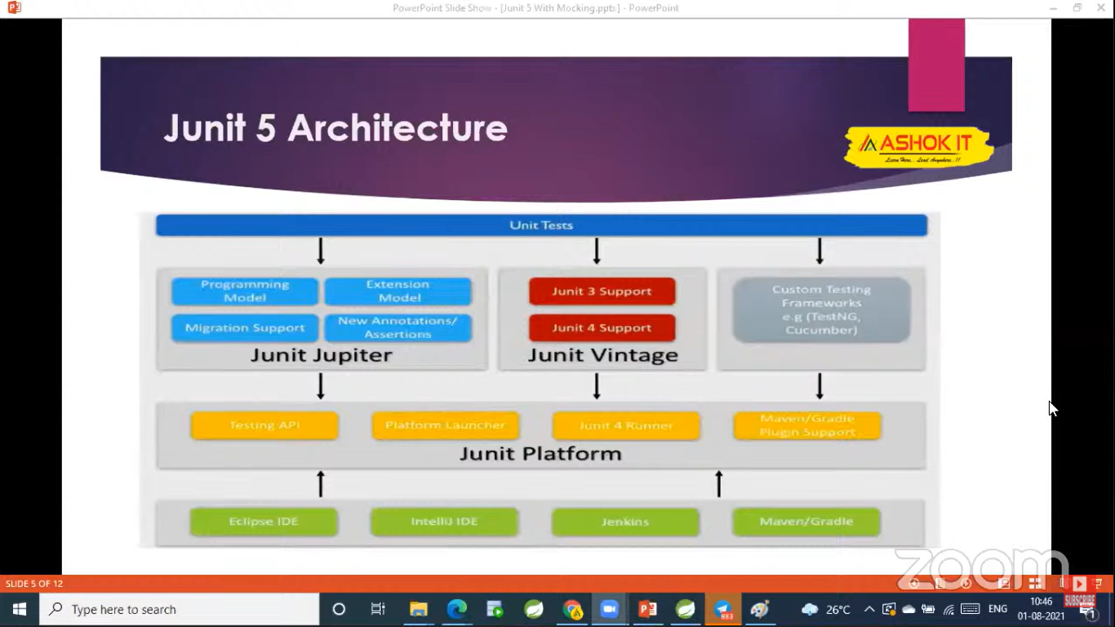

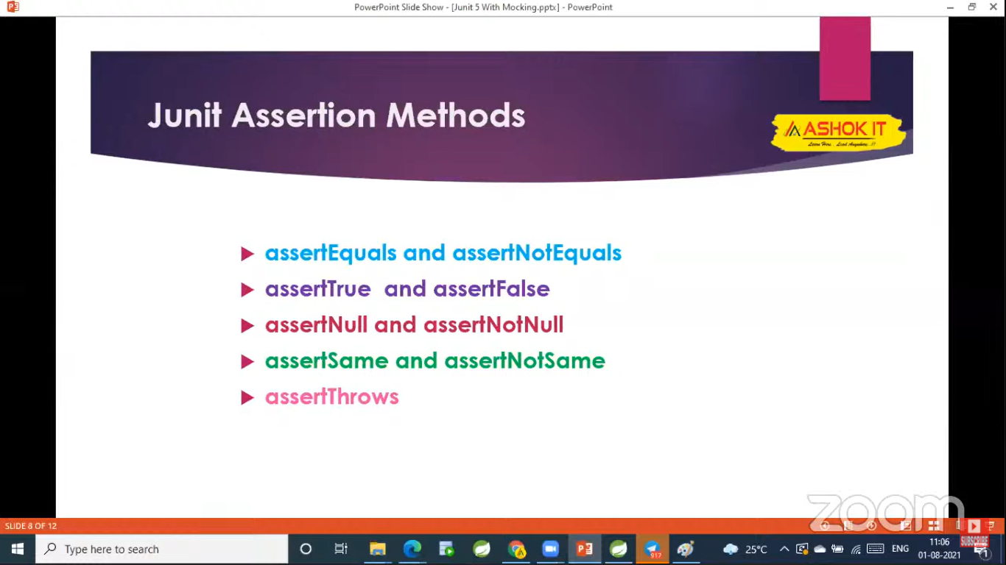

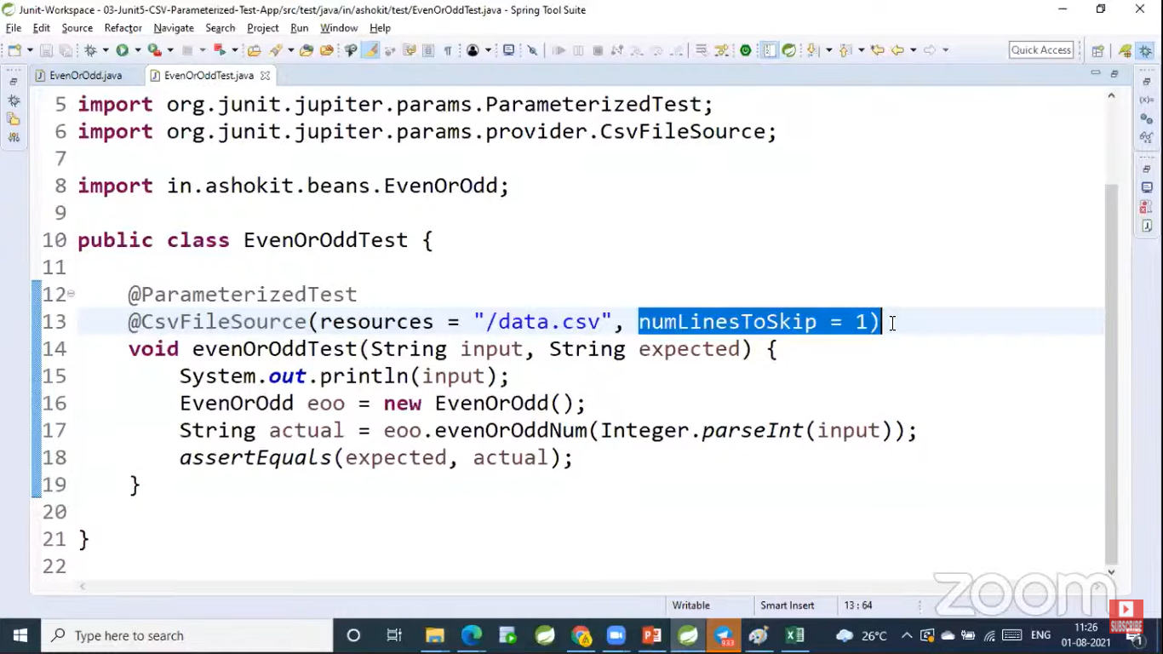

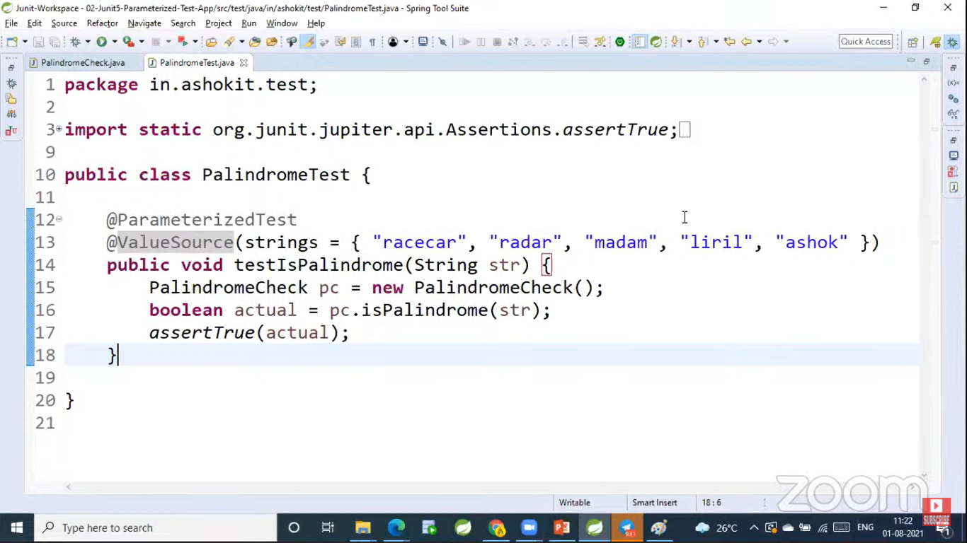

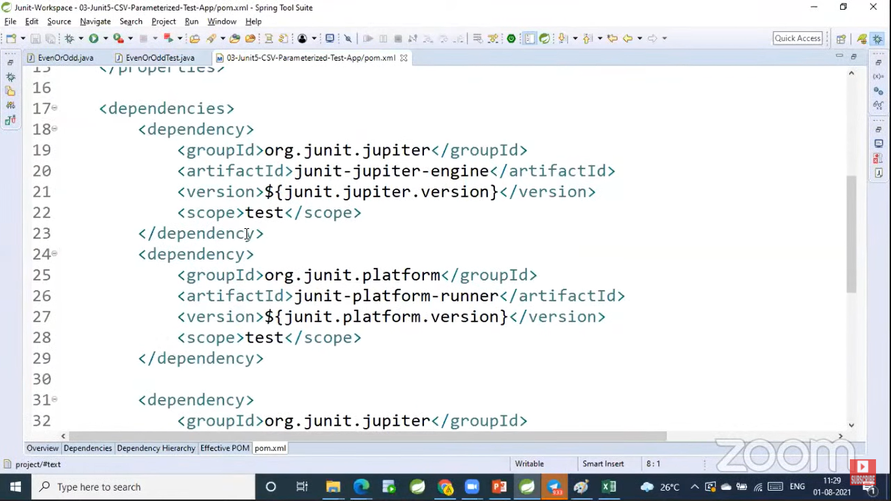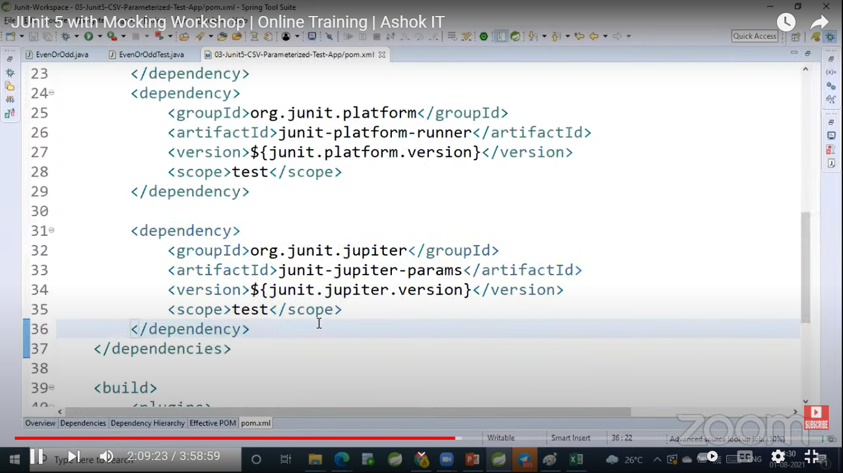

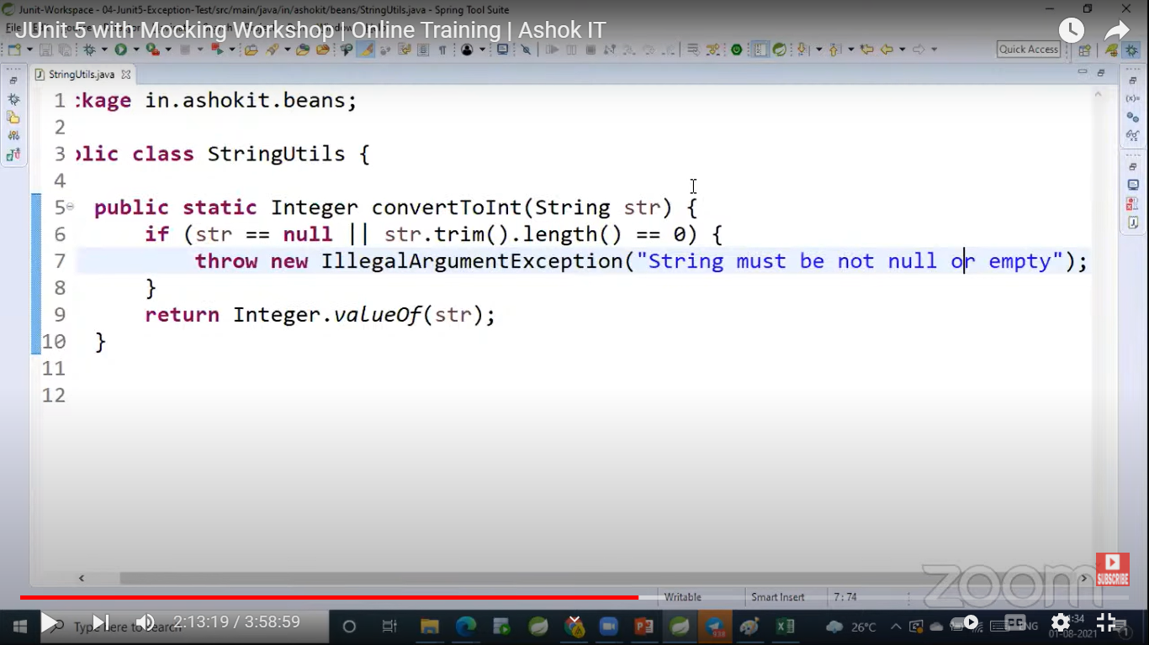

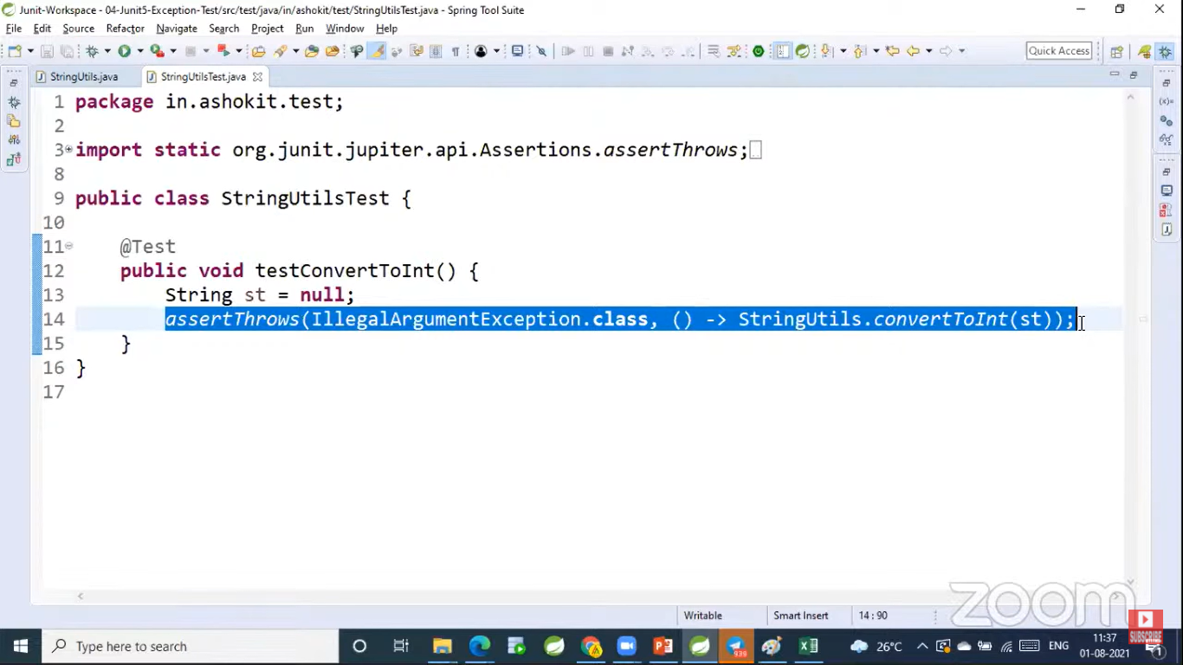

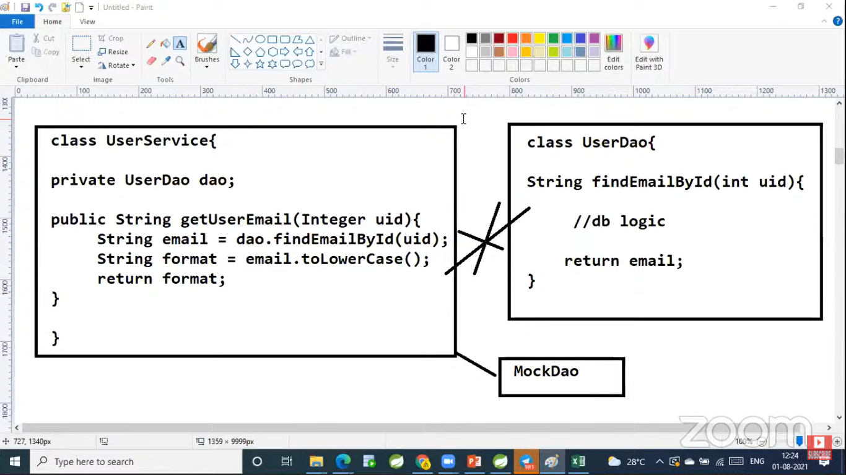

To perform isolated unit testing, we will go with Mocking. Here UserService is dependent on UserDao, so without calling actual DAO class we will go with MockDao class. This is called Mocking.

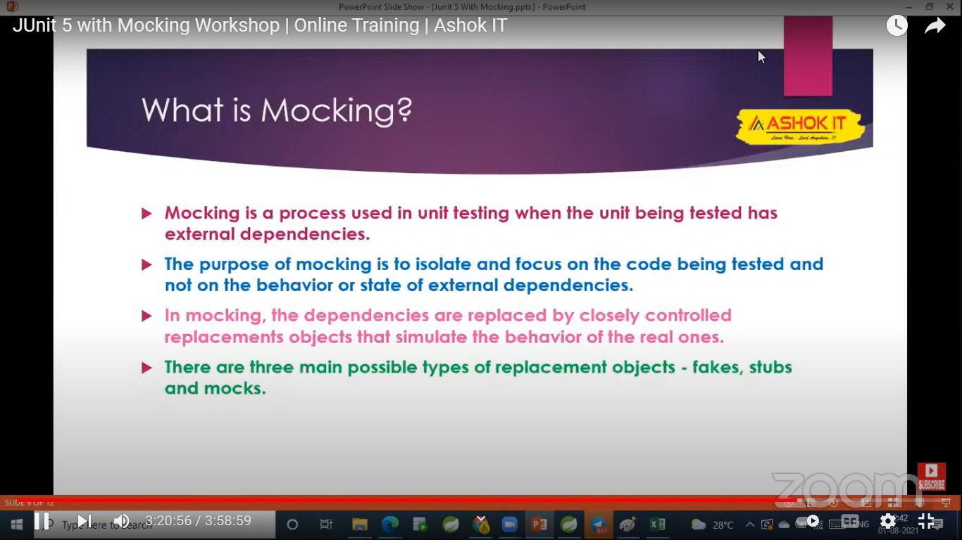

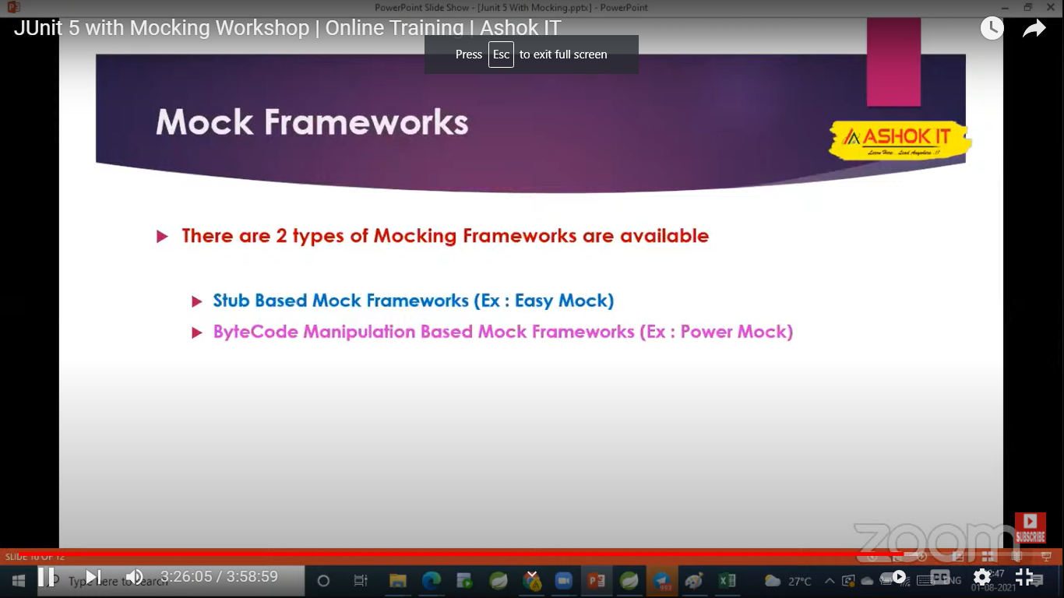

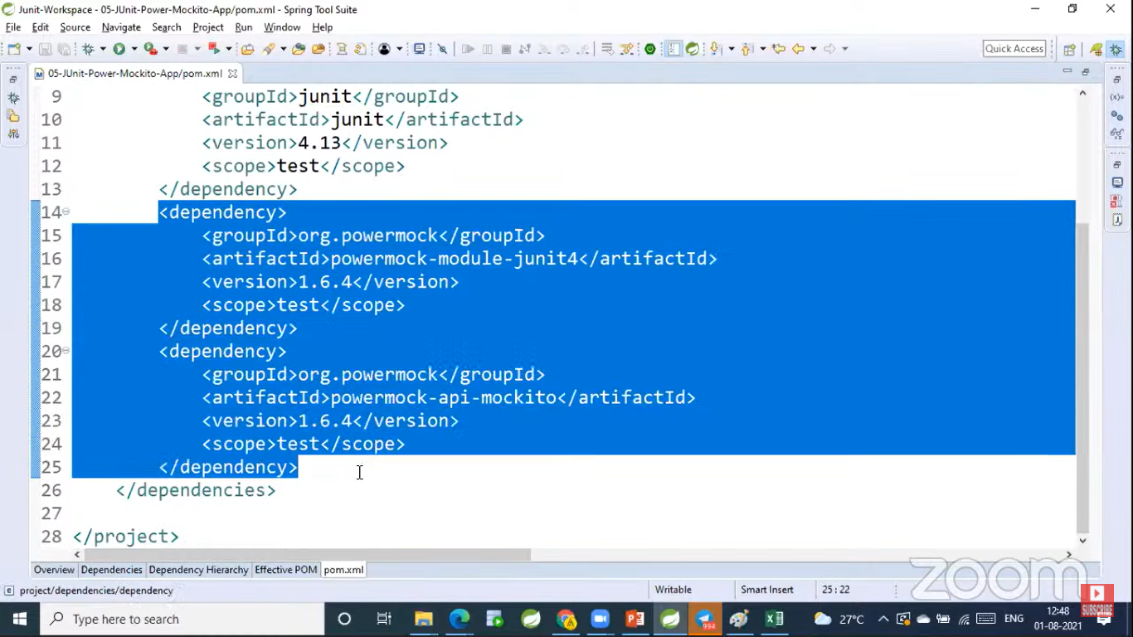

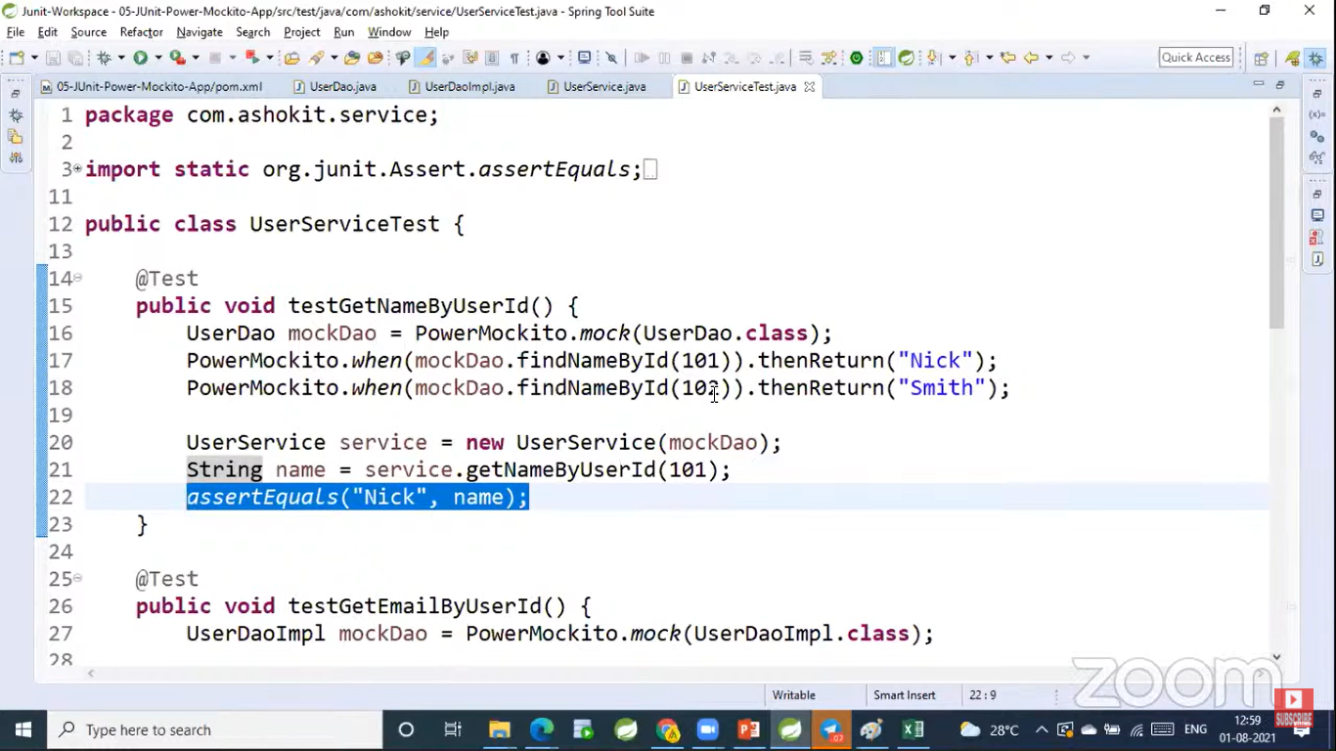

To perform unit testing on private methods, we have to use spy method.

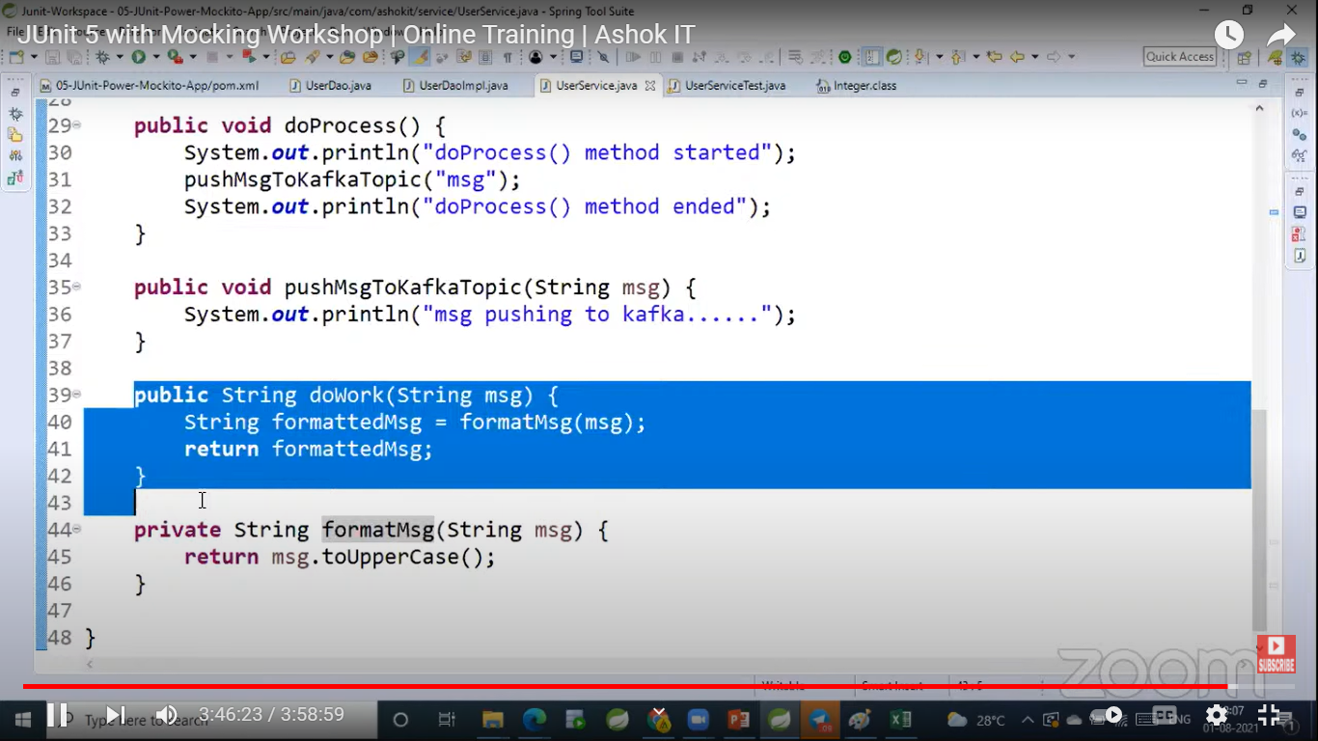

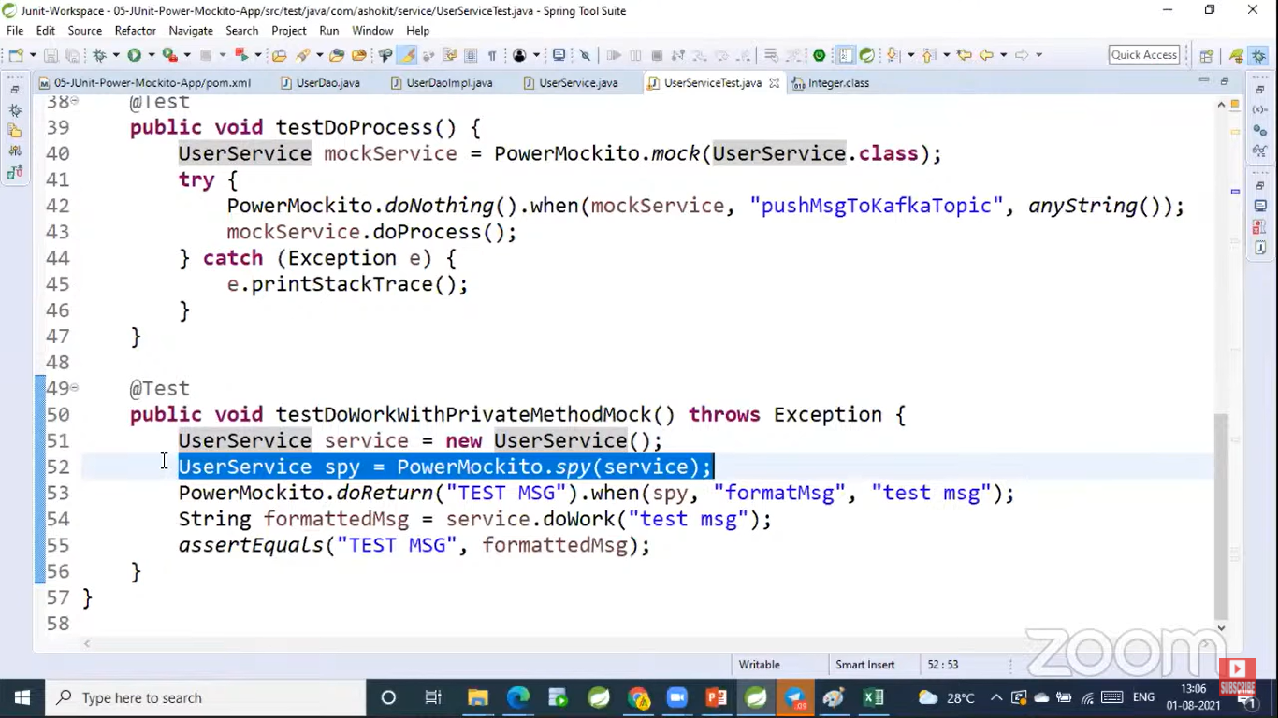

If we want to call real method of daoImpl then we have to call “thenCallRealMethod()” as below

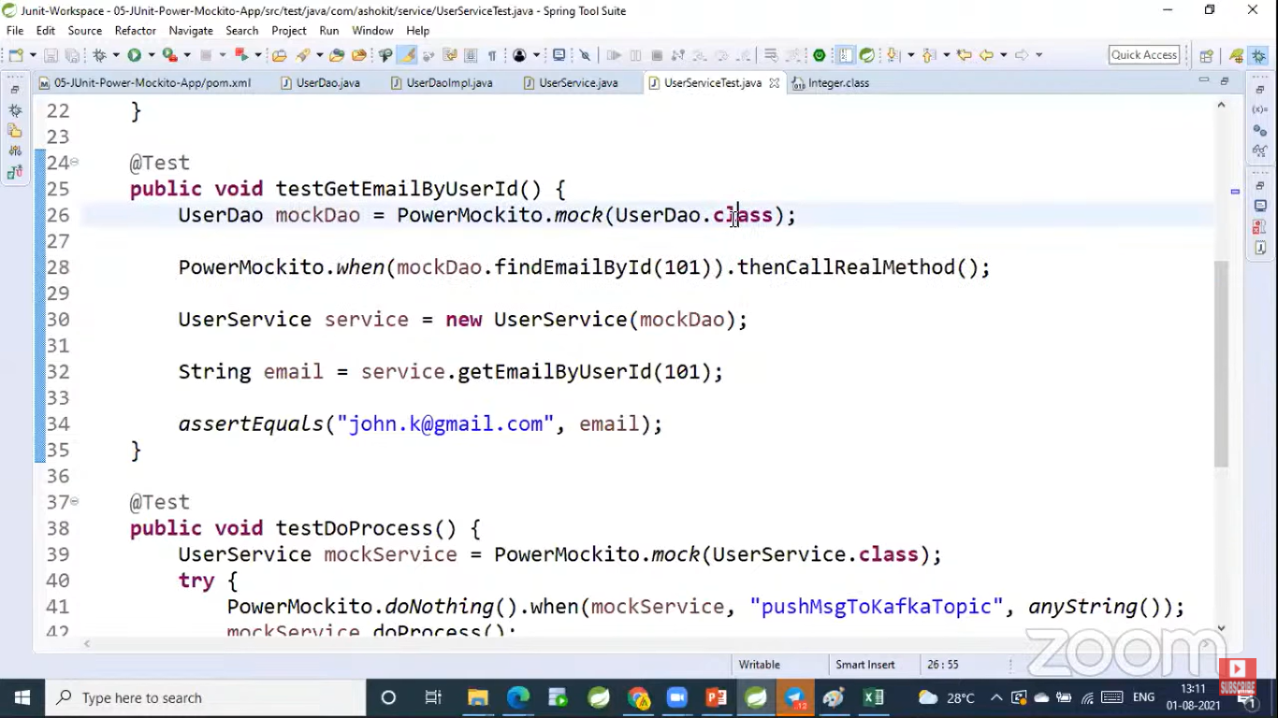

<https://www.youtube.com/watch?v=8iHUjXkCuwI> -- Continue Video

What is Rest API?

Rest API is a distributed application which is used to achieve interoperability.

What is Interoperability?

Irrespective of the platform if One application is communicating with other application is called Interoperability

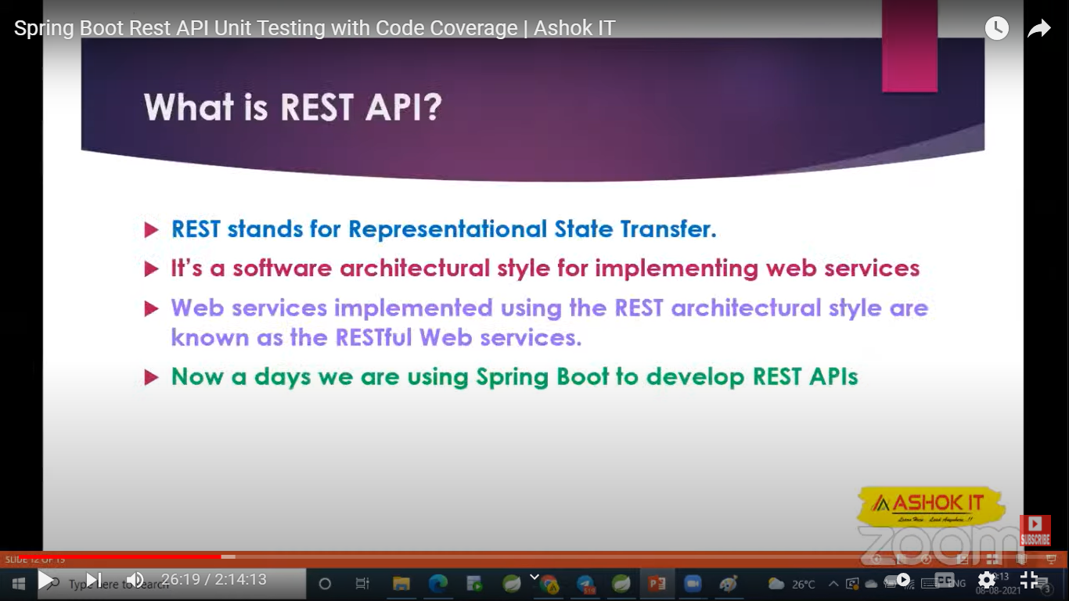

@WebMvcTest – If we want to perform unit testing on spring components then we have to use this annotation

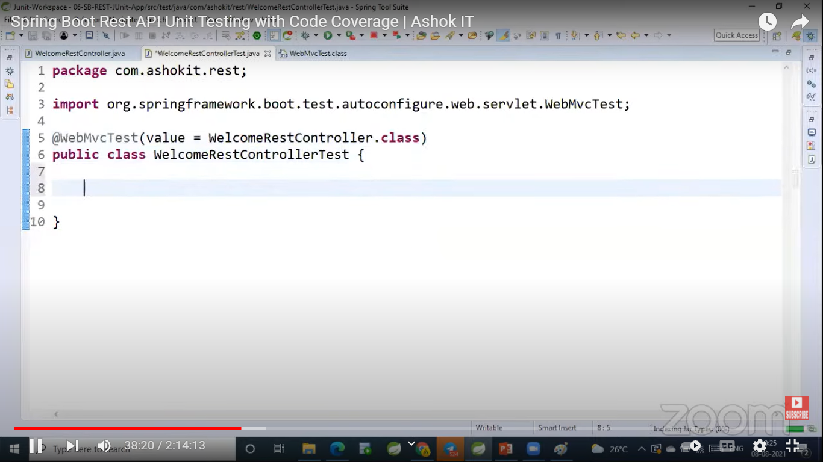

@MockBean – Is used to create mock object for the dependent classes in Spring Boot.

@MockMvc – Is used to send a request to the rest API.

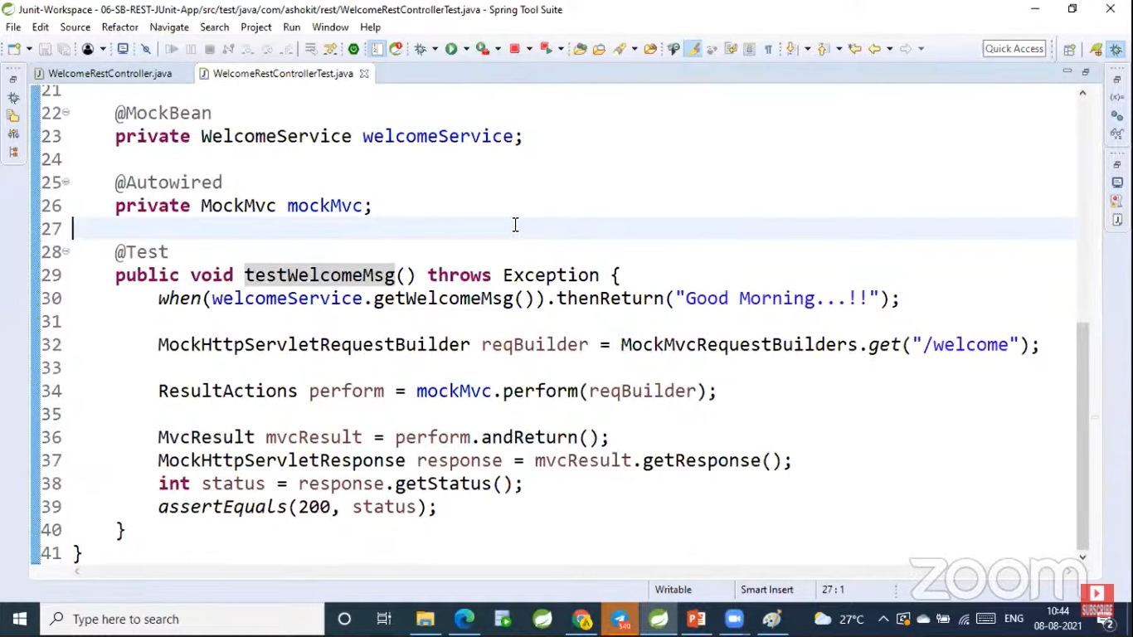

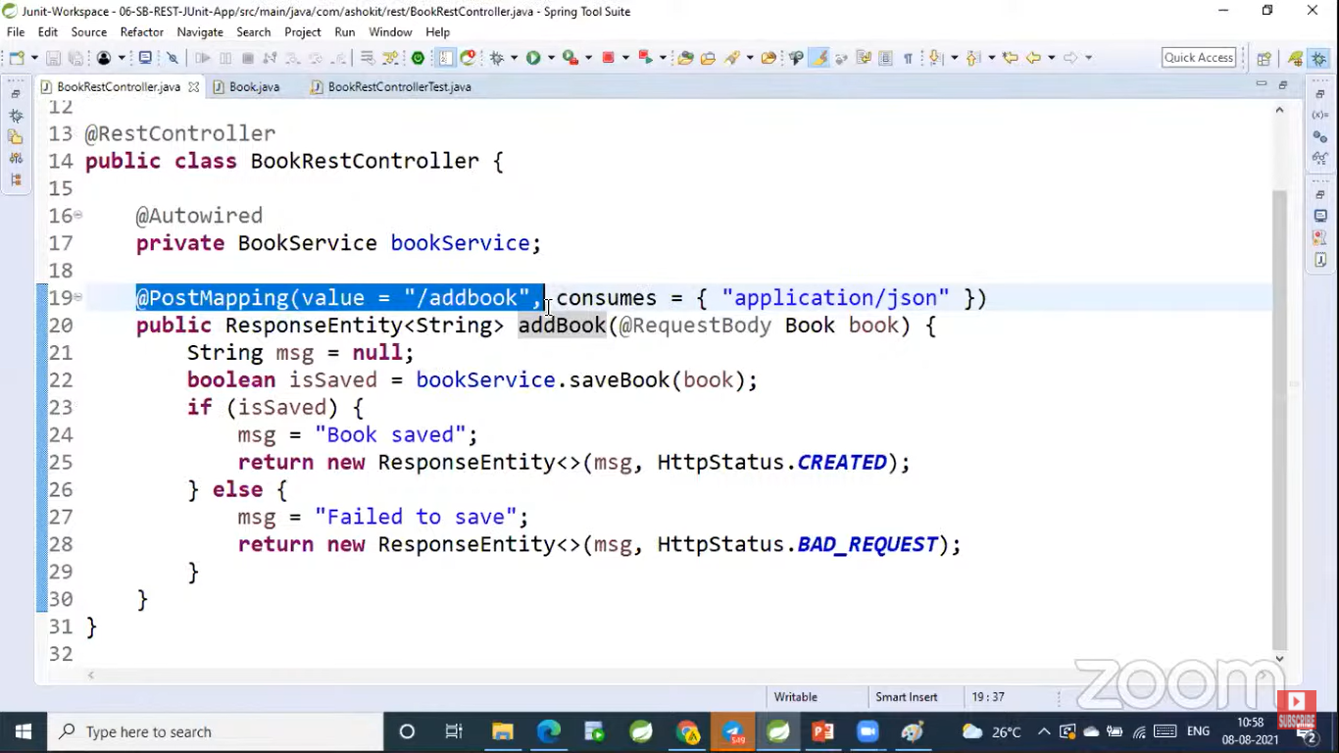

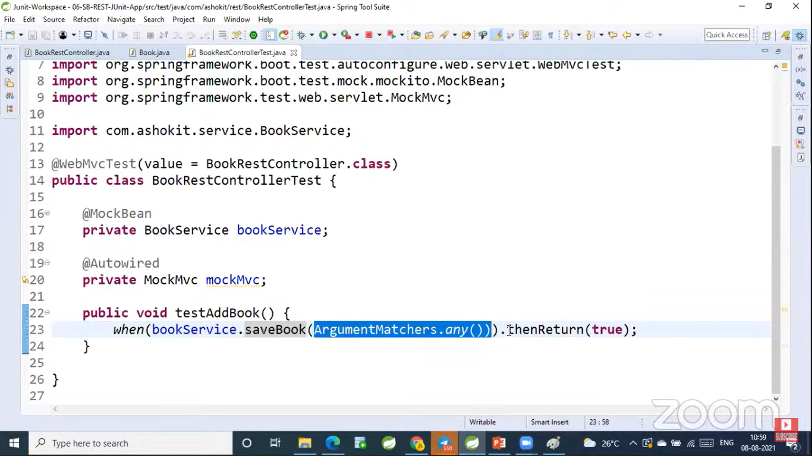

Here ArgumentMatchers.any() – is used to send any object

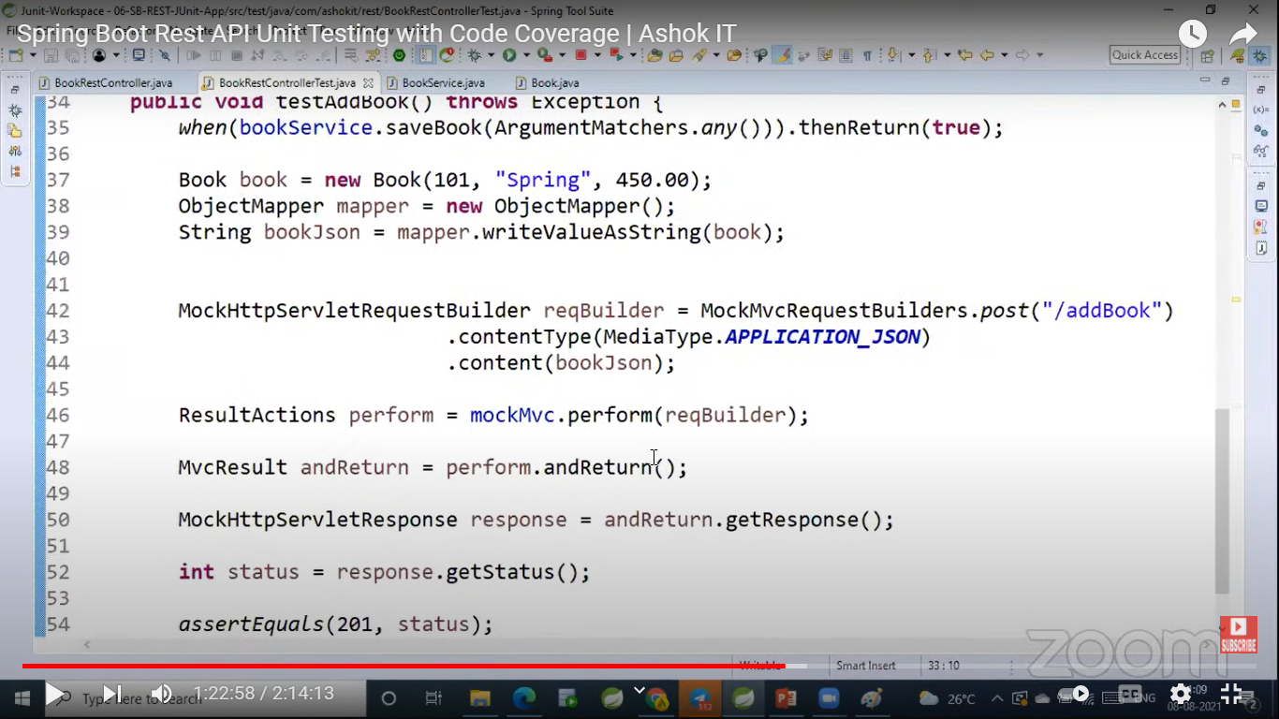

<https://www.javaguides.net/2022/03/springboottest-vs-webmvctest.html> ---- Refer this link to get the complete knowledge about unit testing in spring boot ---- vvvvvvvvvvvvvvvvvvvvvvvvvvvvvvvvvvvvvvvvvvvvvvvvvvvvvvvvvimp

Jacoco Code Coverage

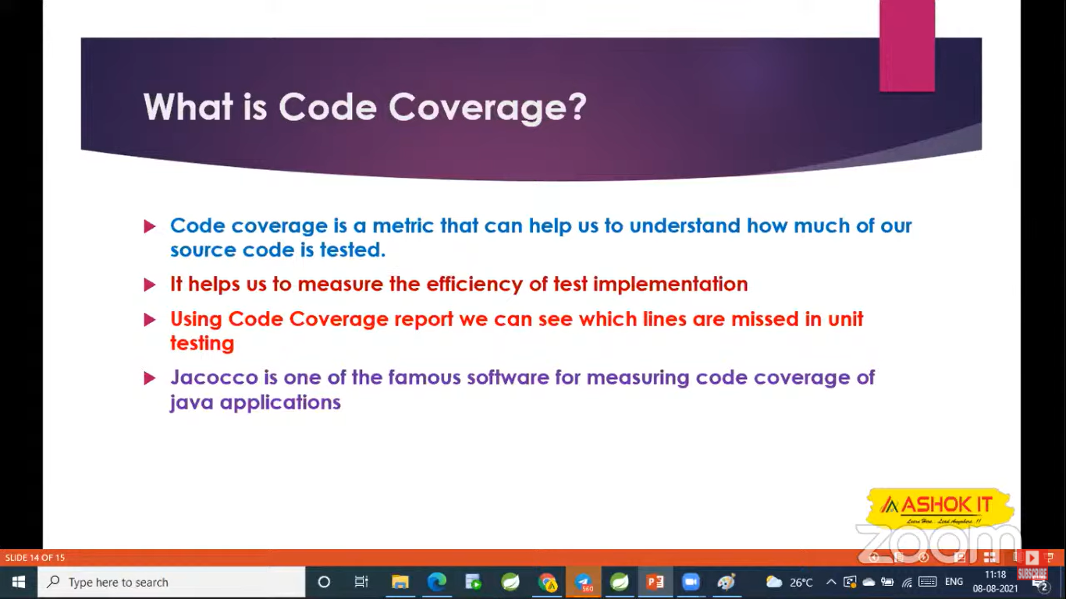

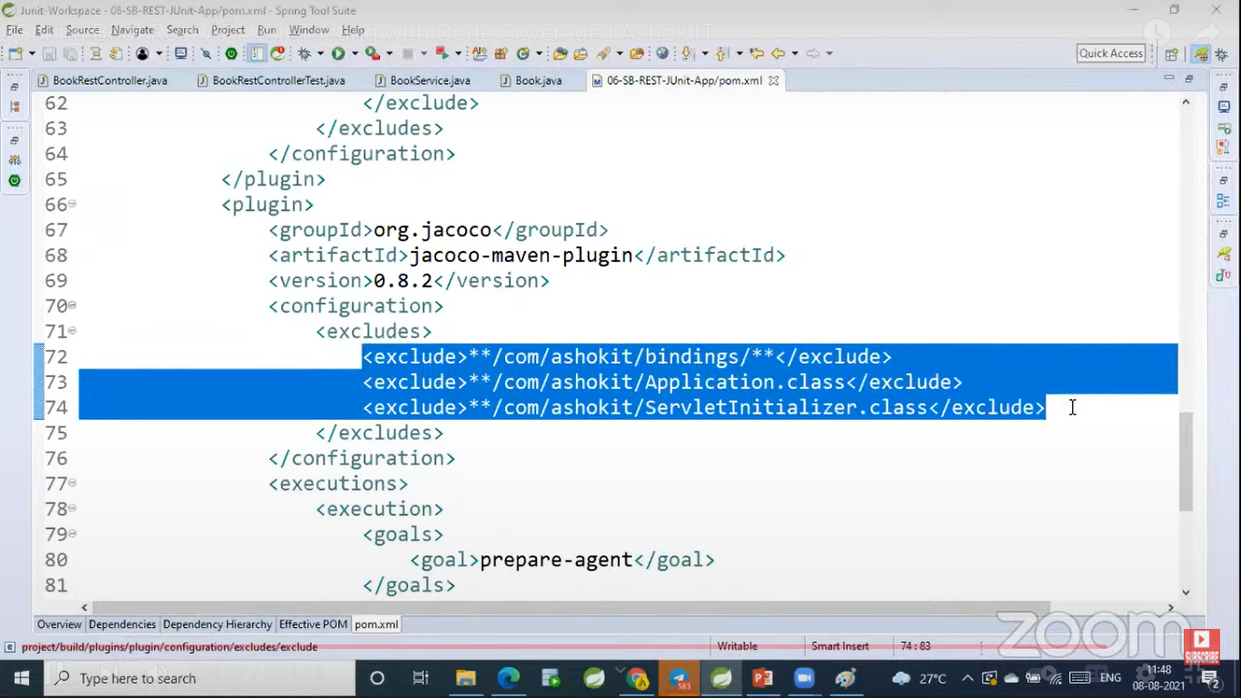

**To Download the source code**

<https://www.mediafire.com/file/bfj50tiwgs8qr4n/Junit-Workspace.rar/file>

Load Balancing

**Monolithic Architecture**

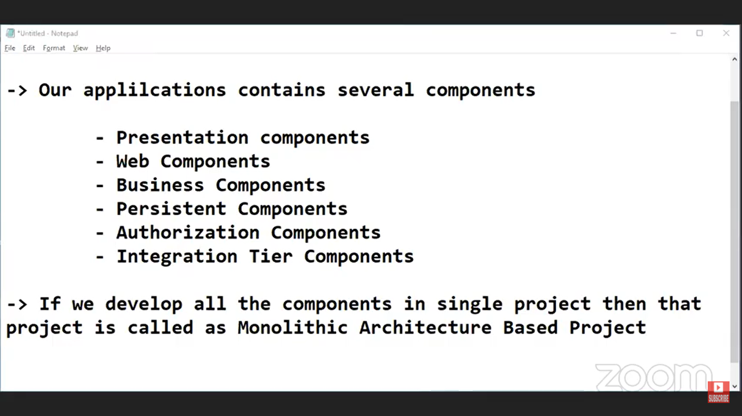

Presentation Components – UI

Web components – Controllers

Business Components – Helpers or Service Components

Integration Tier Components – If our application want to connect with other applications then we will use integration components

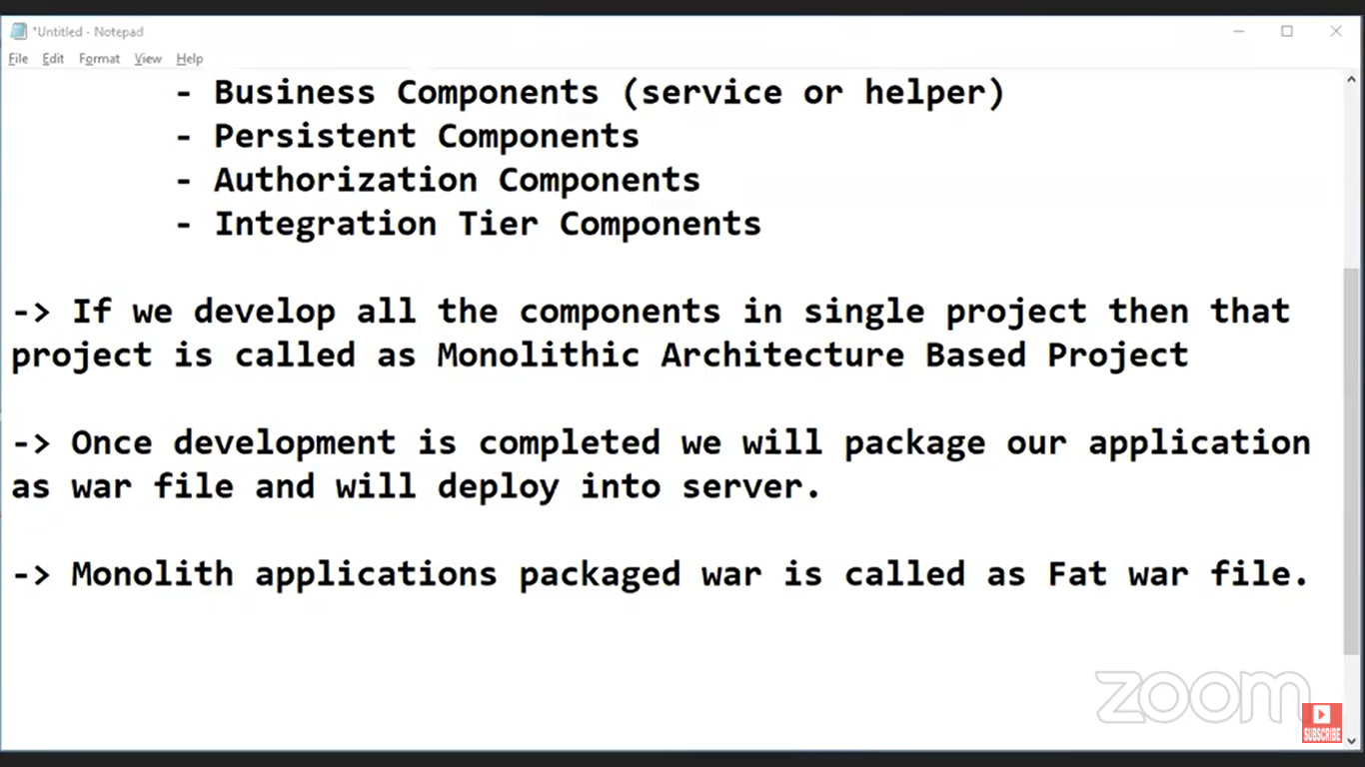

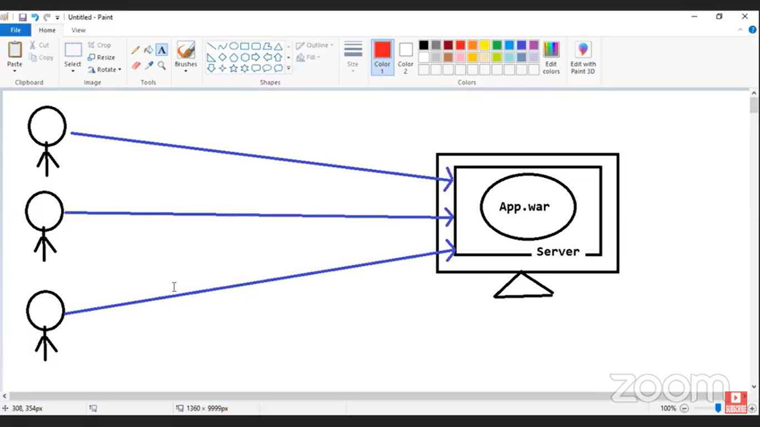

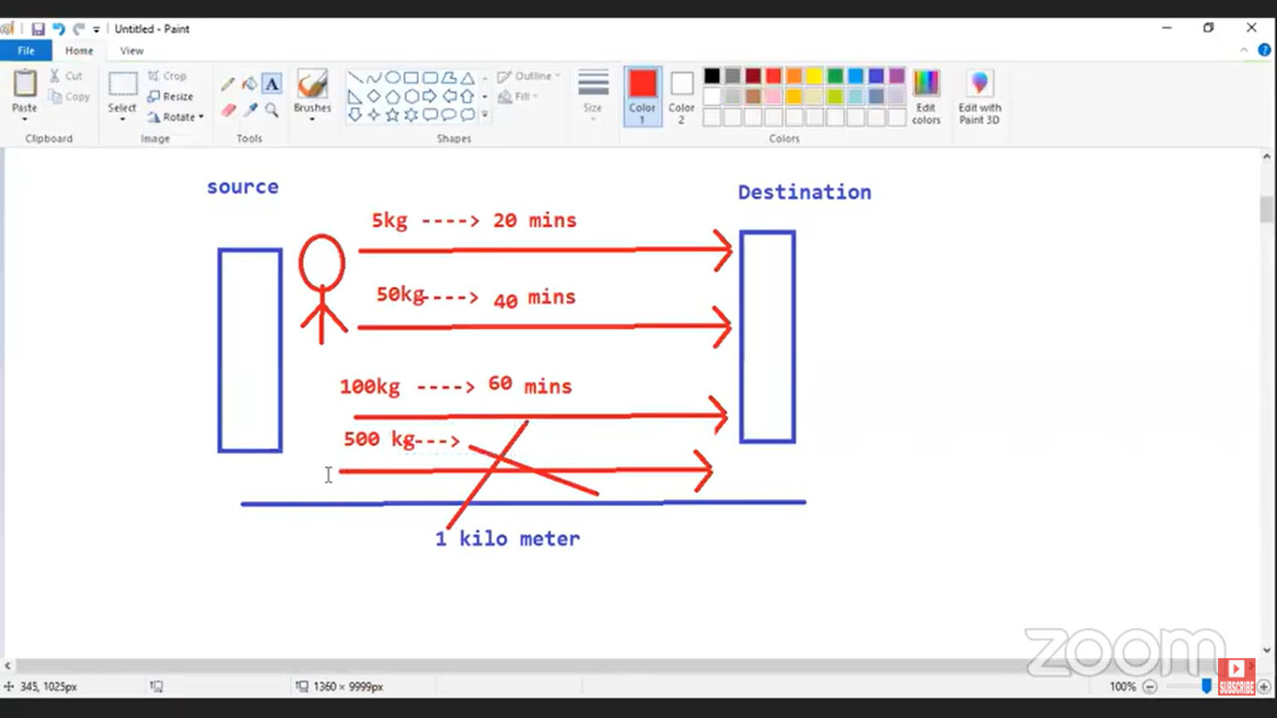

If Load increased on the server, server may get crash then application will be down. To avoid server crashes we need to scale our application.

Scaling can be done in two ways. Those are

1. Vertical Scaling
2. Horizontal Scaling

Question : How can you handle if 1 million requests come to your application?

Ans : To handle this issue, We need to scale the application. In order to scale our application we will go for Load balancing

Question : Why we need to go for Load Balancing?

Ans : To distribute the load to multiple servers

Load Balancing is one of the scaling technique.

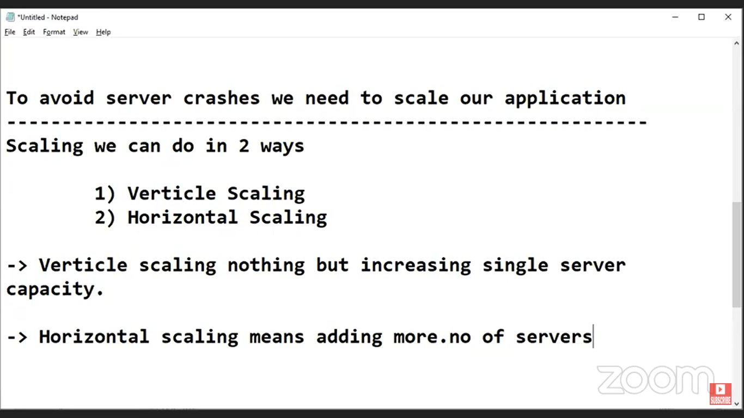

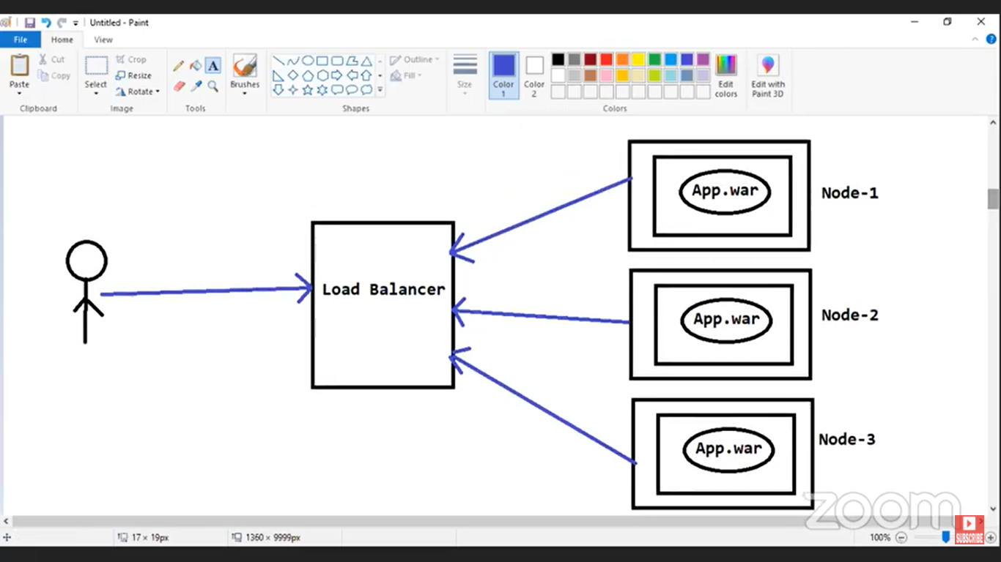

Question : How the Load Balancer system know, to which node the request has to send?

Ans : Load Balancing Algorithms will handle

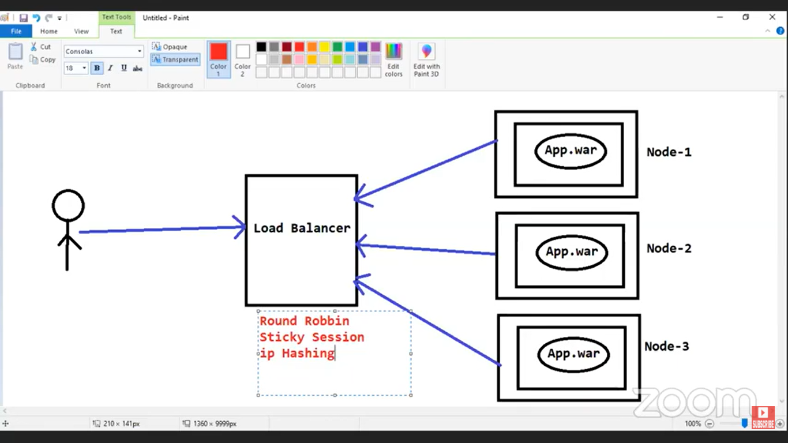

What is horizontal scaling ?

Ans : Adding number of servers to the cluster is called Horizontal scaling.

What is Vertical Scaling ?

Ans : The process of increasing the capacity of single server is called Vertical Scaling.

**Caching**

https://www.youtube.com/watch?v=d0ui0x4Sw2w&list=PLq3uEqRnr_2HY6LMQsbvsK4btj51sWhBS&index=2

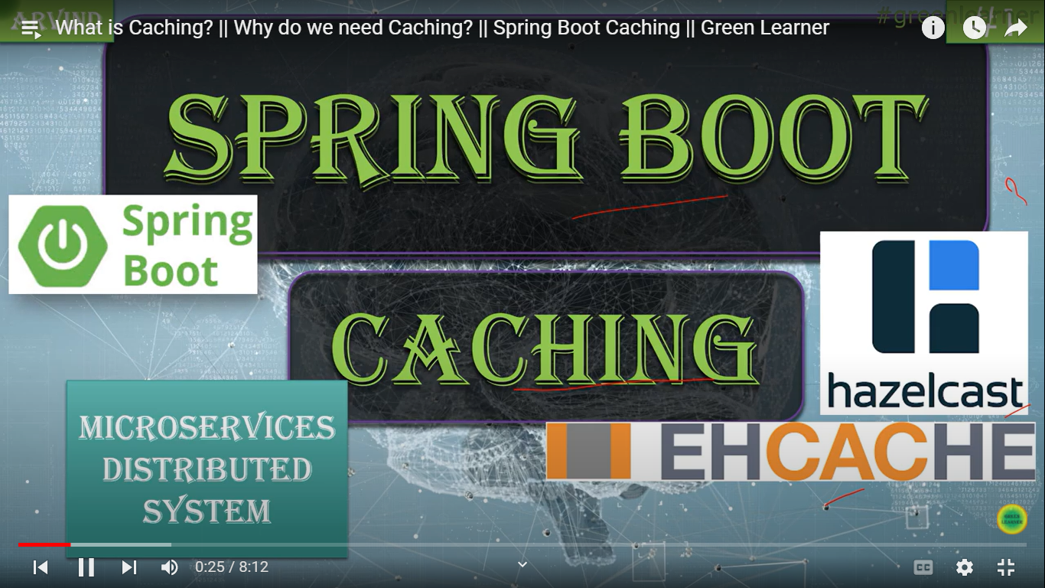

Different Types of Caching providers:

1. Hazelcast
2. EHCACHE
3. Jcache etc

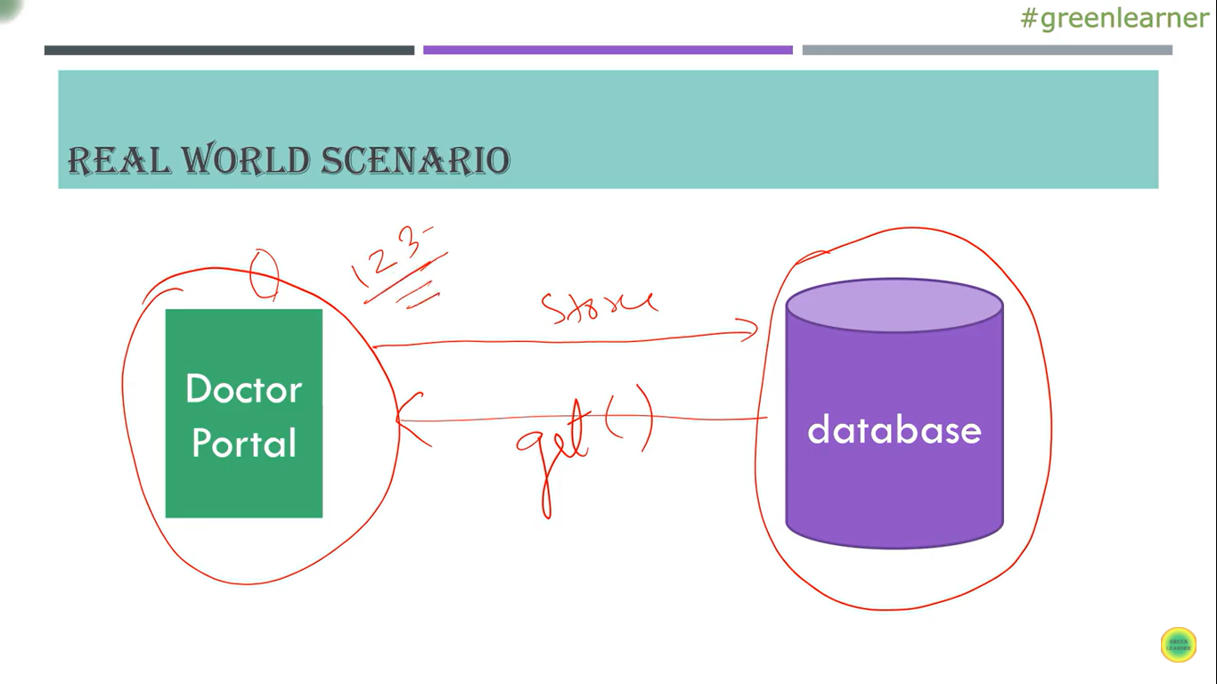

* For how many users the data we need to maintain in cache should be handled by the developer

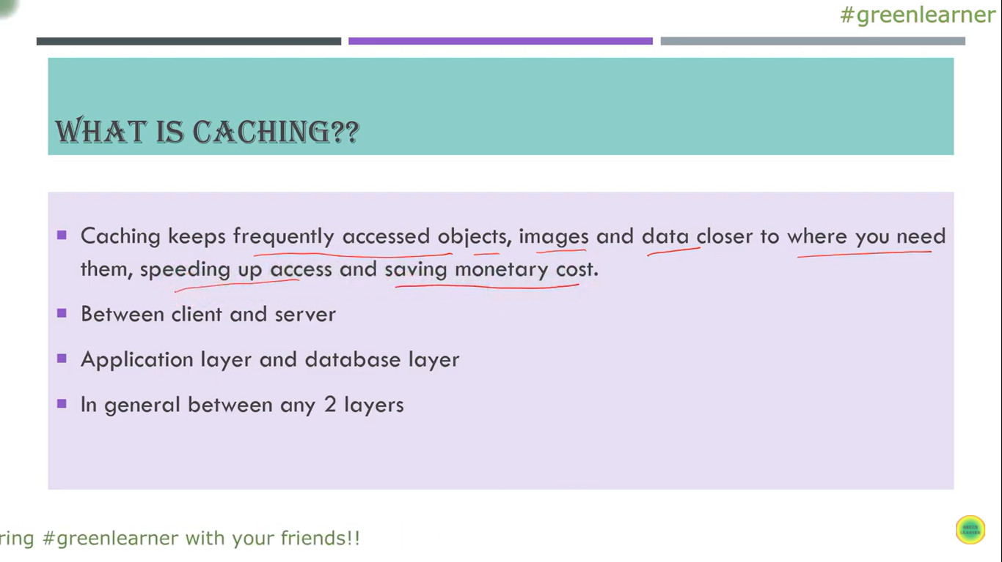

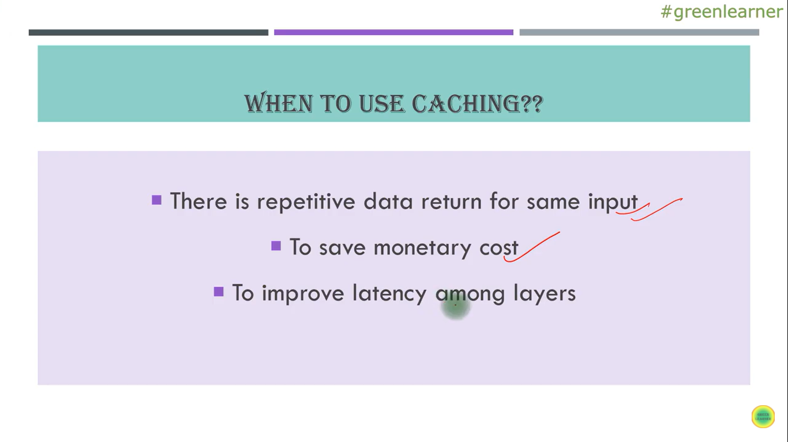

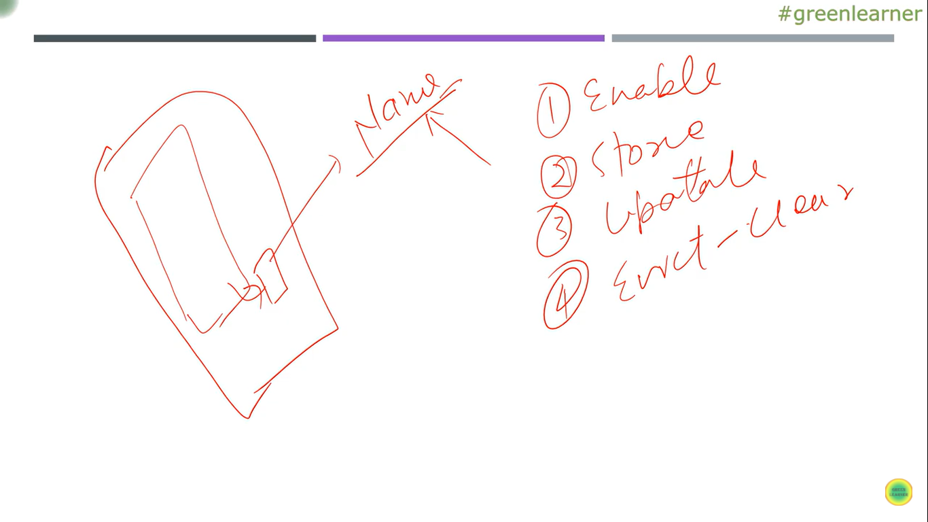

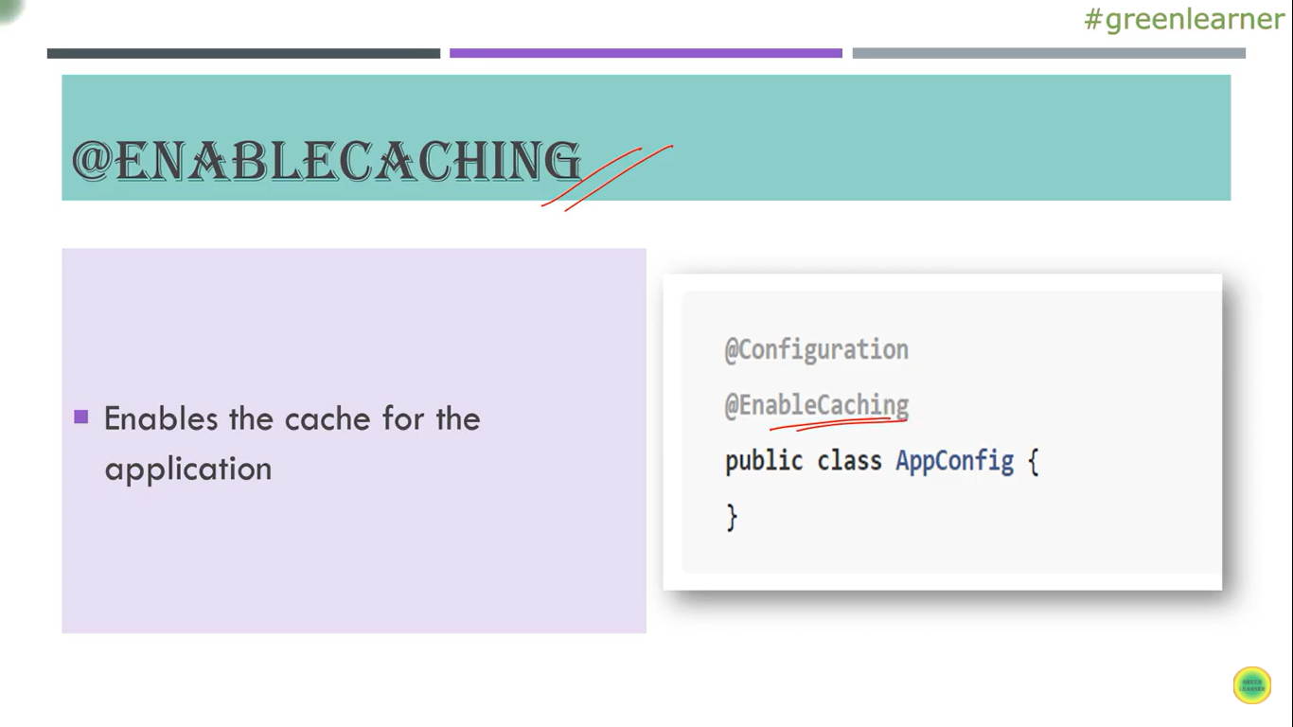

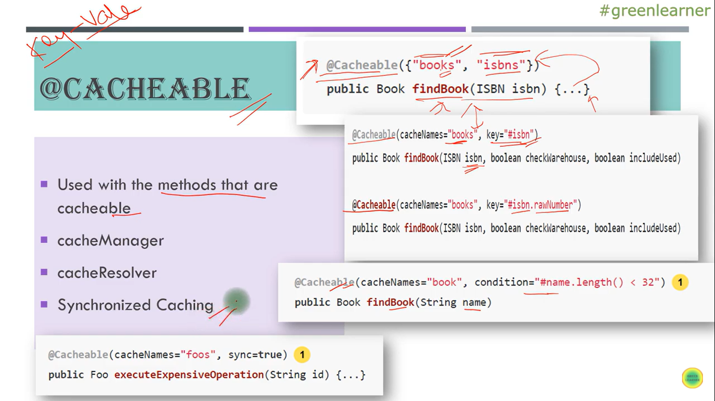

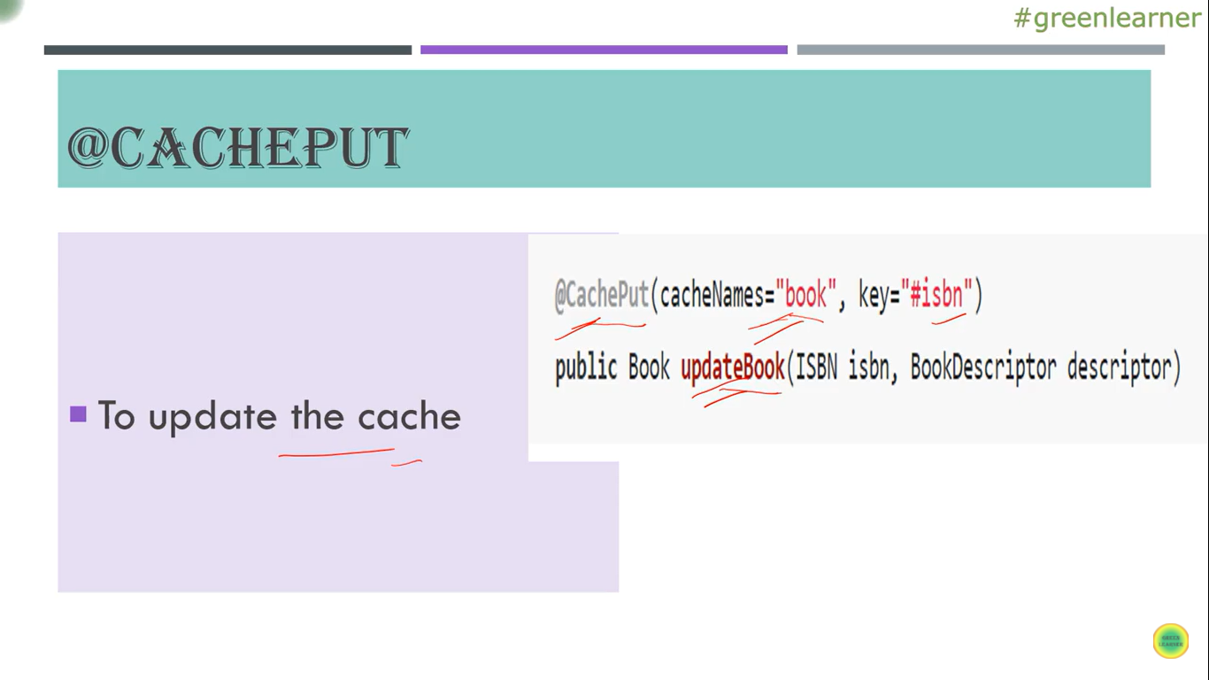

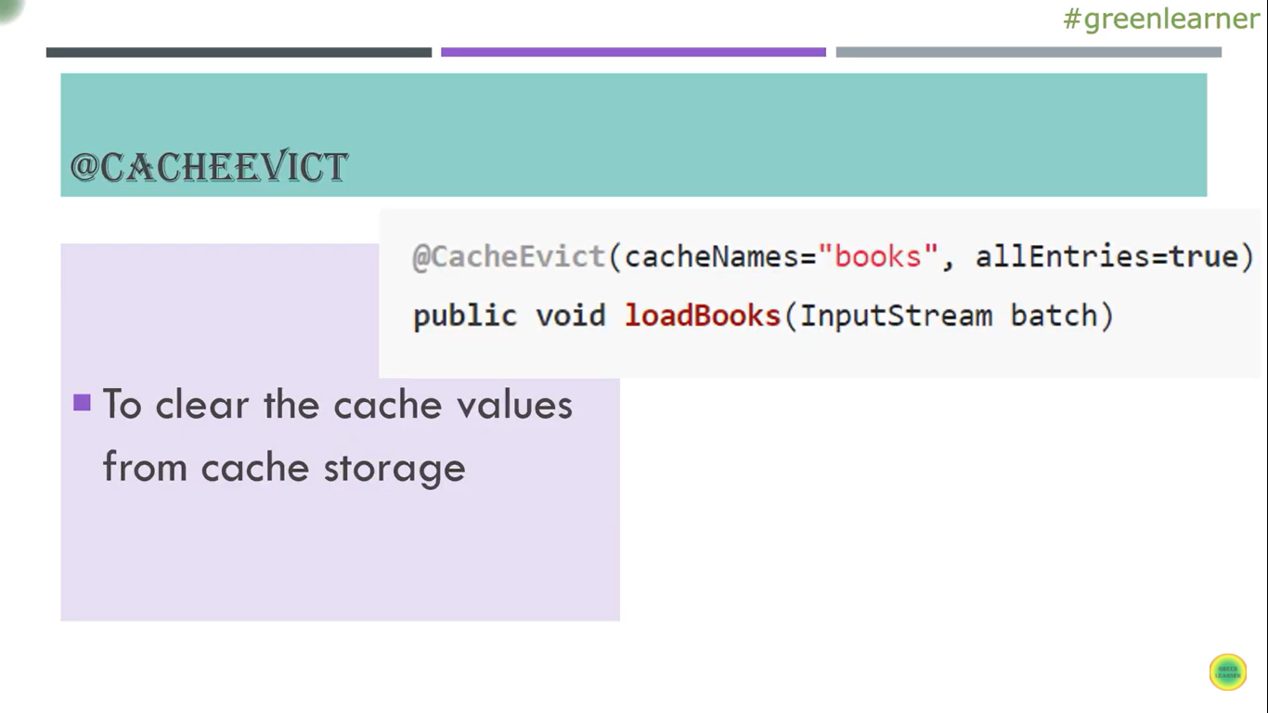

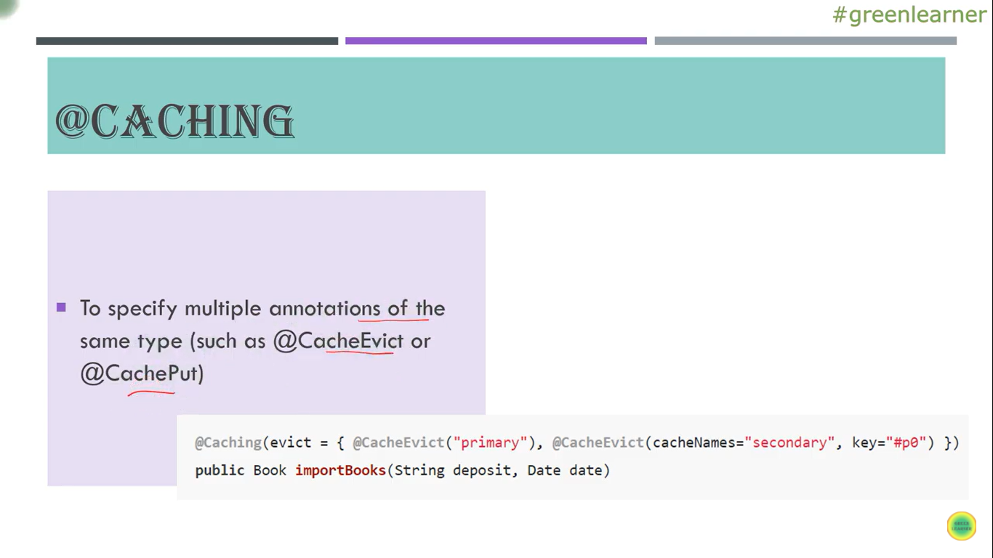

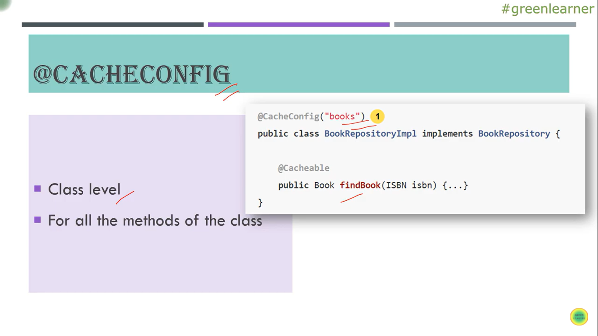

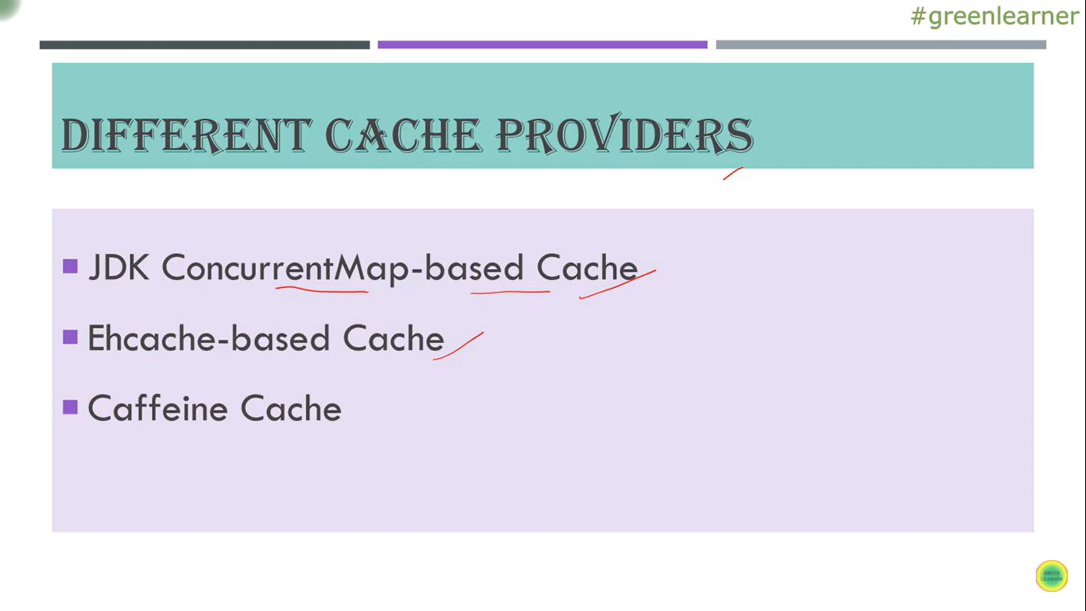

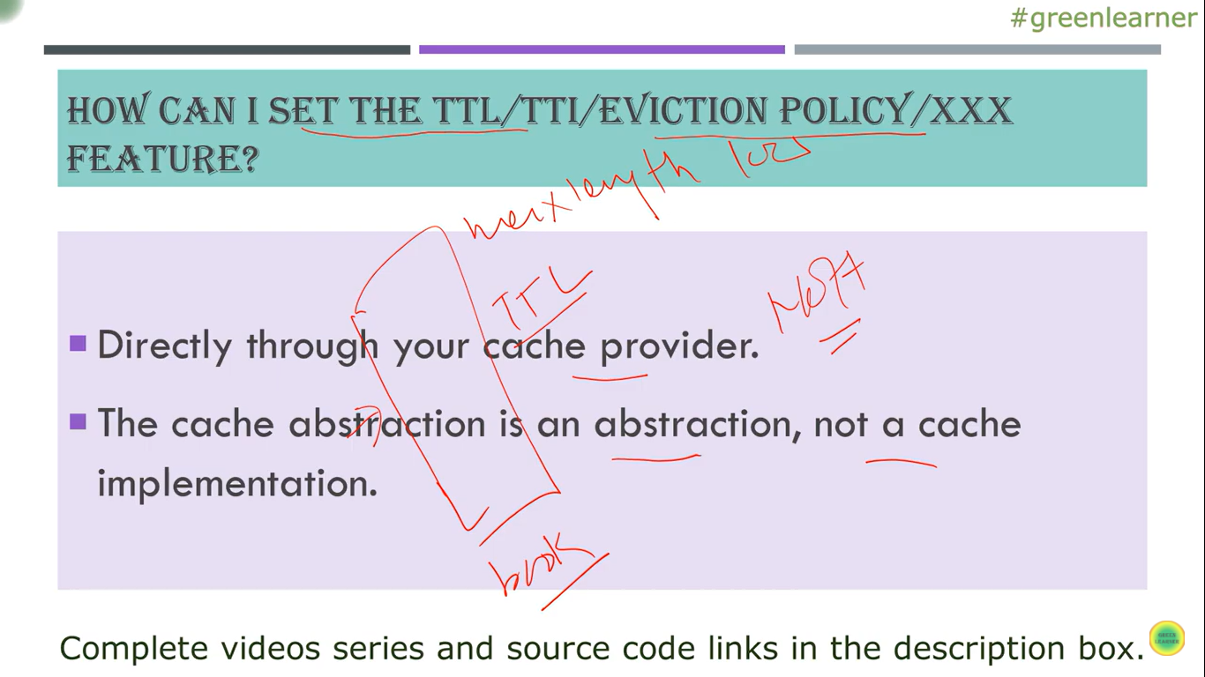

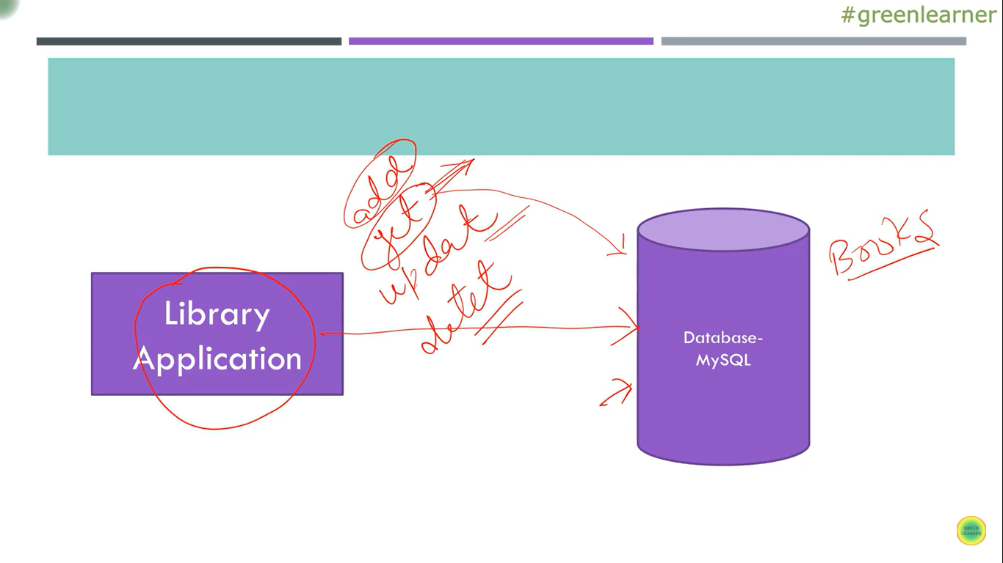

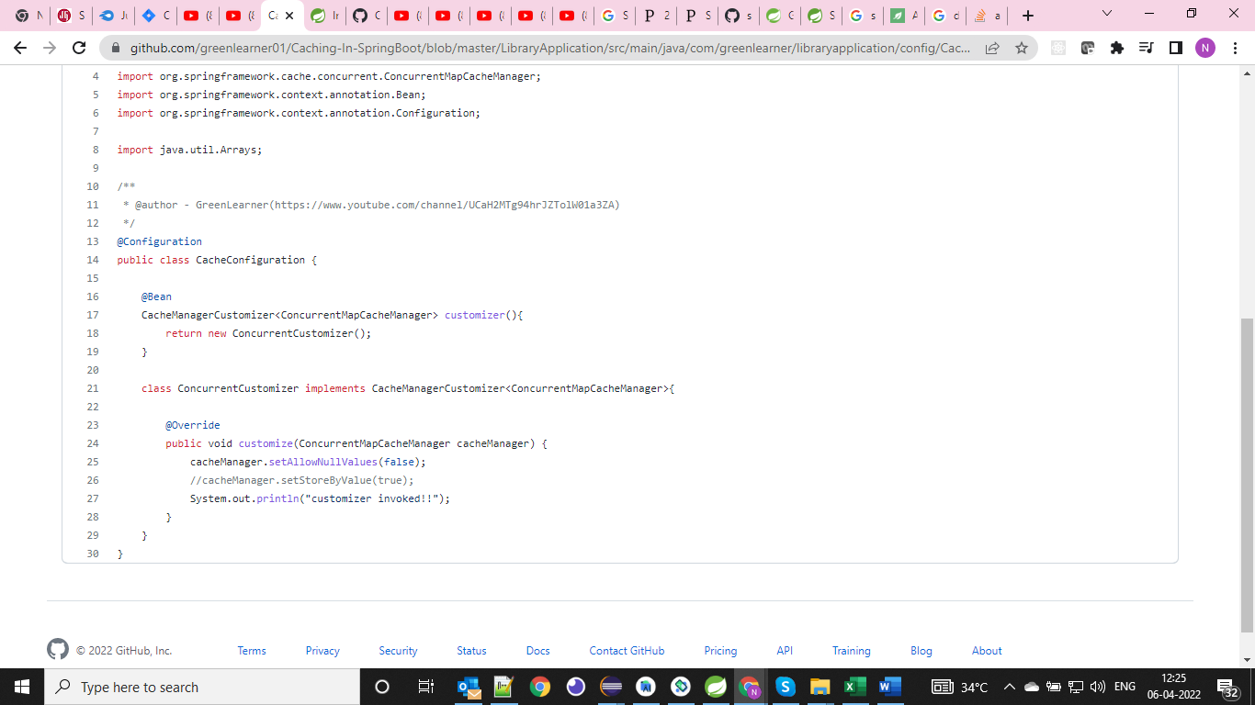

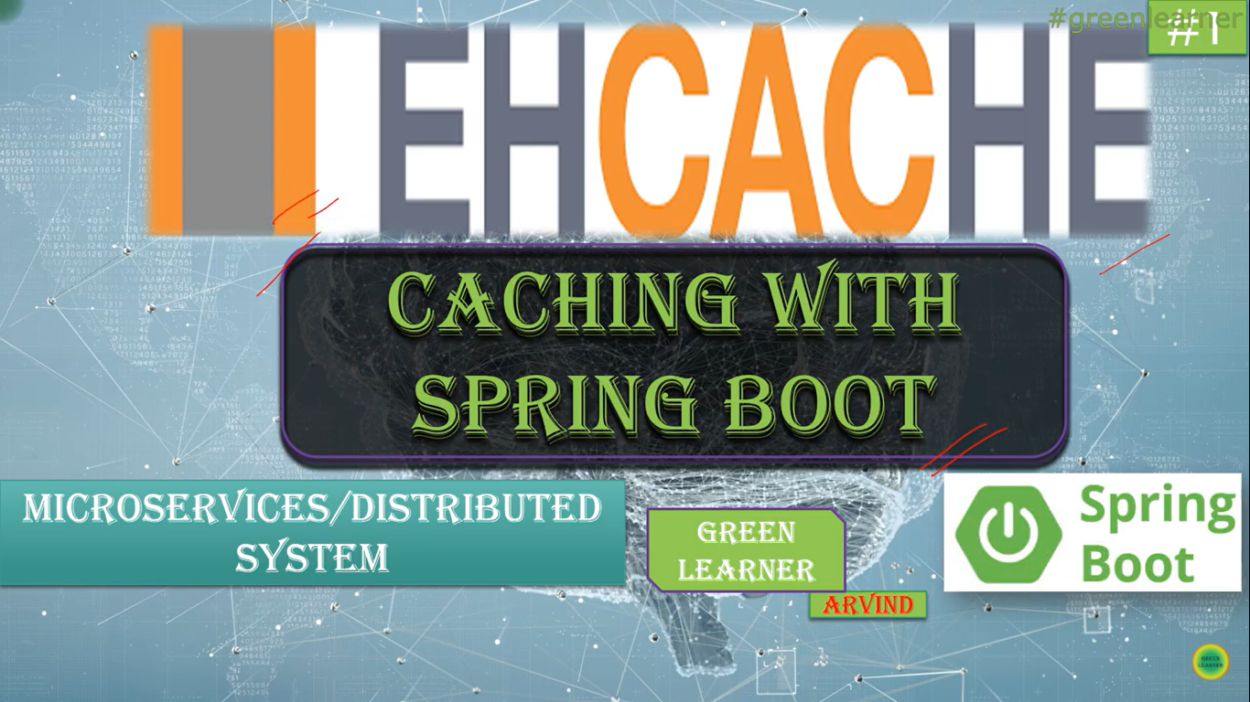

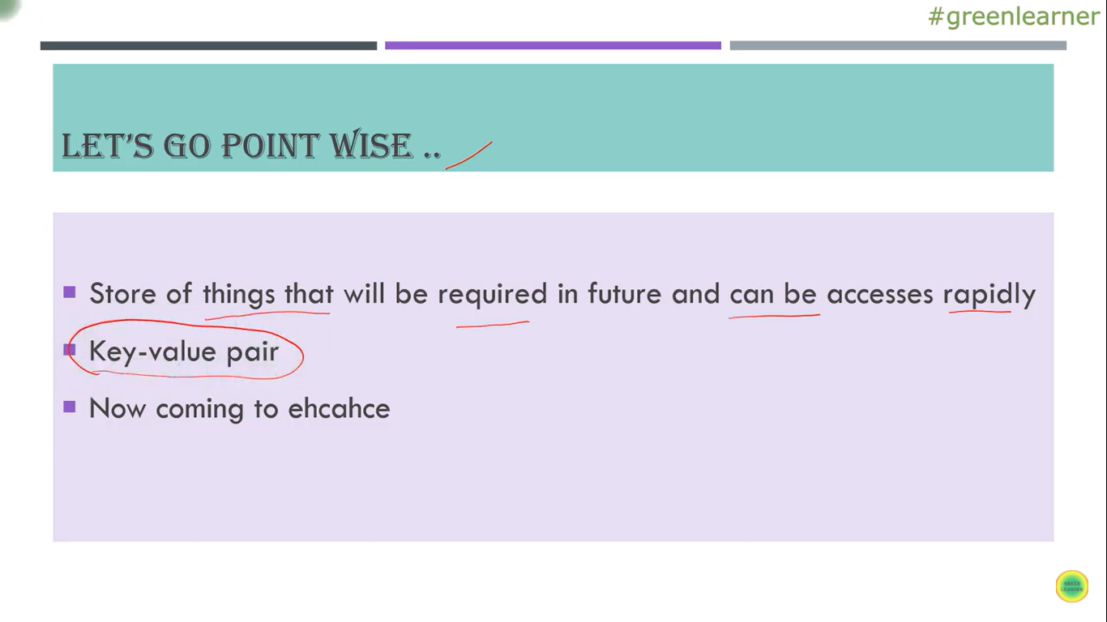

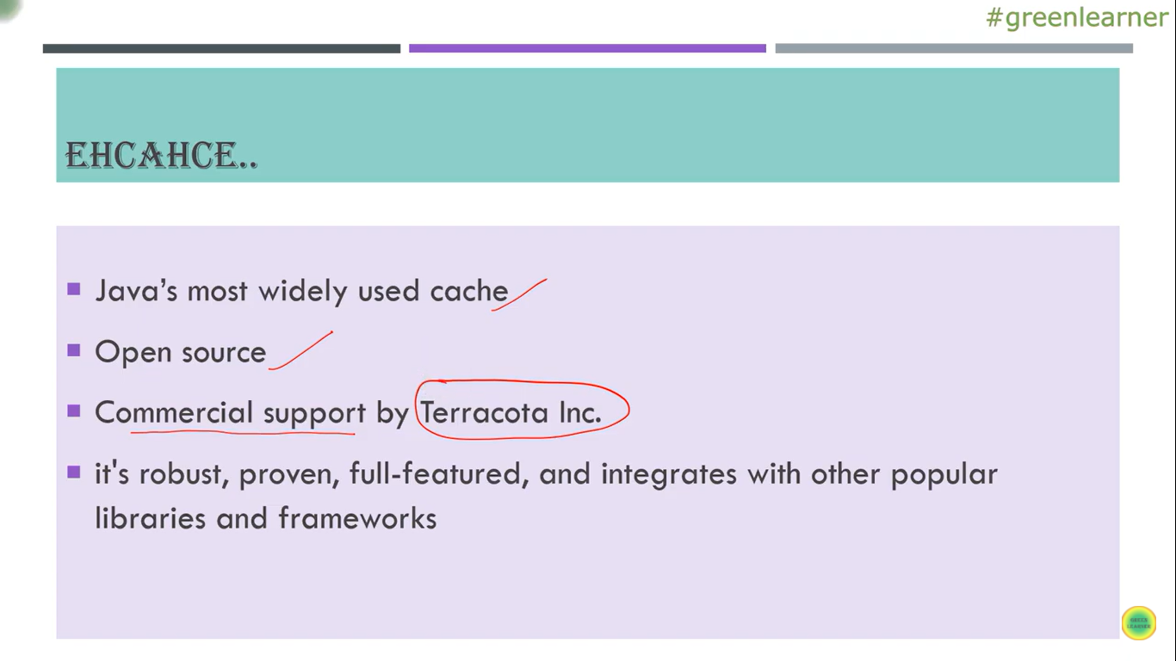

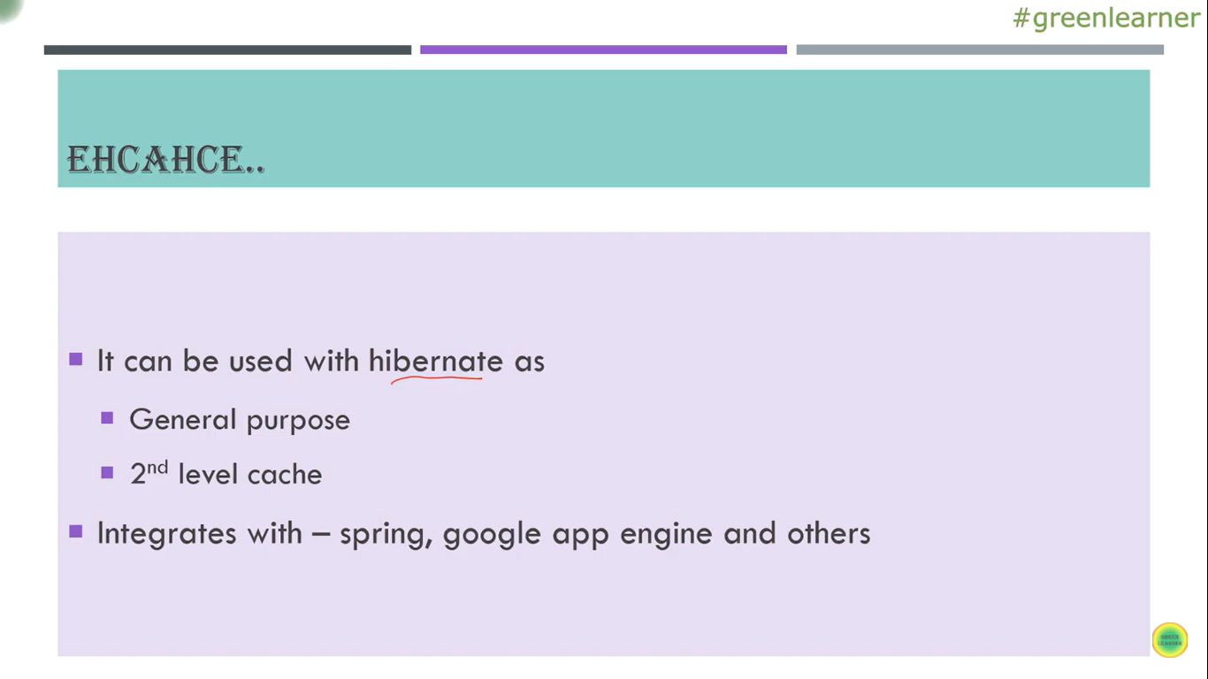

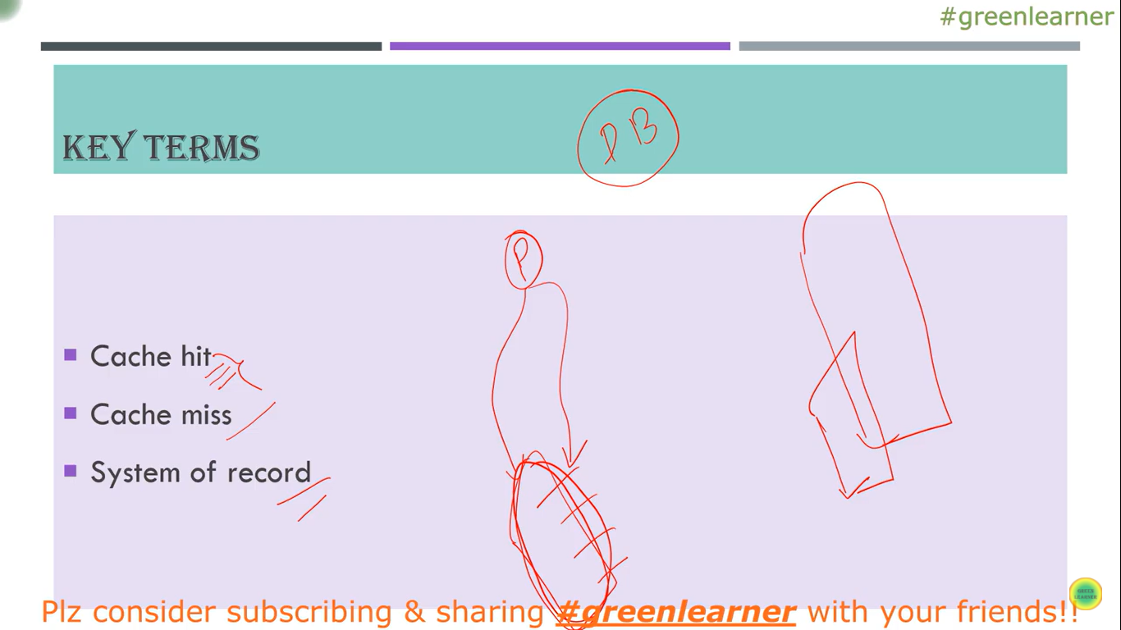

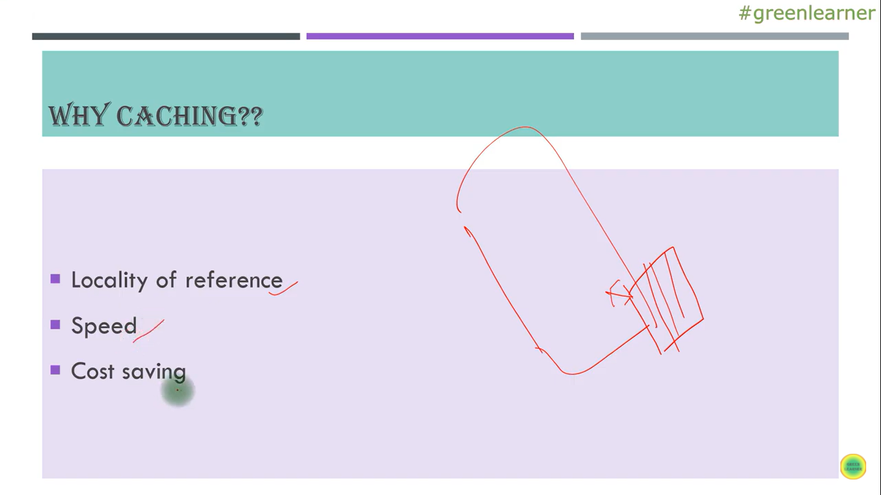

Locality of Reerence : Near to the system

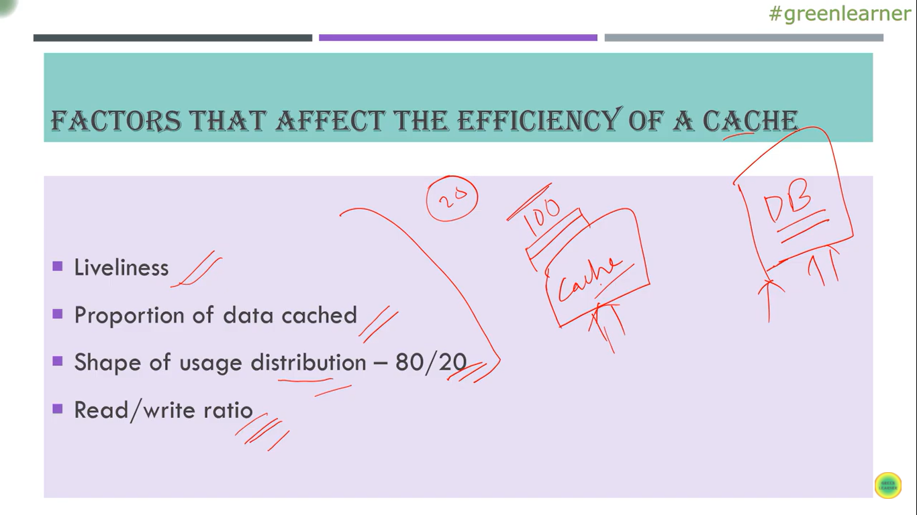

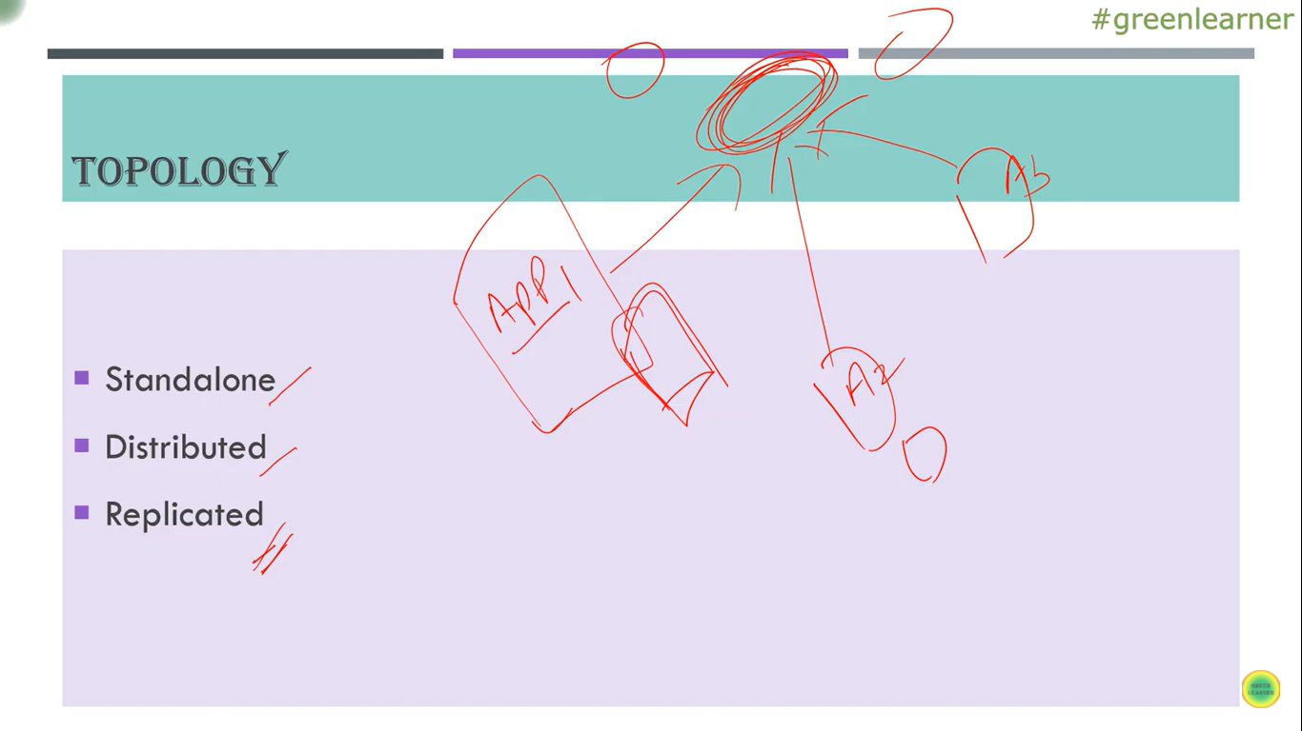

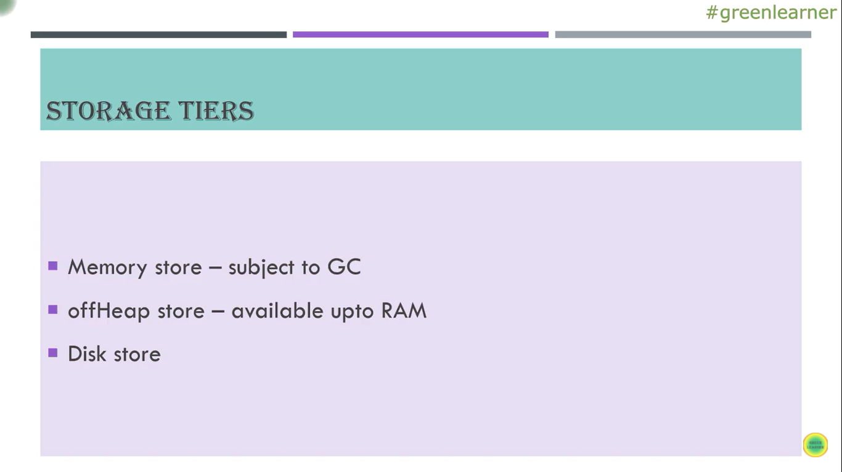

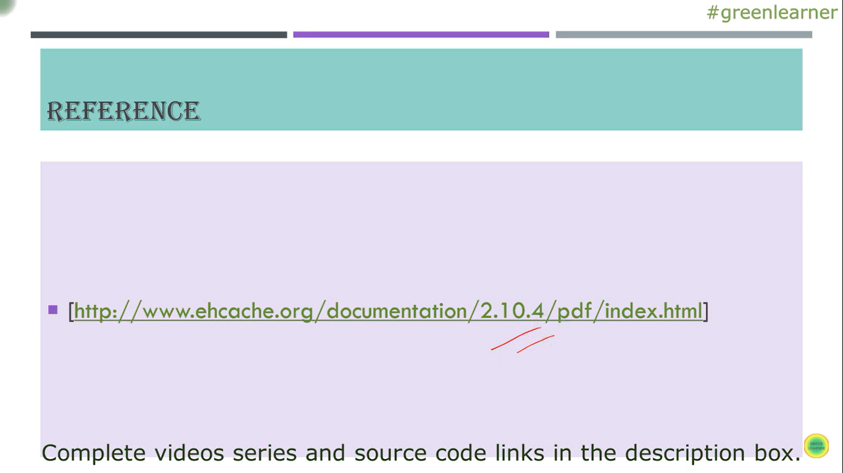

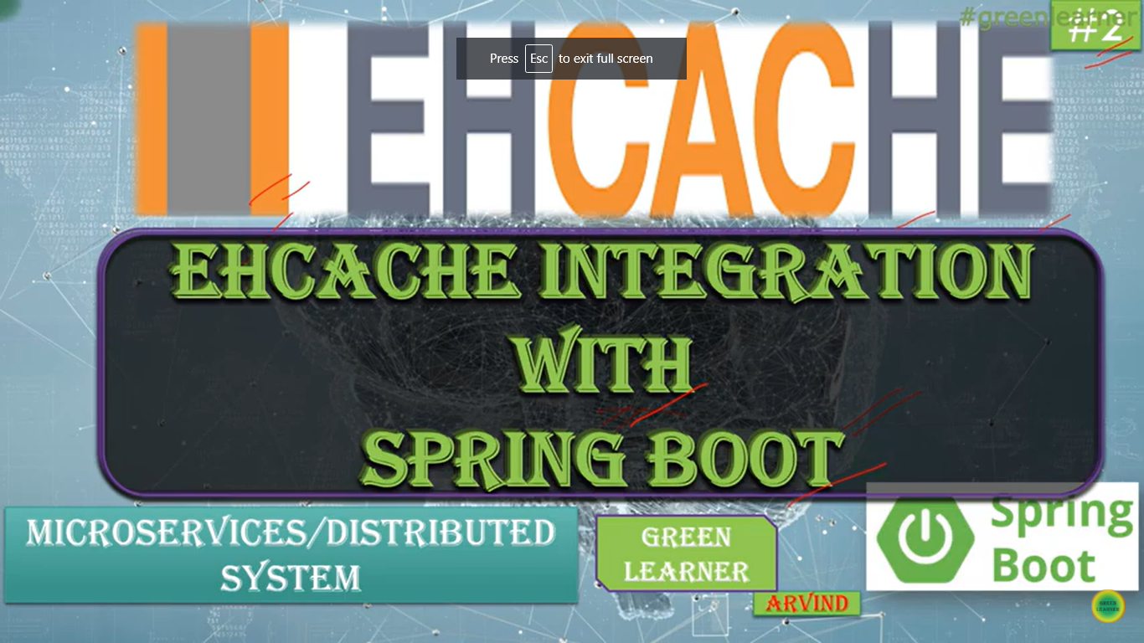

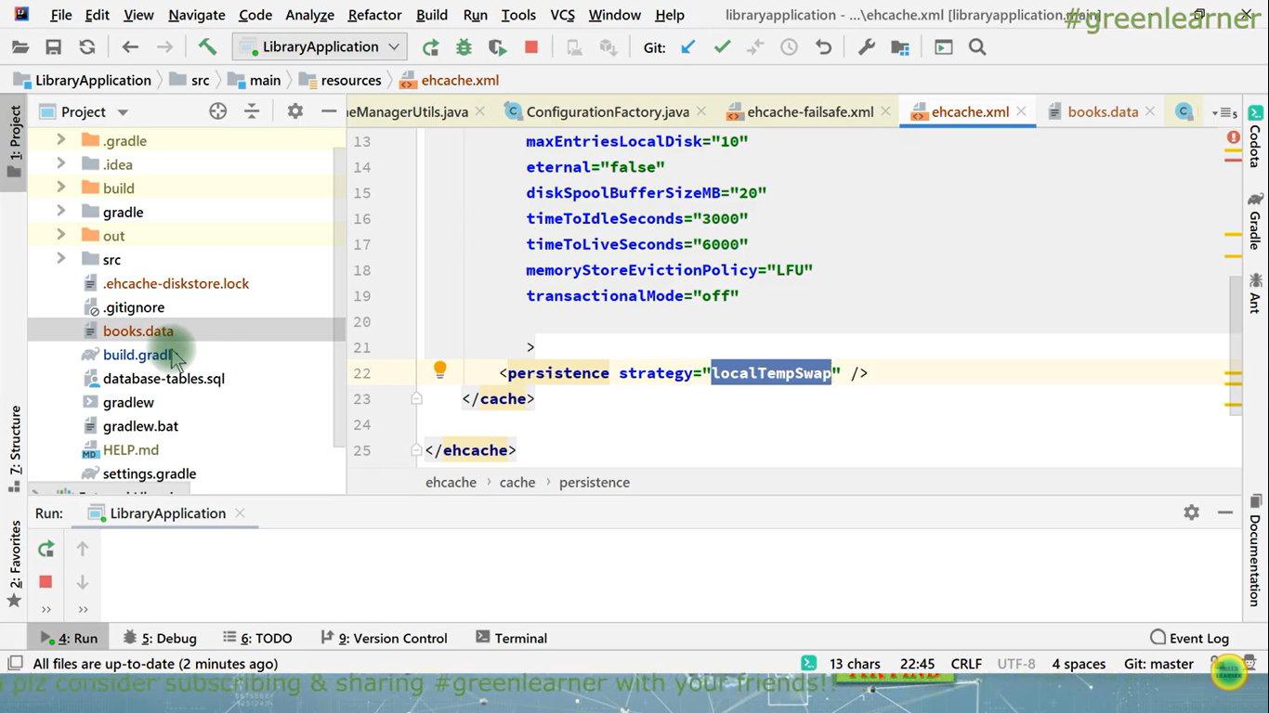

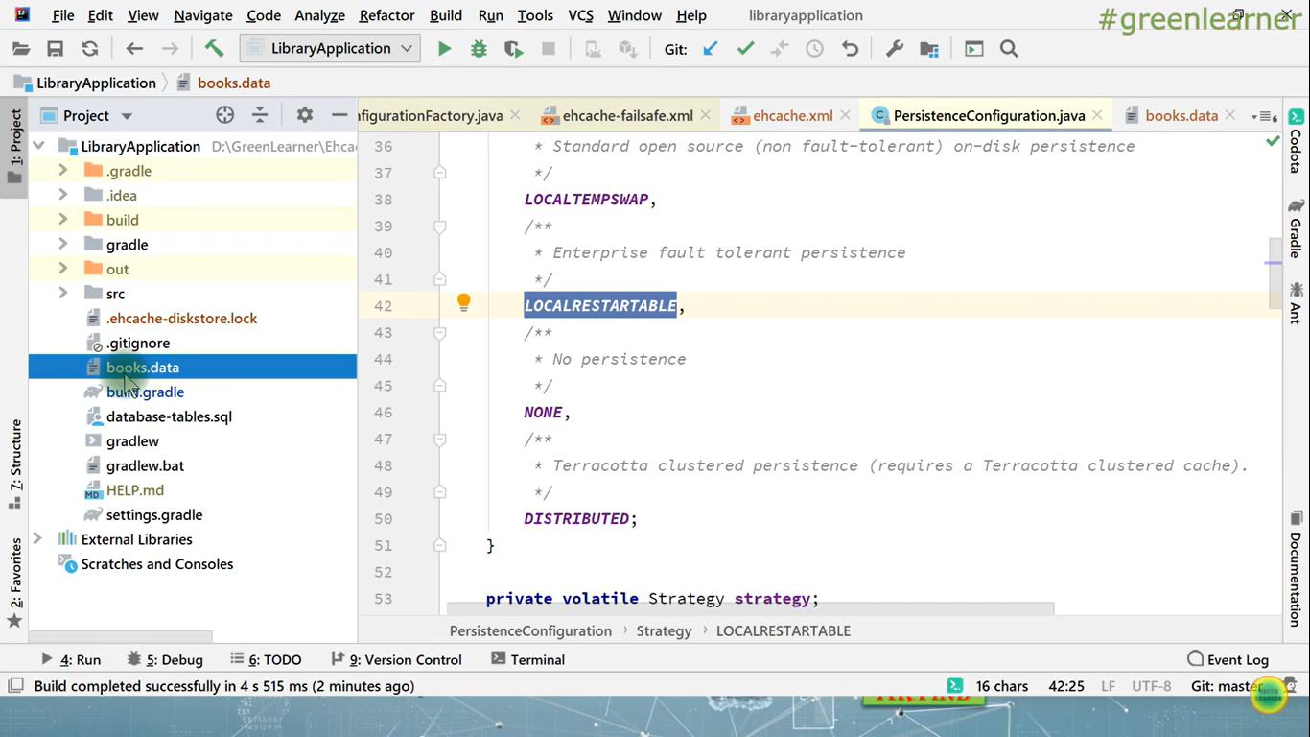

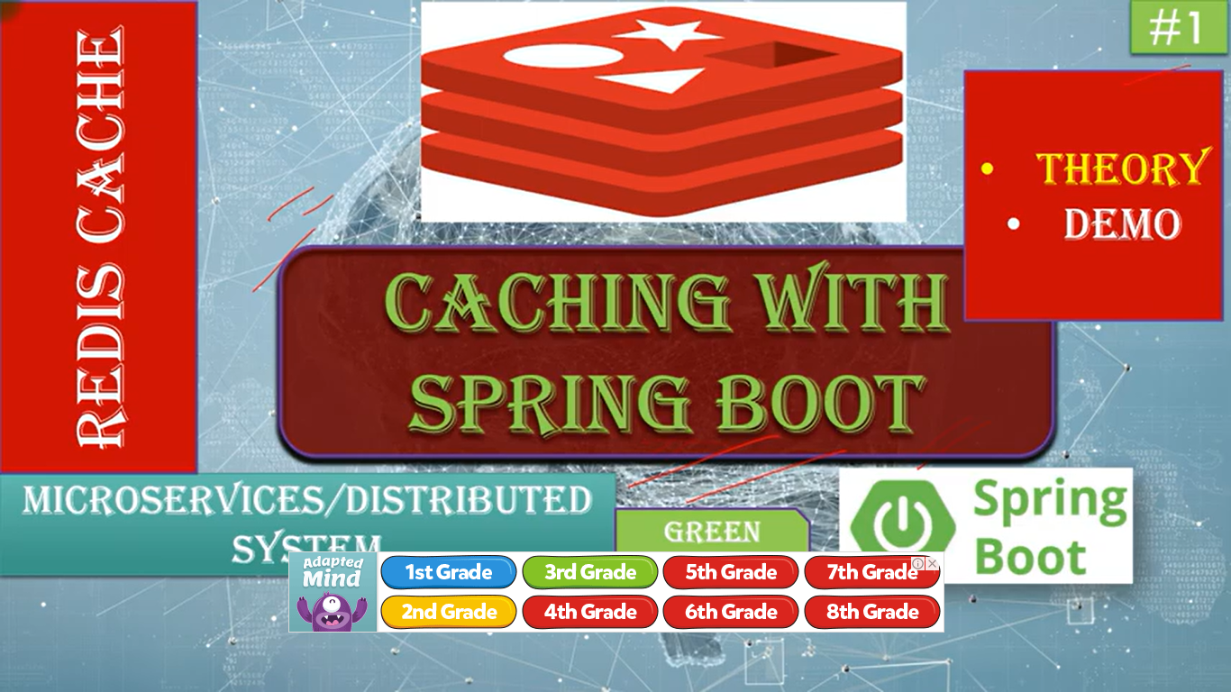

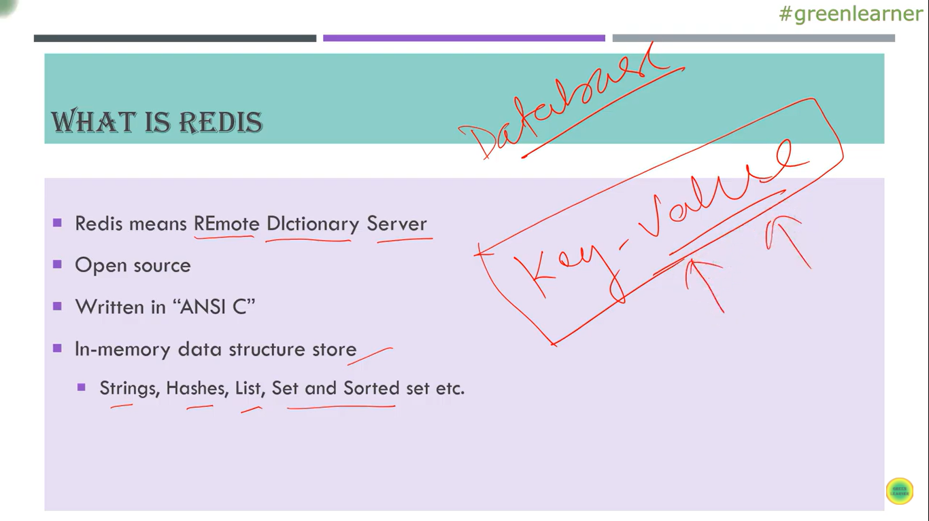

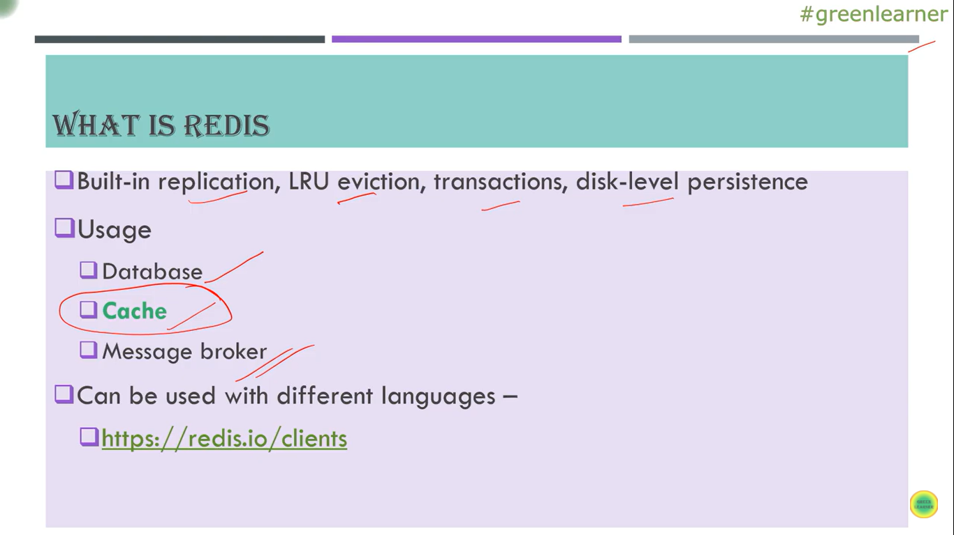

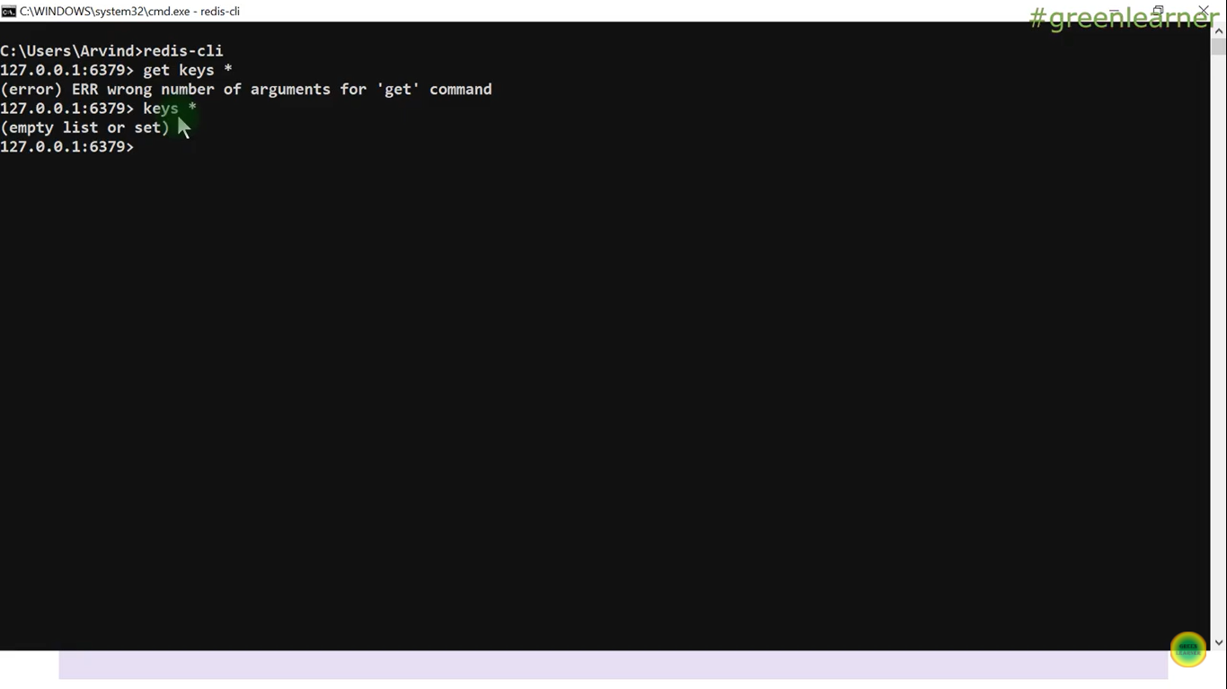

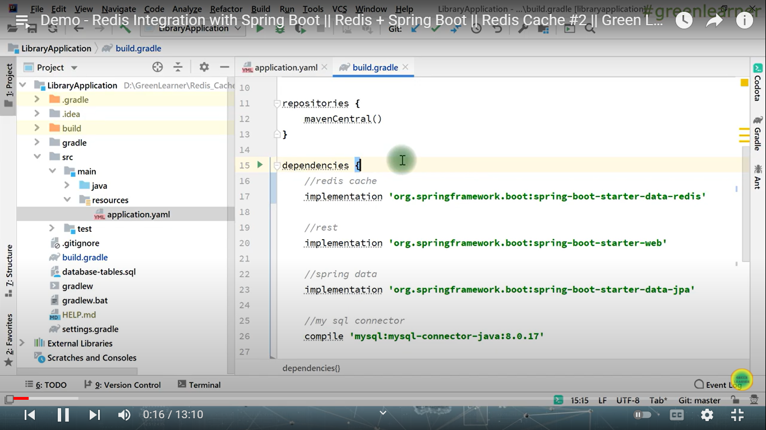

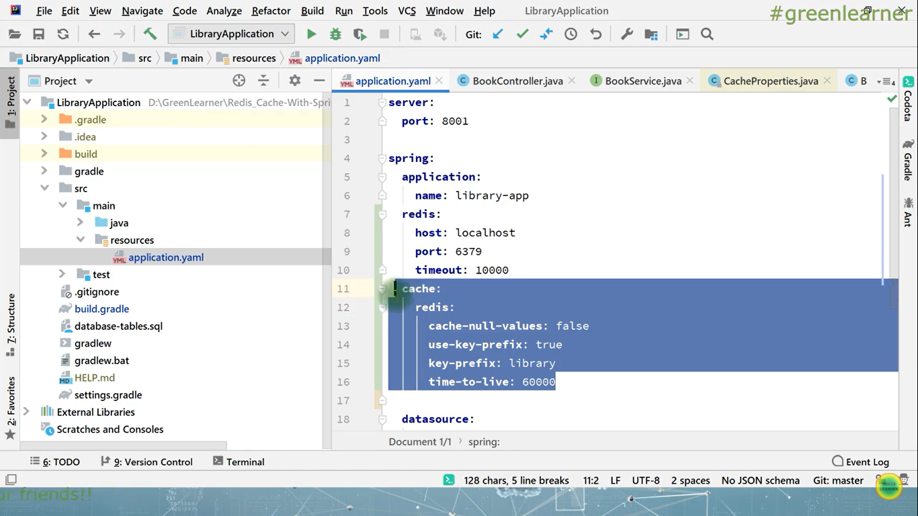

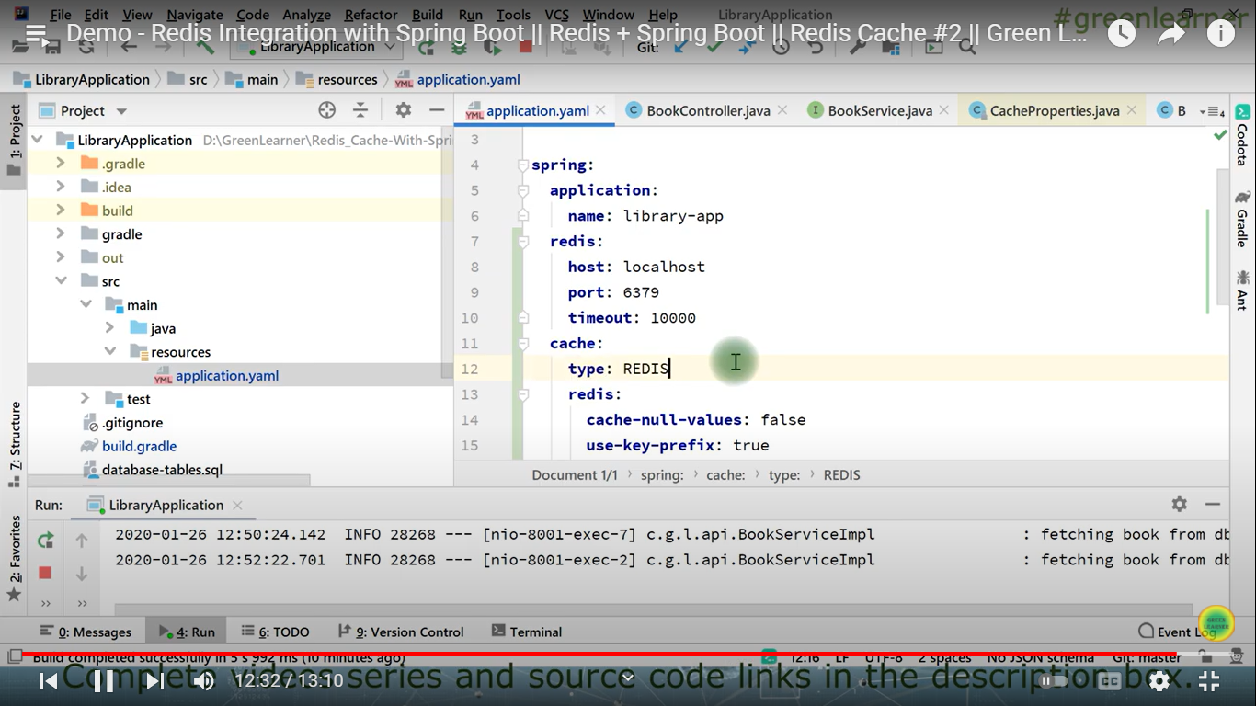

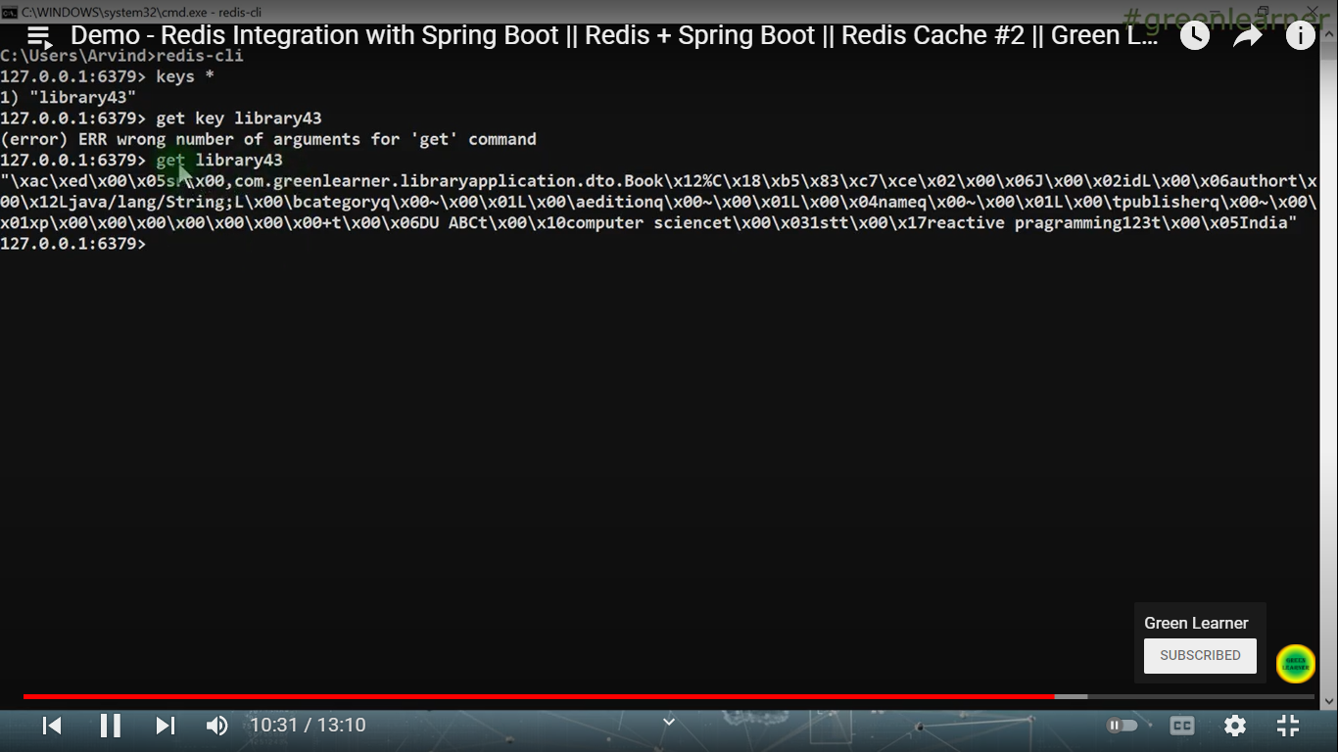

***How Spring Boot works internally***

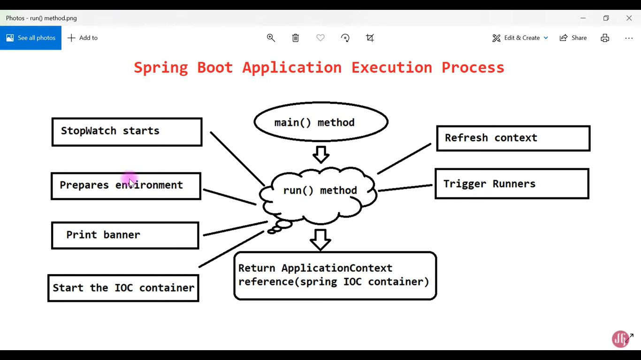

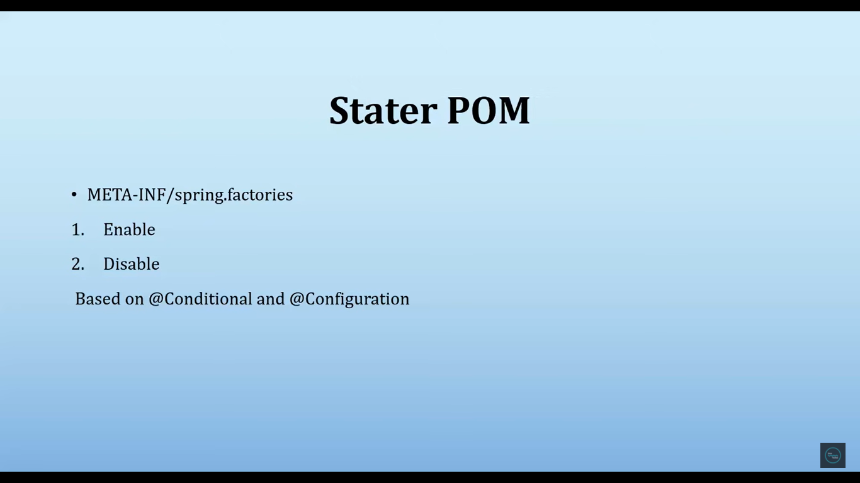

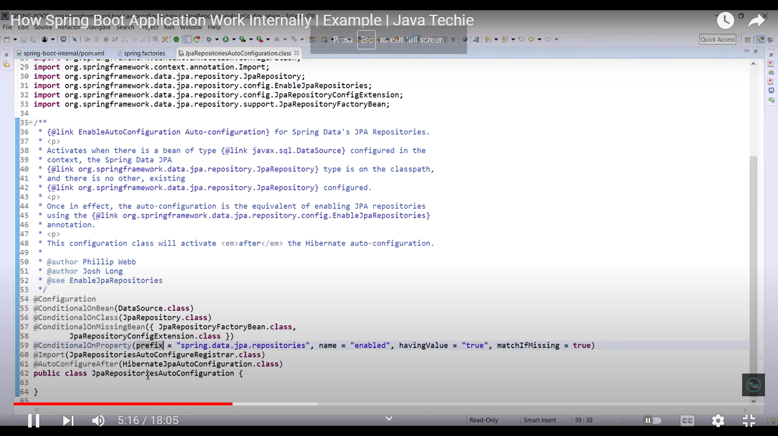

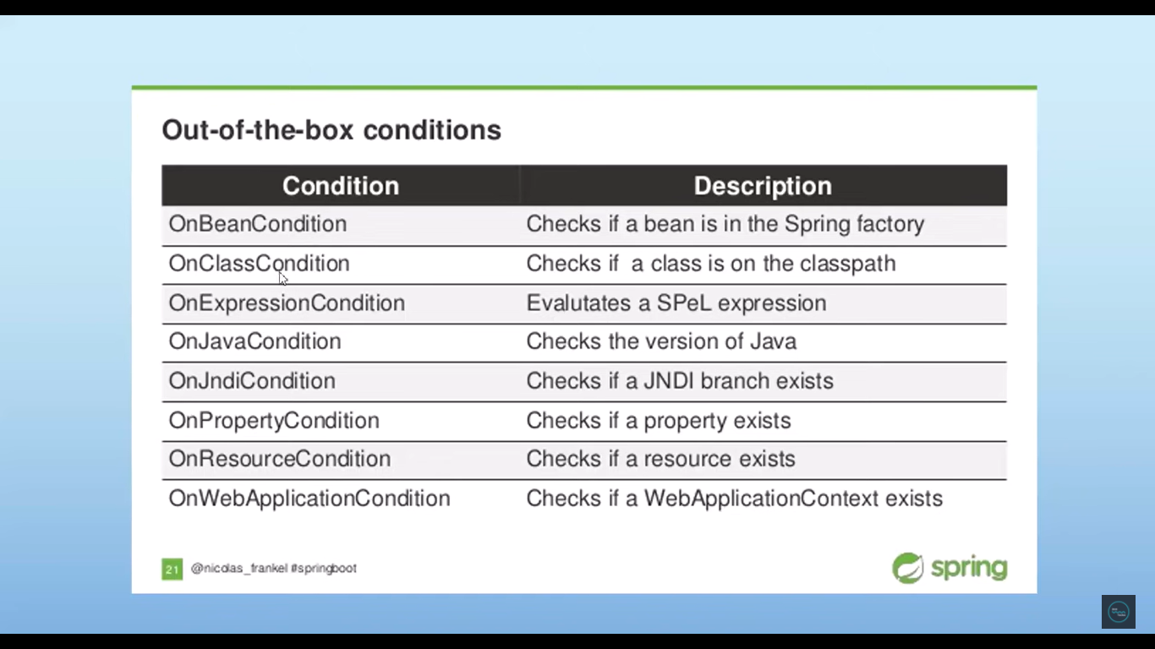

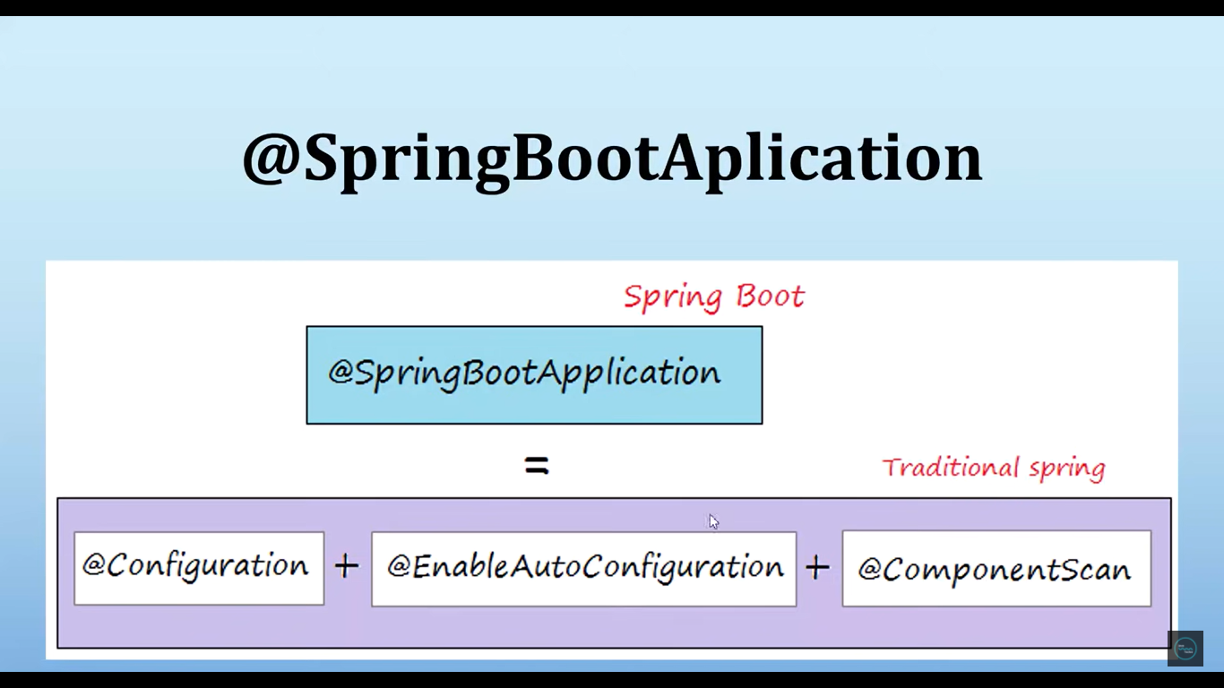

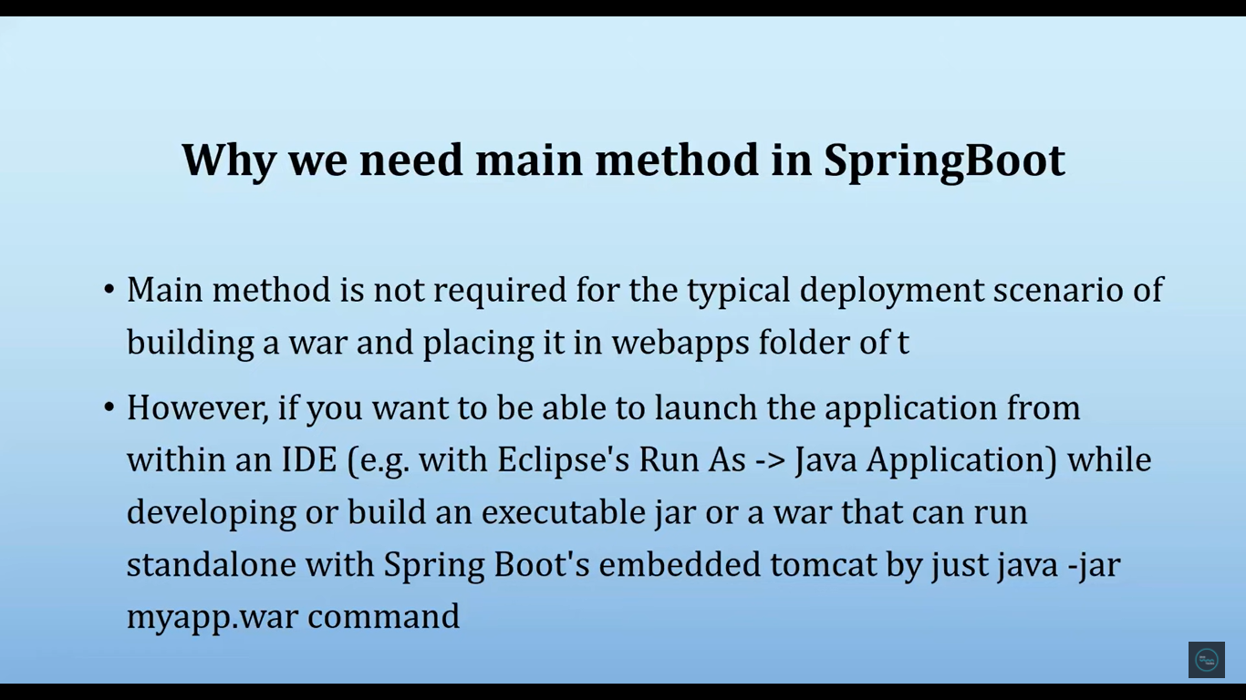

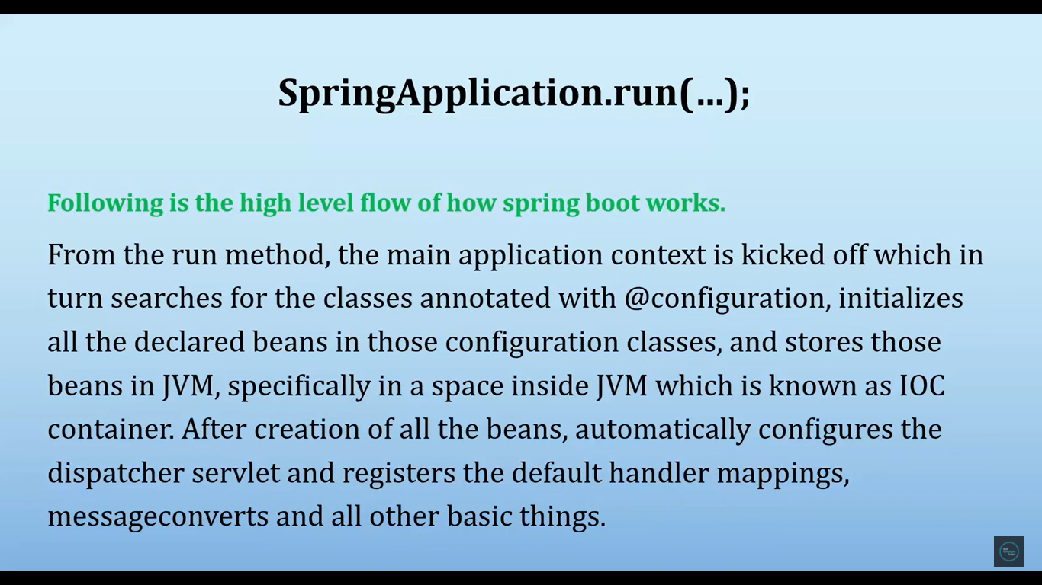

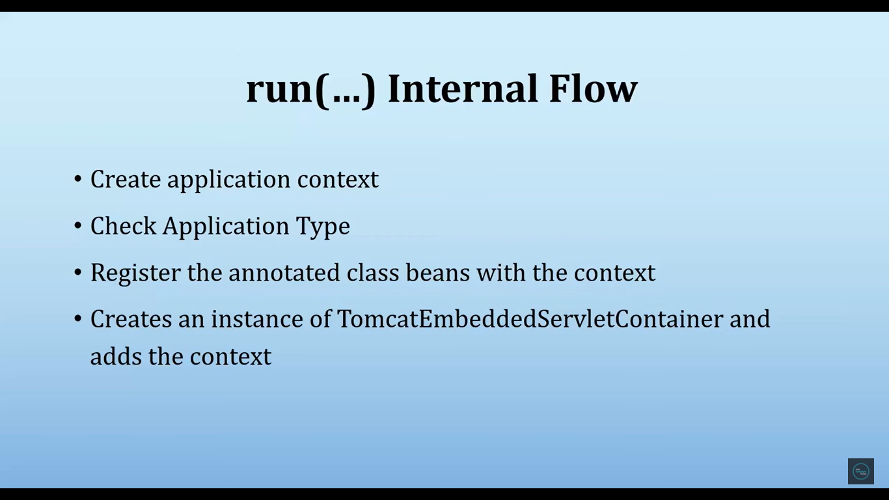

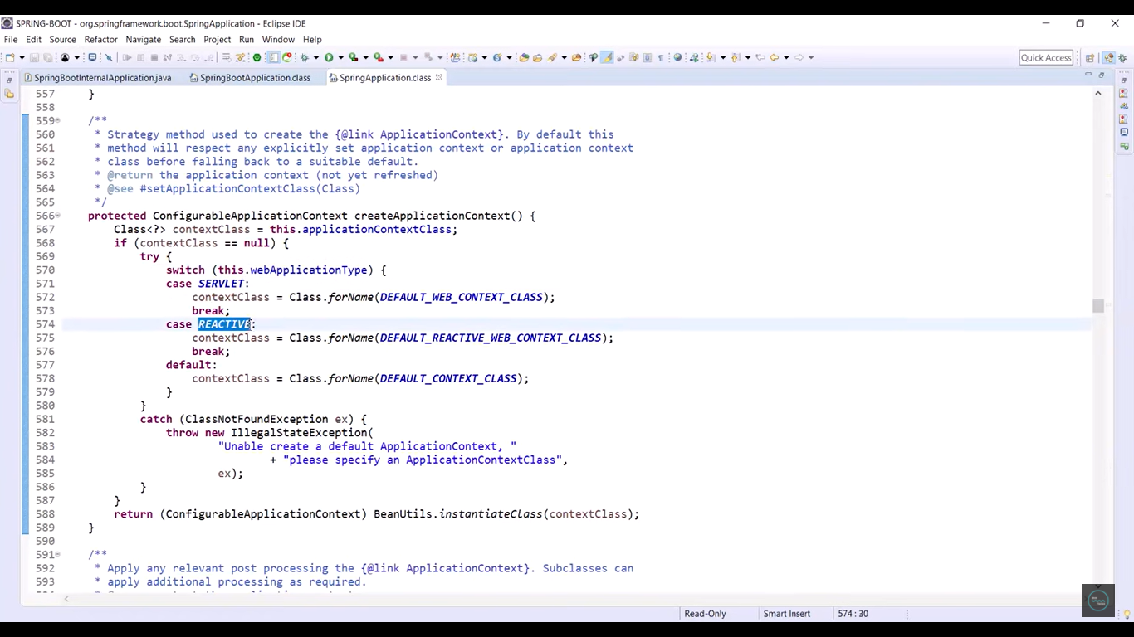

From the below screen shot, we can see all the components of our application register to the context

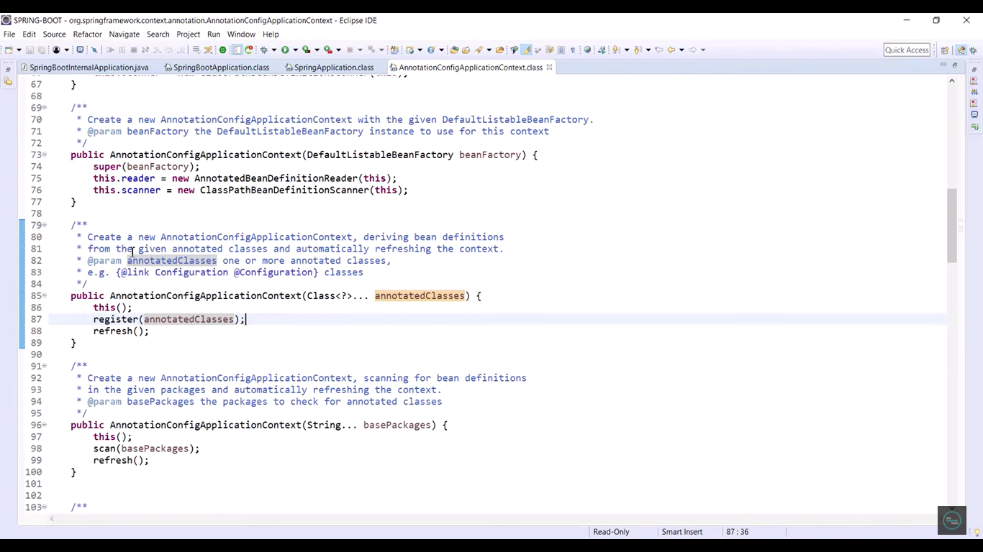

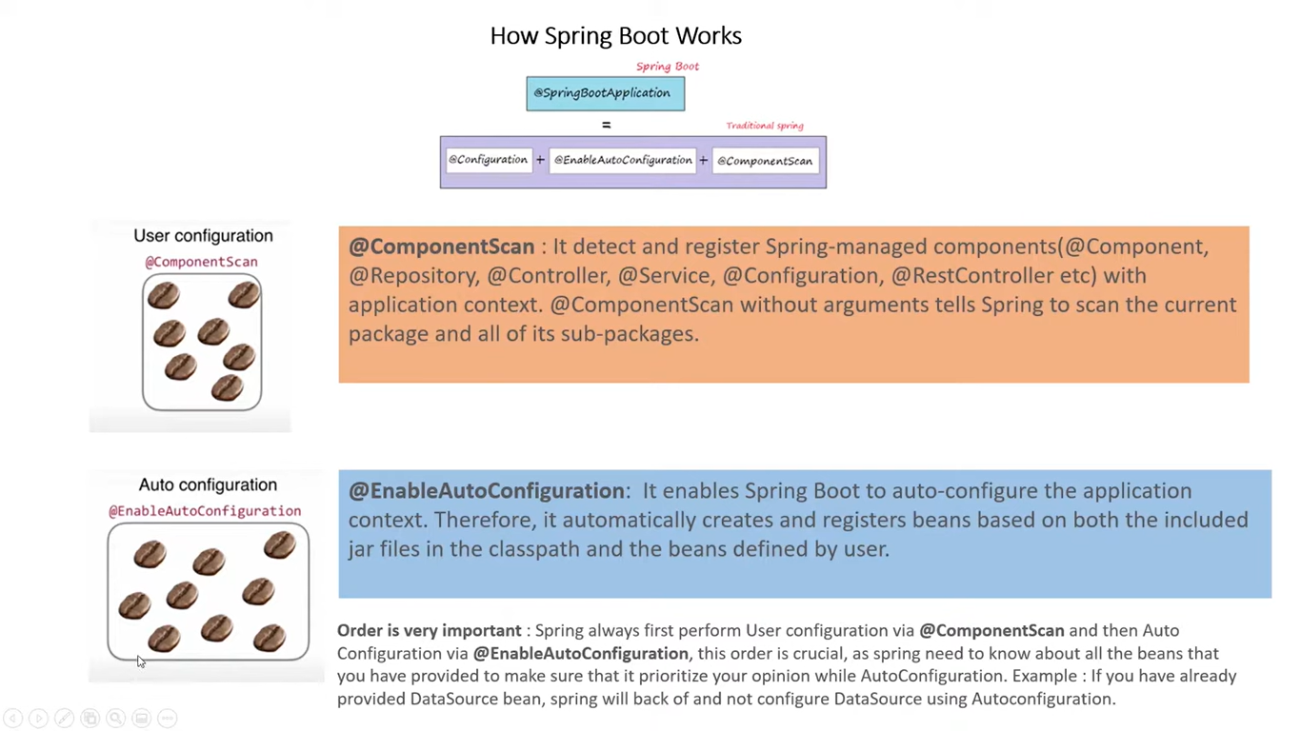

**Feign Client**

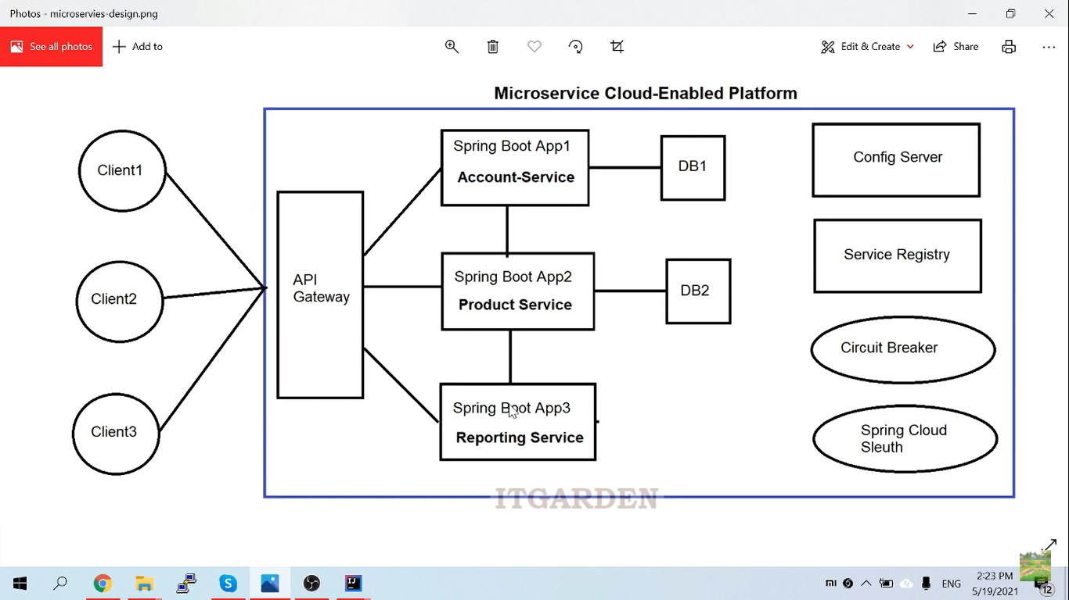

Eureka server is going to call discovery service in this scenario because it is going to identify the url and port of the particular service.

**How Different micro services with different ports calling from client application?**

**Ans.** It is not possible to provide different end points to the front end developers to access multiple services with different end points. To overcome that issue Spring boot has provided one component i.e Cloud component

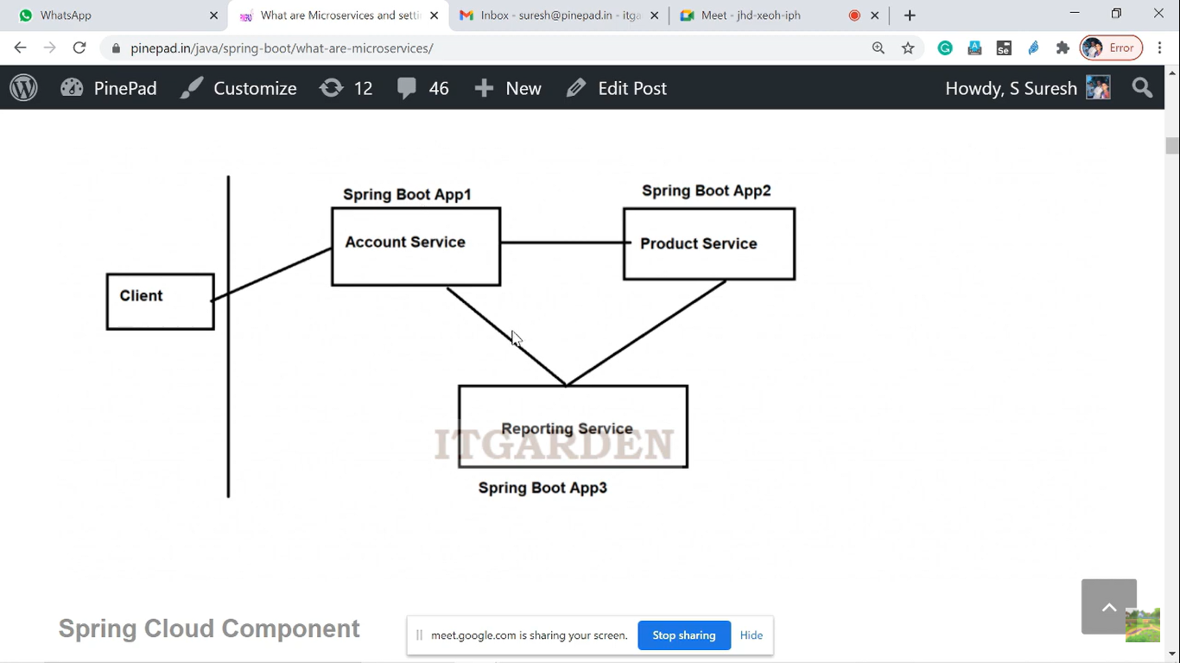

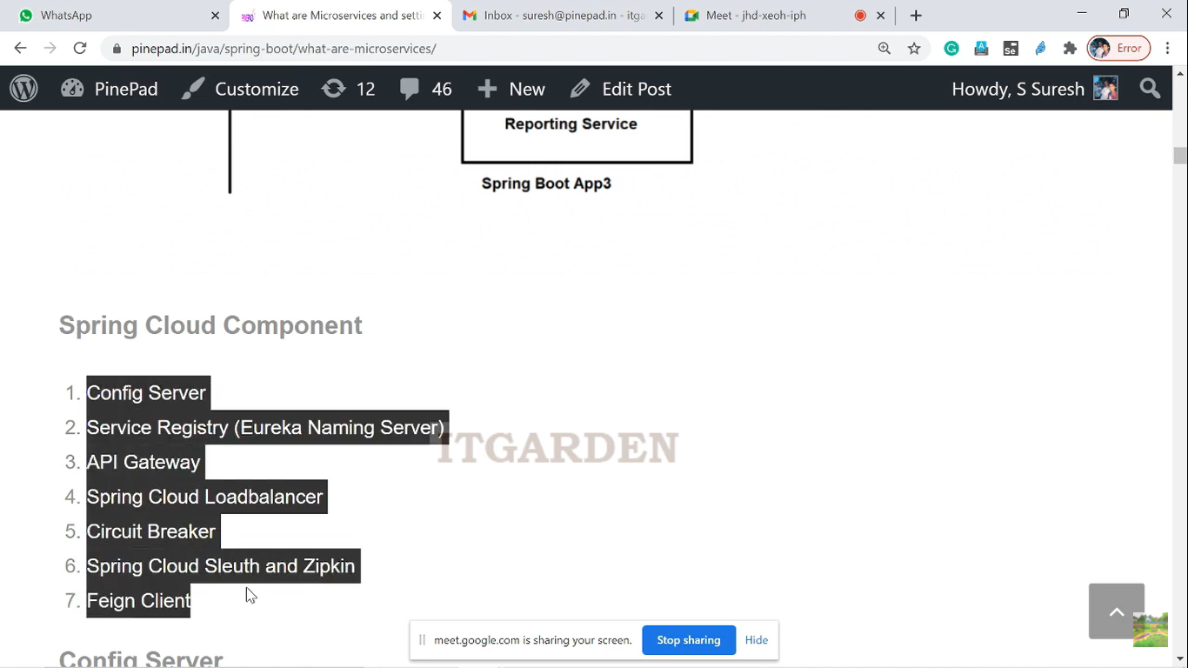

Config Service: By using Config Server, we can maintain all the micro service properties in a centralized location. So we can change those properties at any time and no need to restart the server also

**How to configure config server and Eureka server**

https://www.youtube.com/watch?v=0oPYqt0teGM

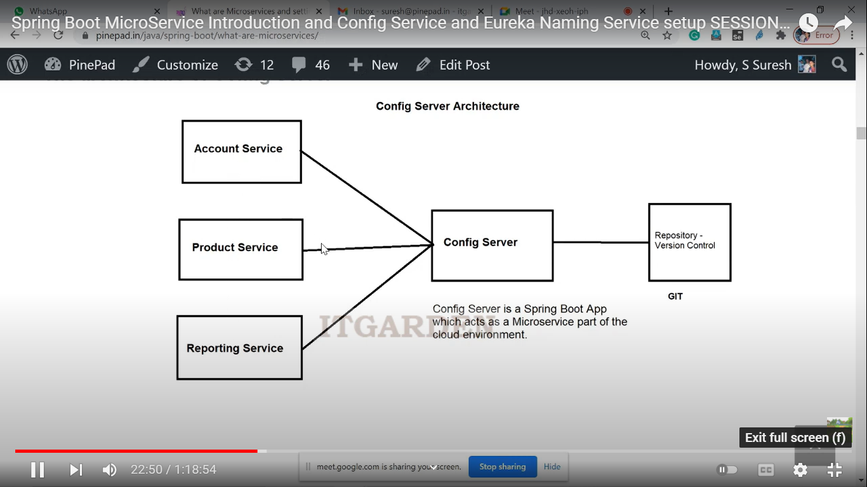

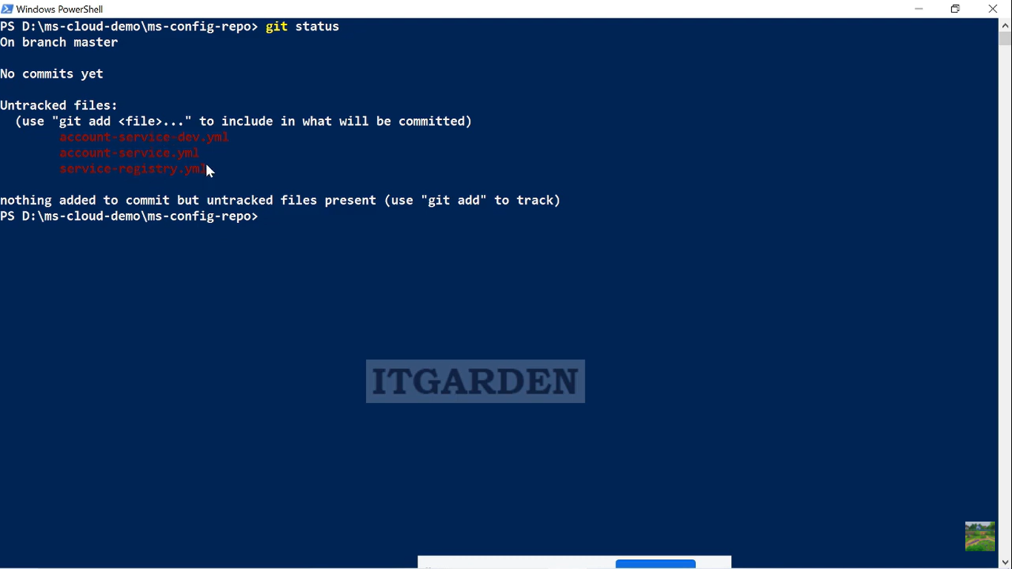

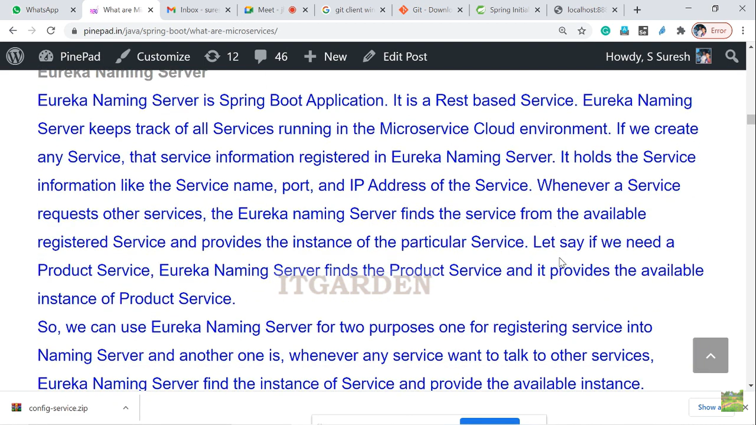

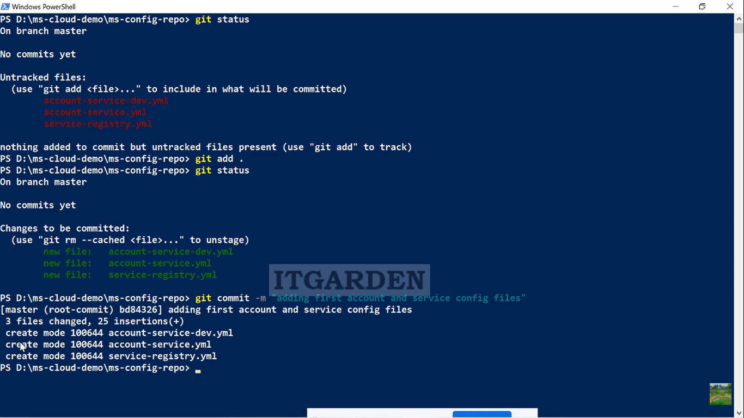

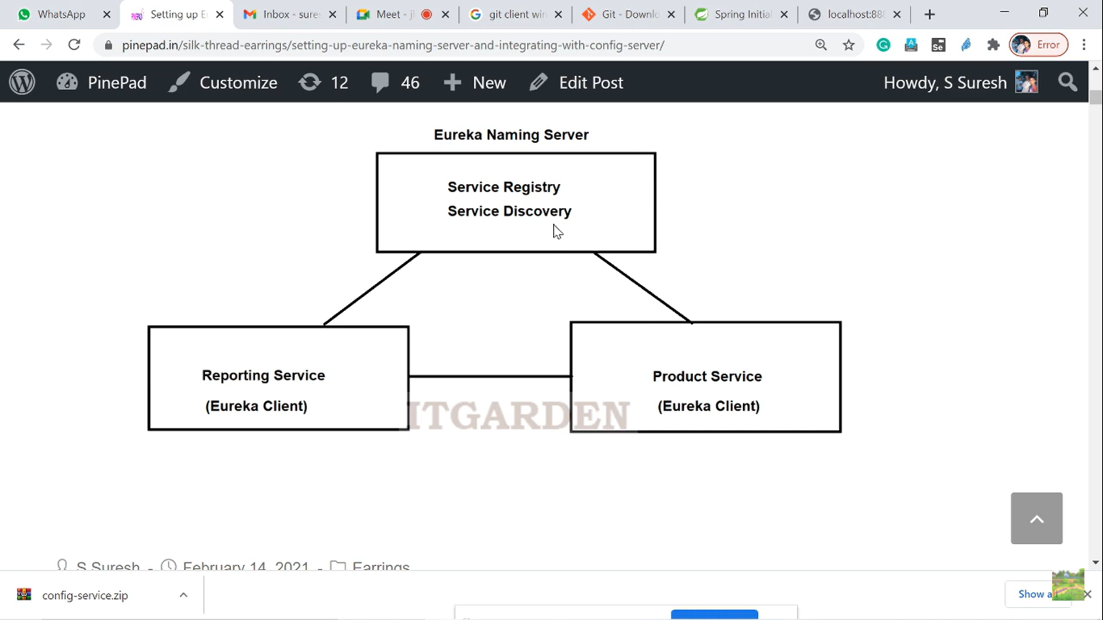

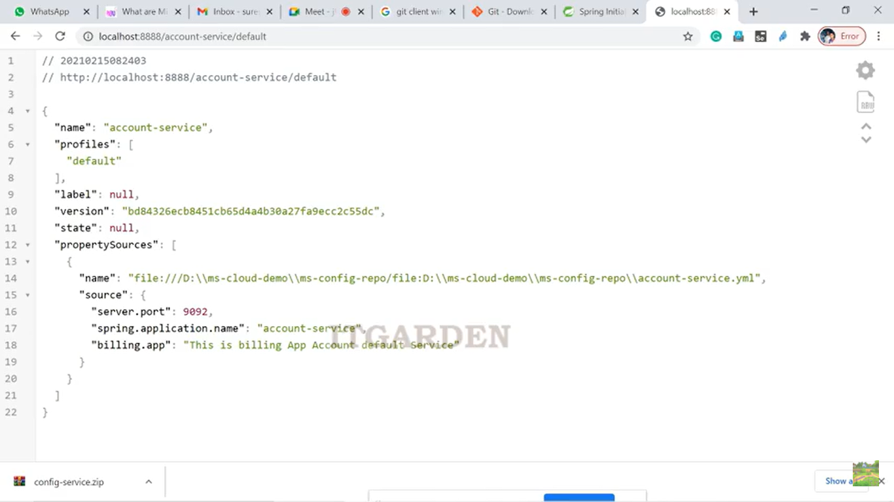

**Micro Service Architecture:**

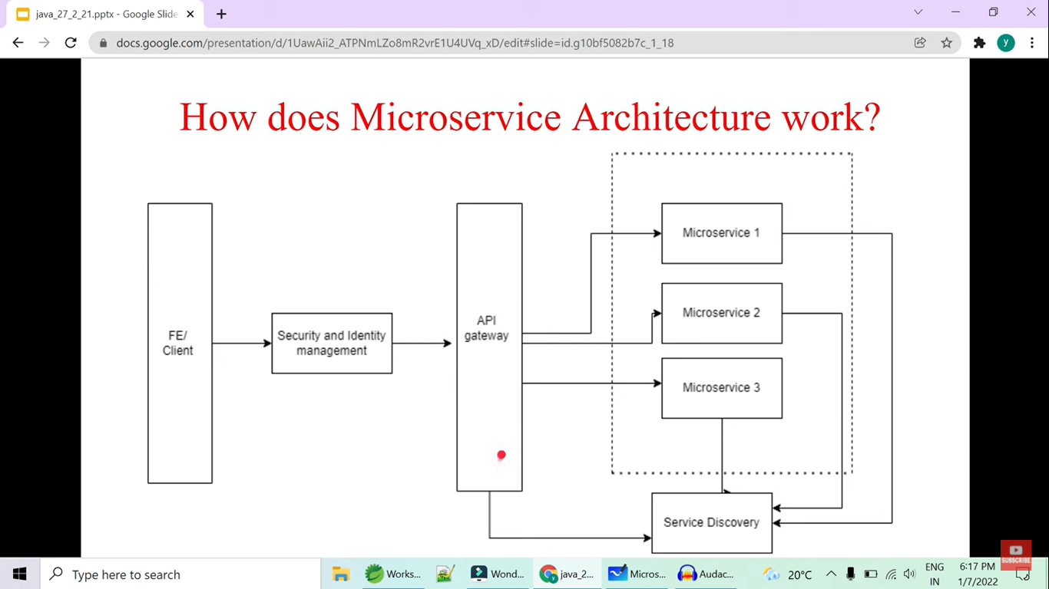

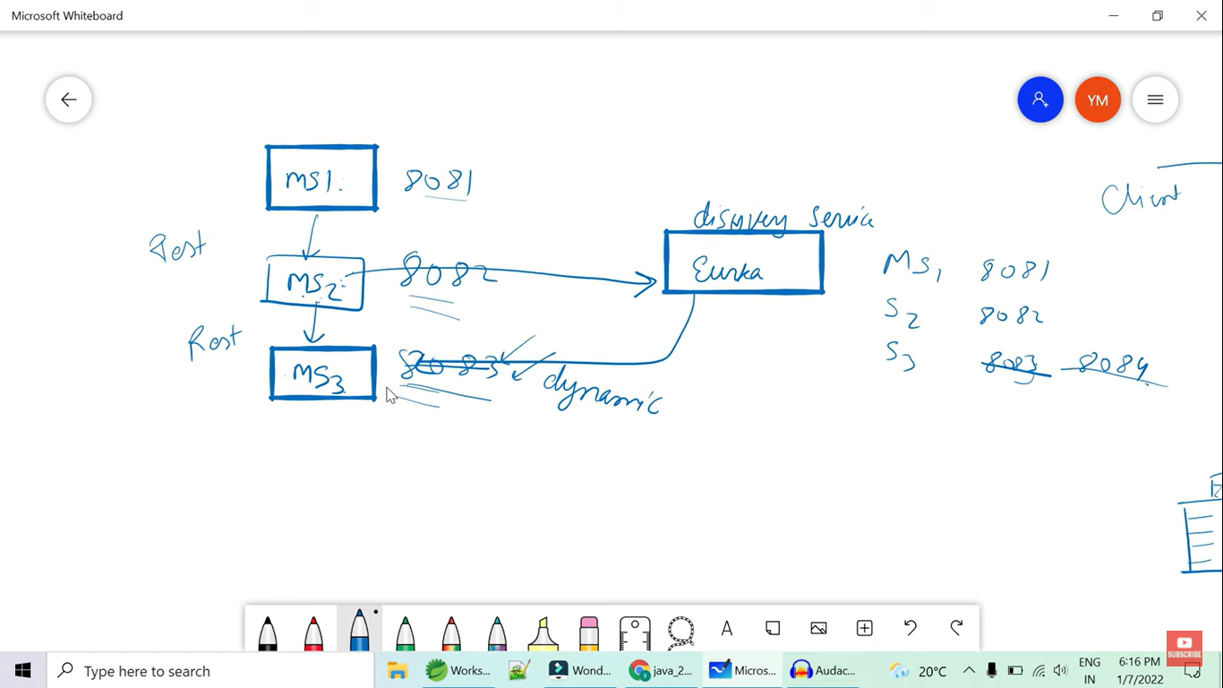

Here in the above diagram, the micro service port number is going to change dynamically with different ports and eureka is the server to discover the ip and port of that service and return to the gateway.

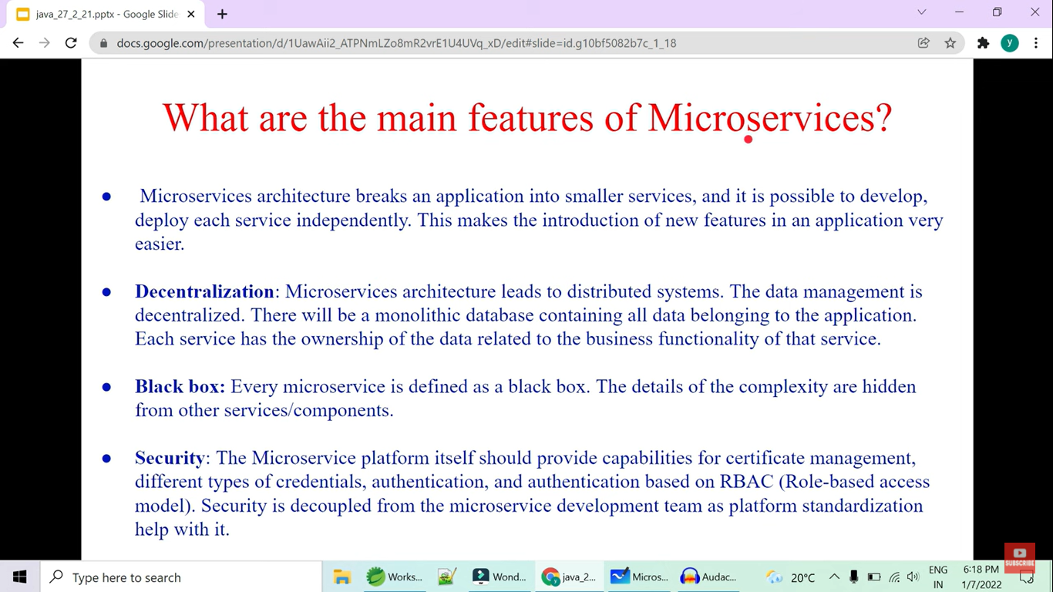

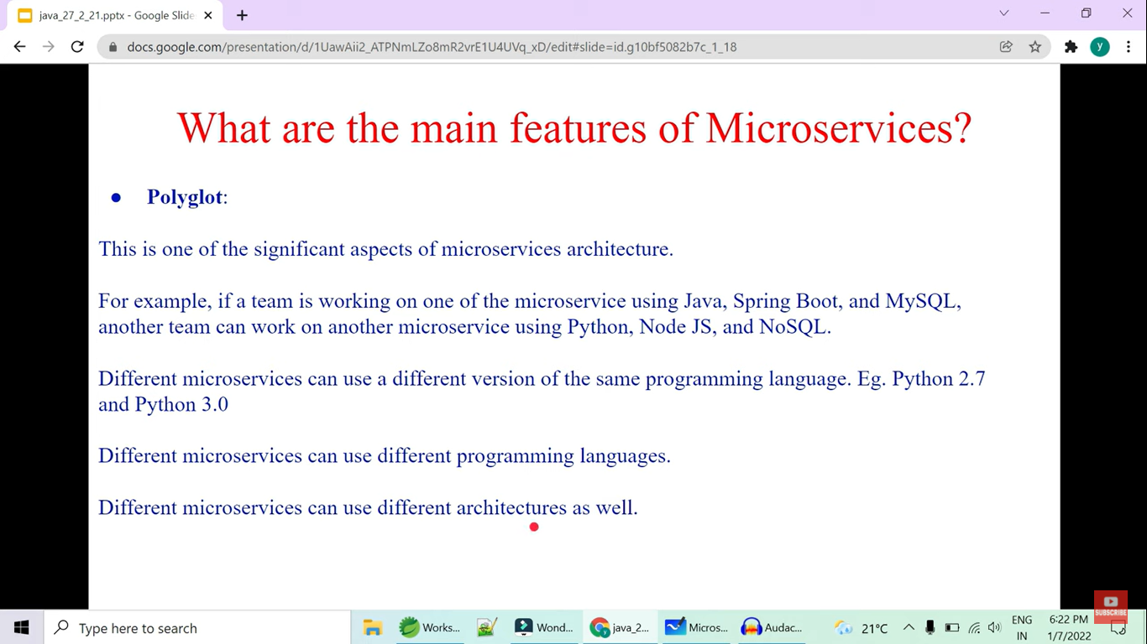

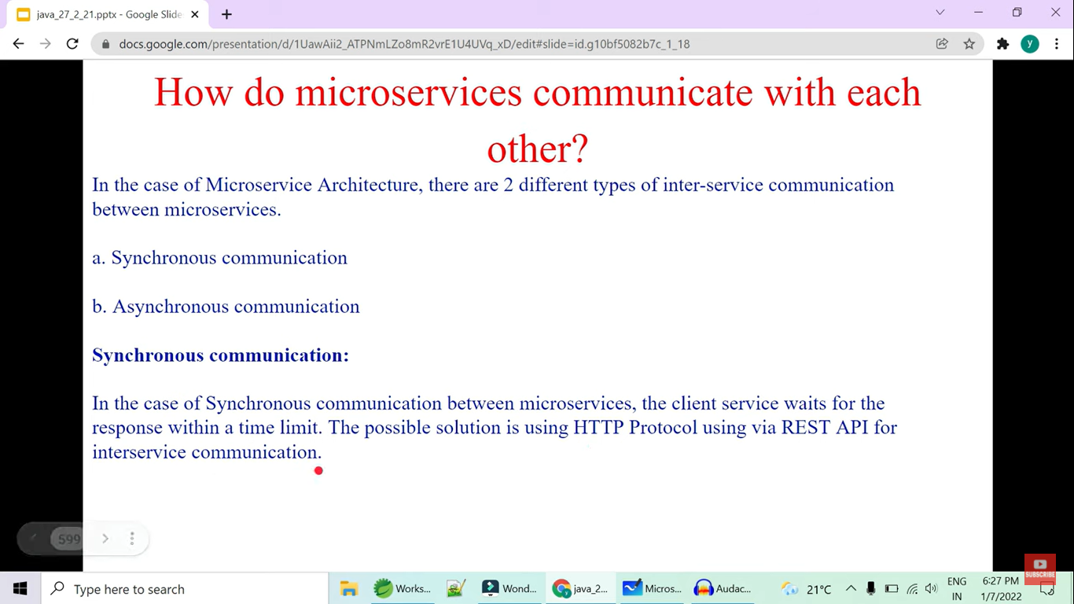

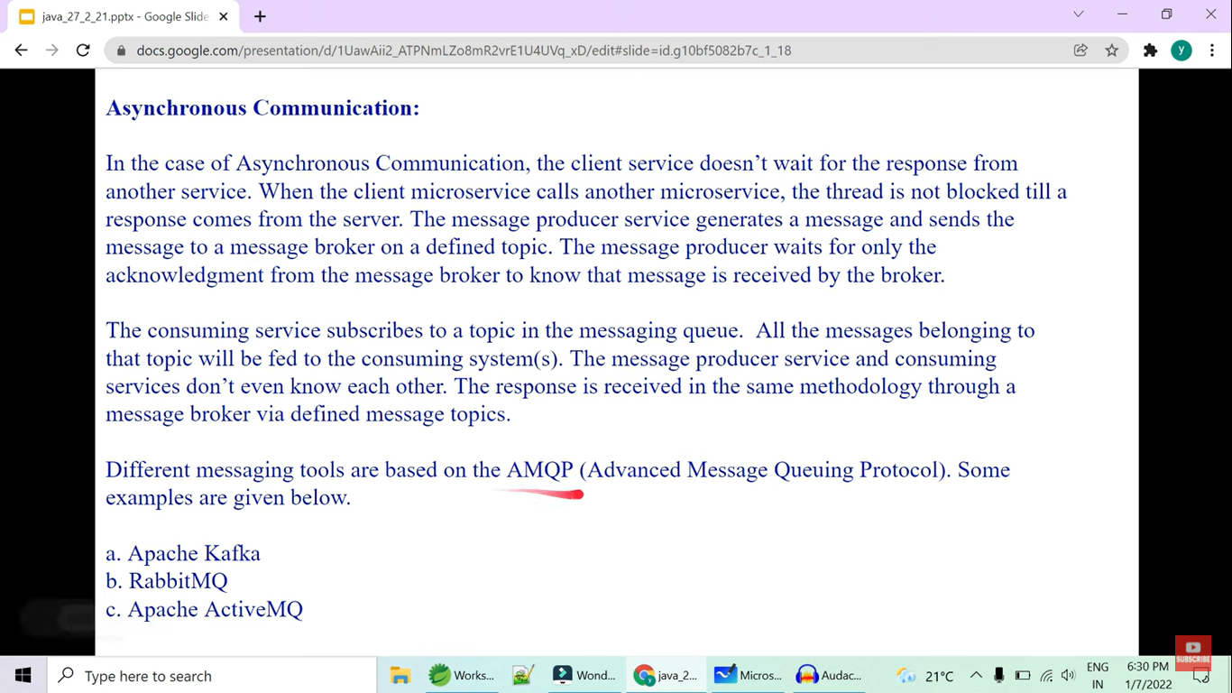

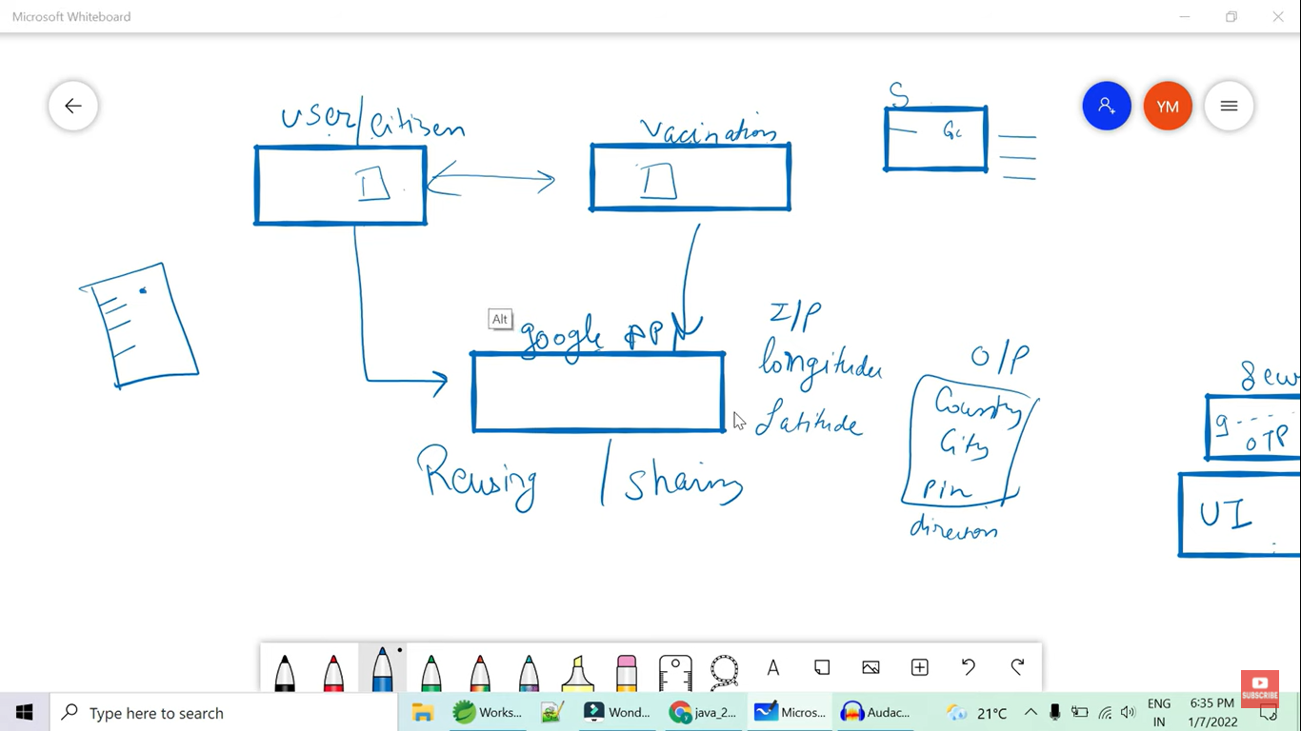

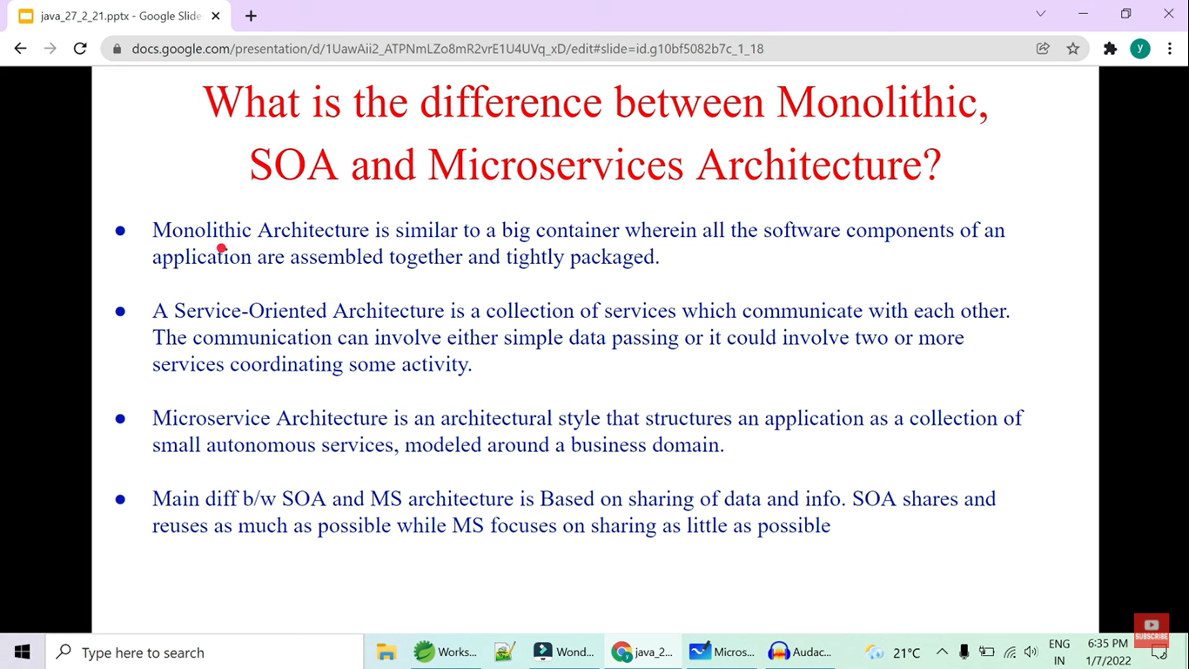

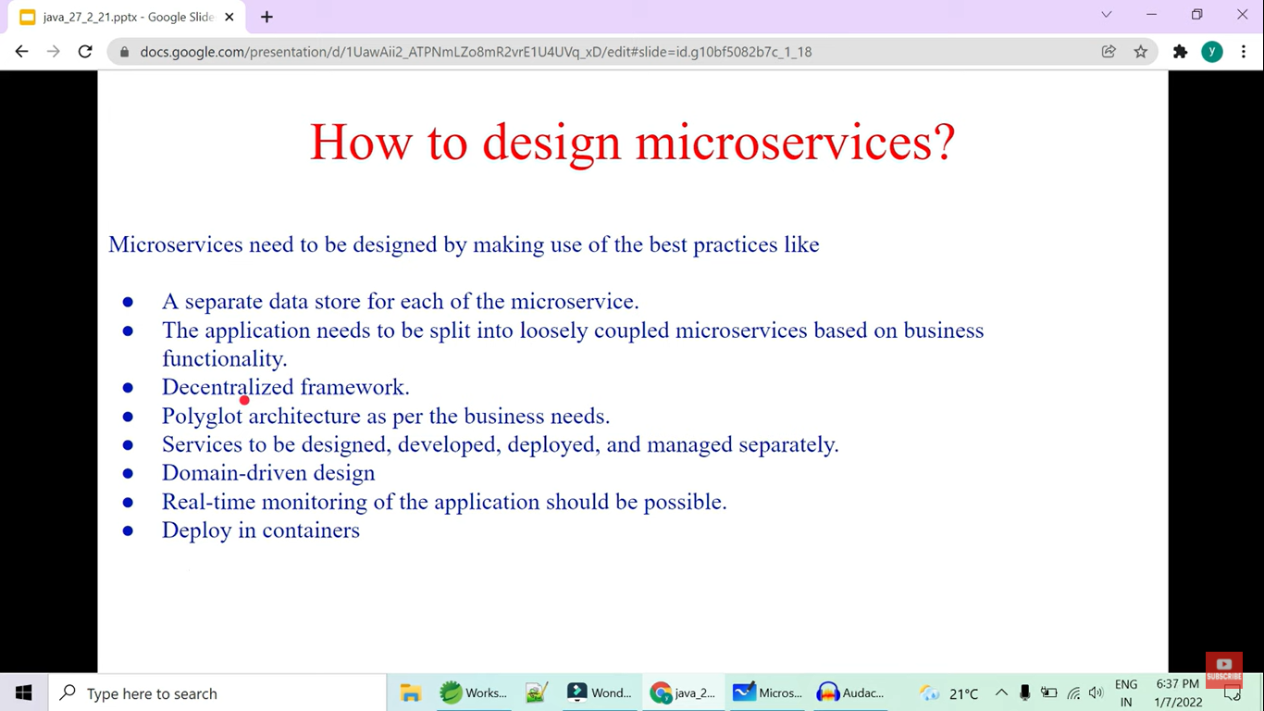

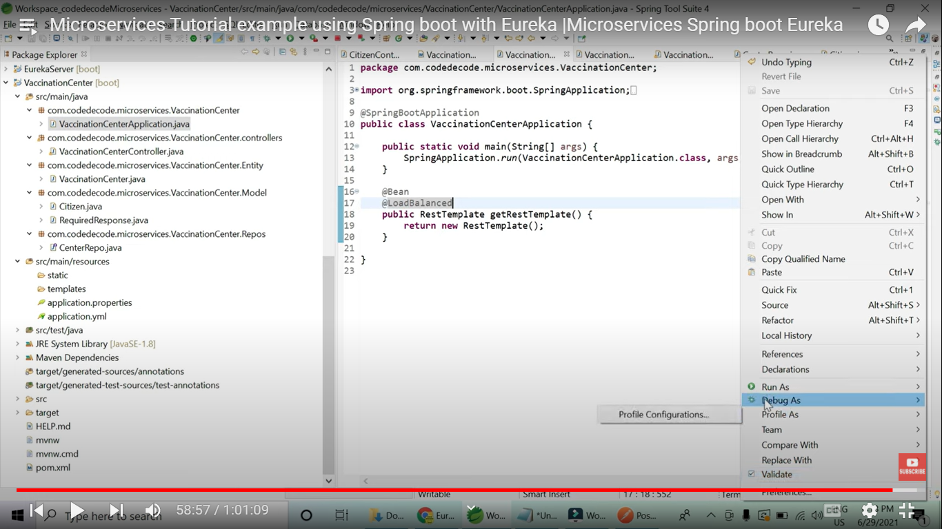

If we are using RestTemplate to call the service then we should use load balanced RestTemplate object to access the service using the Eureka registered name as below

